**KAZAL BROTHERS LTD.**

Sales Force Software Design & API

(Android & Desktop Version)

Table of Contents

**Basic Setup** 2

Financial Year 2

Designation 2

User/Employee Registration 3

Region Type 5

Region/Area 6

Institution Type 7

Institution 8

Books Category 11

Books (Products) 12

TA/DA Allowance Type 13

Visit Purposes 14

Mapping Employee VS Region 15

Party Management 16

**Transactions** 19

Assign Visit Plans 19

Visit Approval Process 21

Visit Entry 22

Visit Approval 25

Production Order 28

Product Receipt 30

Sales Orders 32

Money Receipt 36

Sales Return 42

Damage Products/Books 49

Inventory Transfer 56

Sales Orders Approval Process 58

Delivery Challan 59

Invoice/Bill 60

Specimen Requisition 61

Specimen Approval 62

# **Introduction**

## **Application Name:**

D-Logic Sales Force Software   
(Including Sales & Distribution)

## **Company Name & Logo:**

**Company Name: Kazal Brothers Limited**



## **Search option for any Column data**

Every List of the data have the **Search option for any Column data** that I send you sample design:

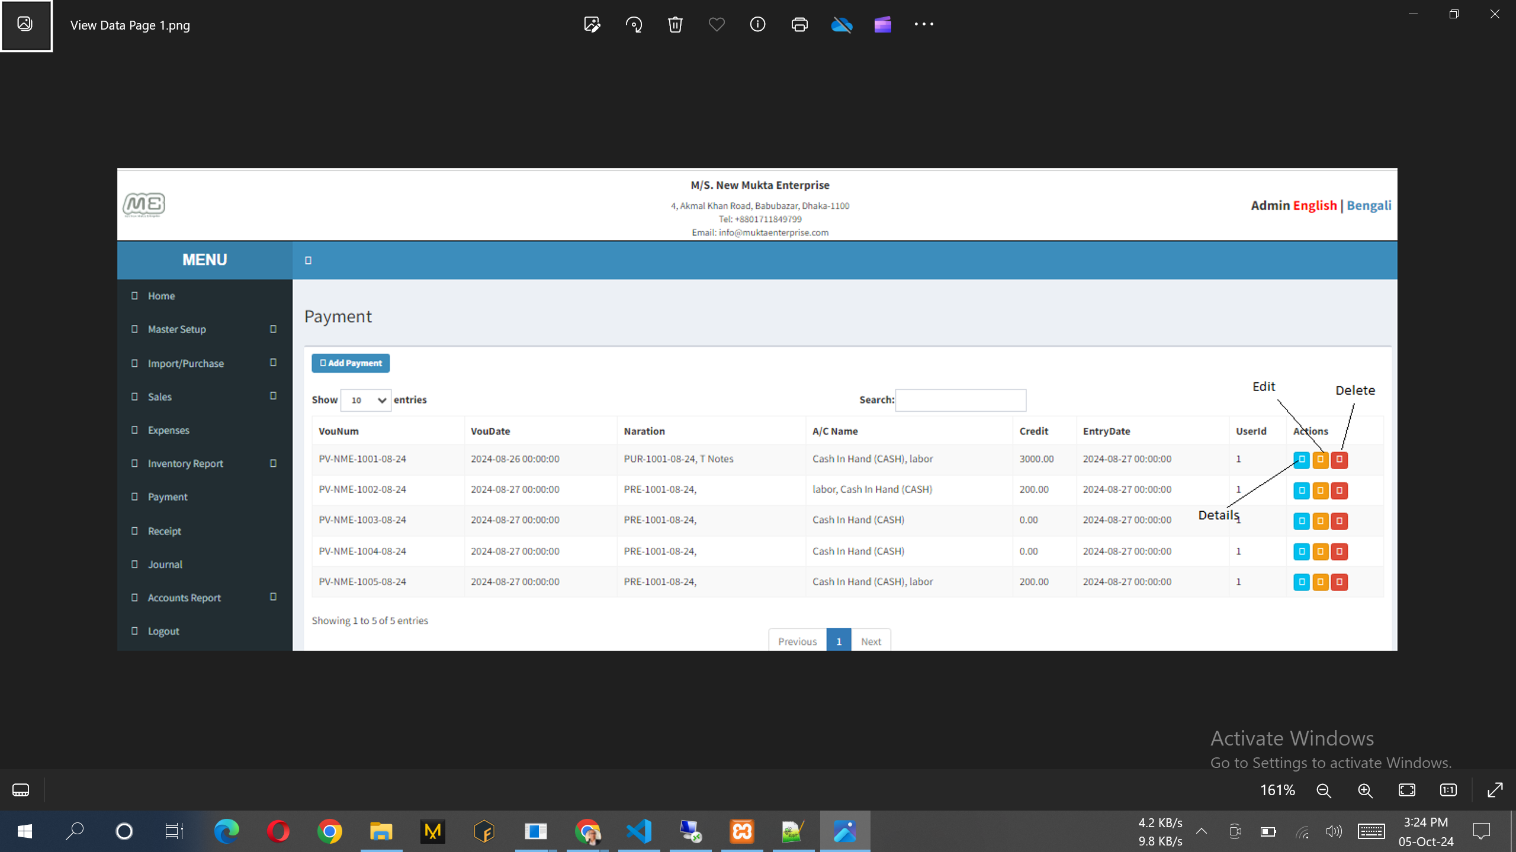

## **Transaction form sample design**

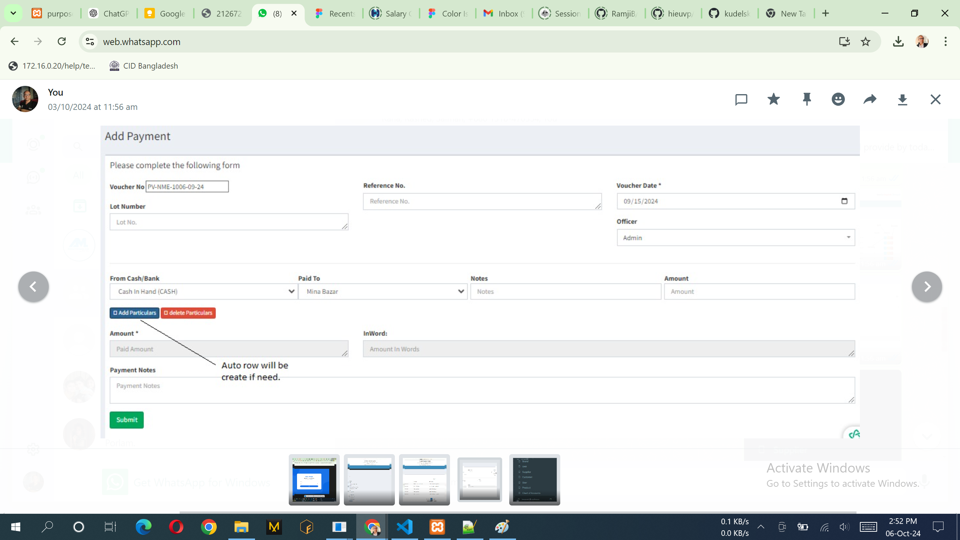

# **Basic Setup**

## **Financial Year**

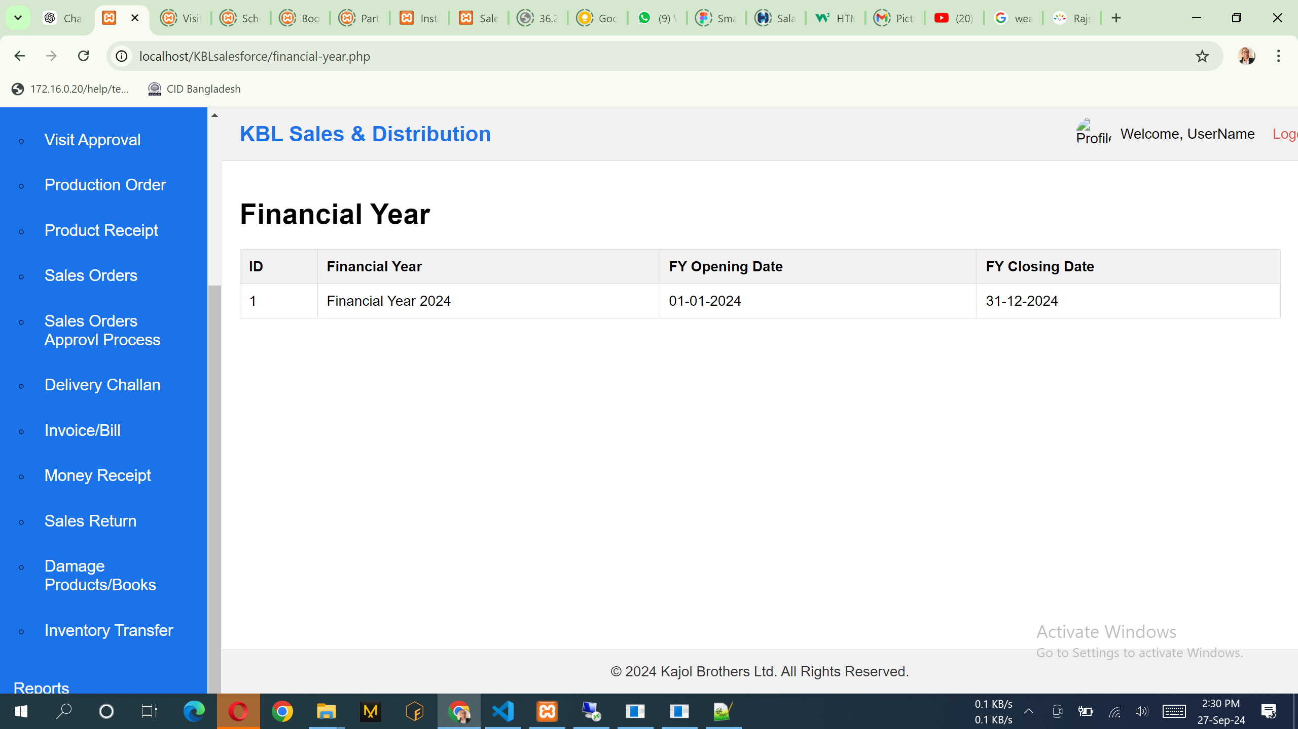

Note:

1. Only show this data from database.

API:1. <http://36.255.68.50:8080/DLogicKBL/salesforce_api.php?action=get_financialyears>

SQL:

select id, name, OpeningDate,ClosingDate, YearClosingStatus from CmnTransactionalYears where ModuleId = '06' and CmnCompanyId = '2'

## **Designation**

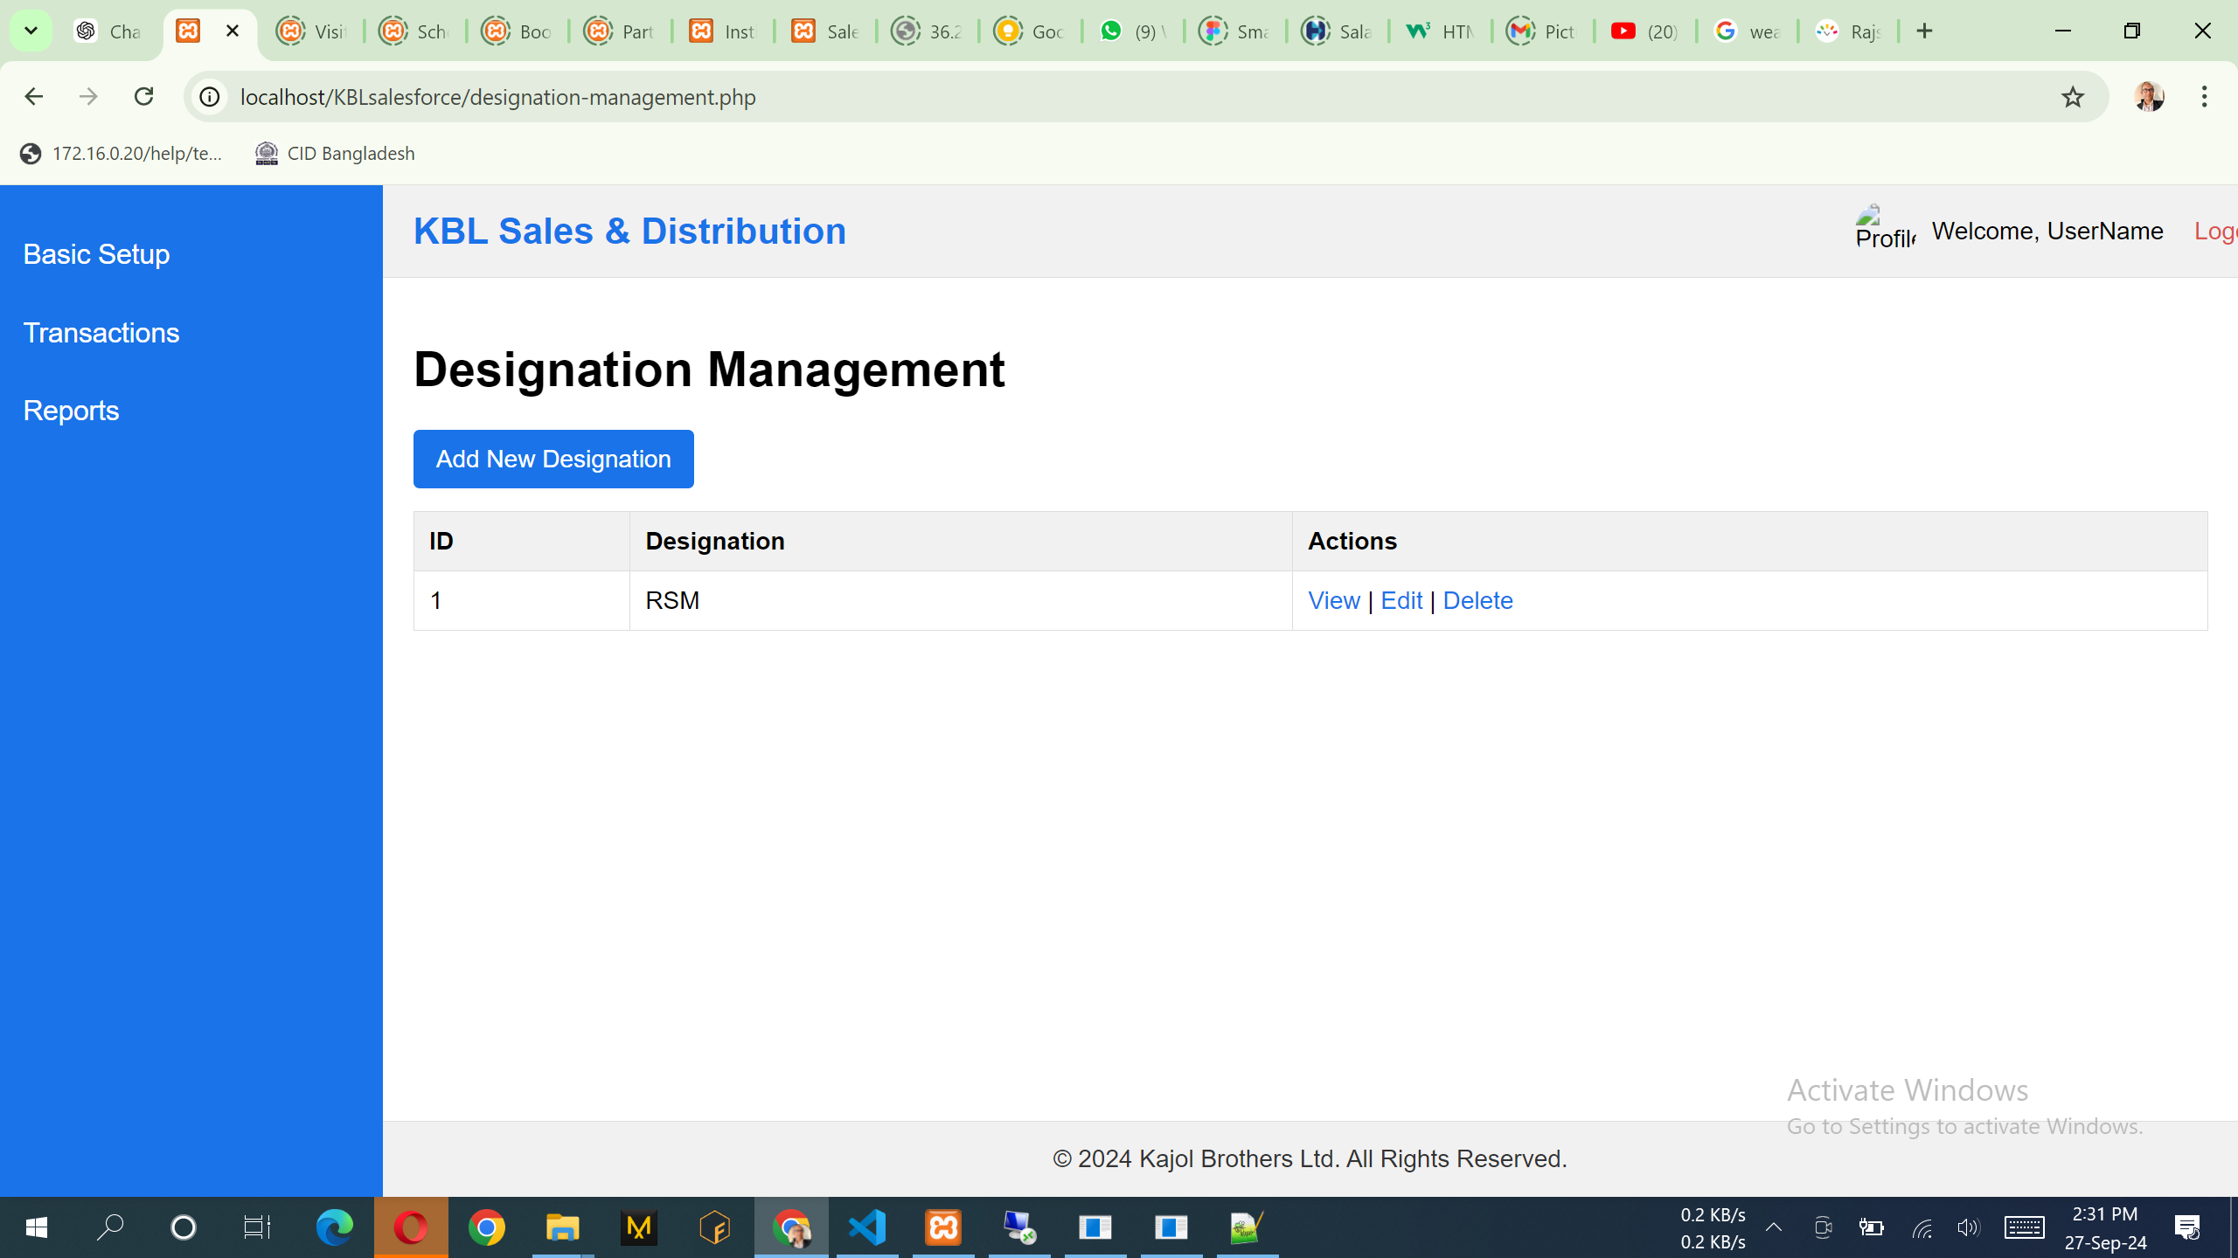

SQL: select id, CategoryName from sndCategorydata where CategoryType = 'Designation'

API:

1. <http://36.255.68.50:8080/DLogicKBL/salesforce_api.php?action=get_designations>
2. <http://36.255.68.50:8080/DLogicKBL/salesforce_api.php?action=get_designation&ID=1>
3. <http://36.255.68.50:8080/DLogicKBL/salesforce_api.php?action=update_designation&ID=1>

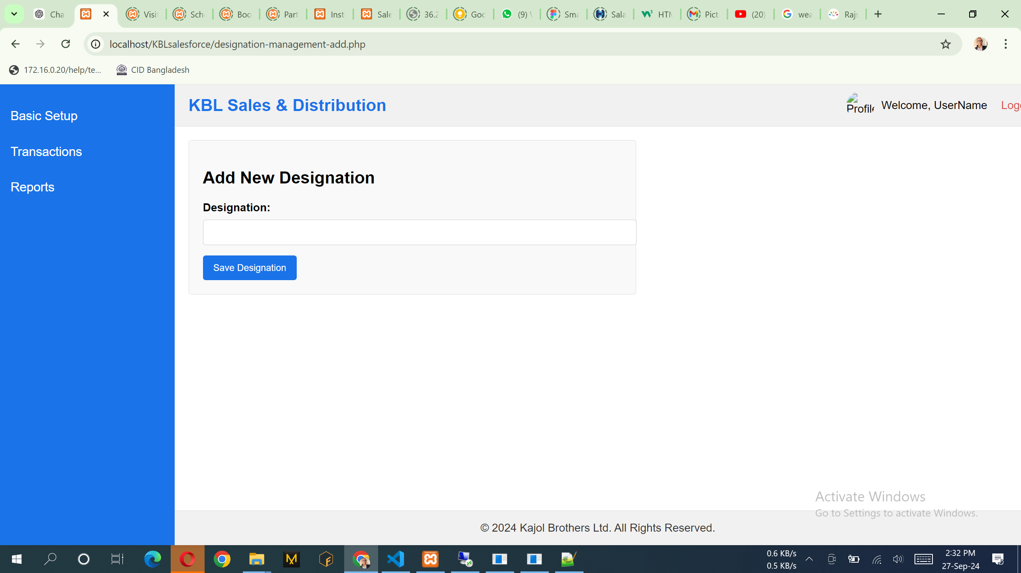

Notes:

1. List of the data can add, view & edit. No delete option.

API:

1. <http://36.255.68.50:8080/DLogicKBL/salesforce_api.php?action=create_designation>

SQL:

INSERT INTO [dbo].[sndCategorydata]

([CategoryType]

,[CategoryName])

VALUES

(<CategoryType, varchar(100),>

,<CategoryName, varchar(150),>)

## **User/Employee Registration**

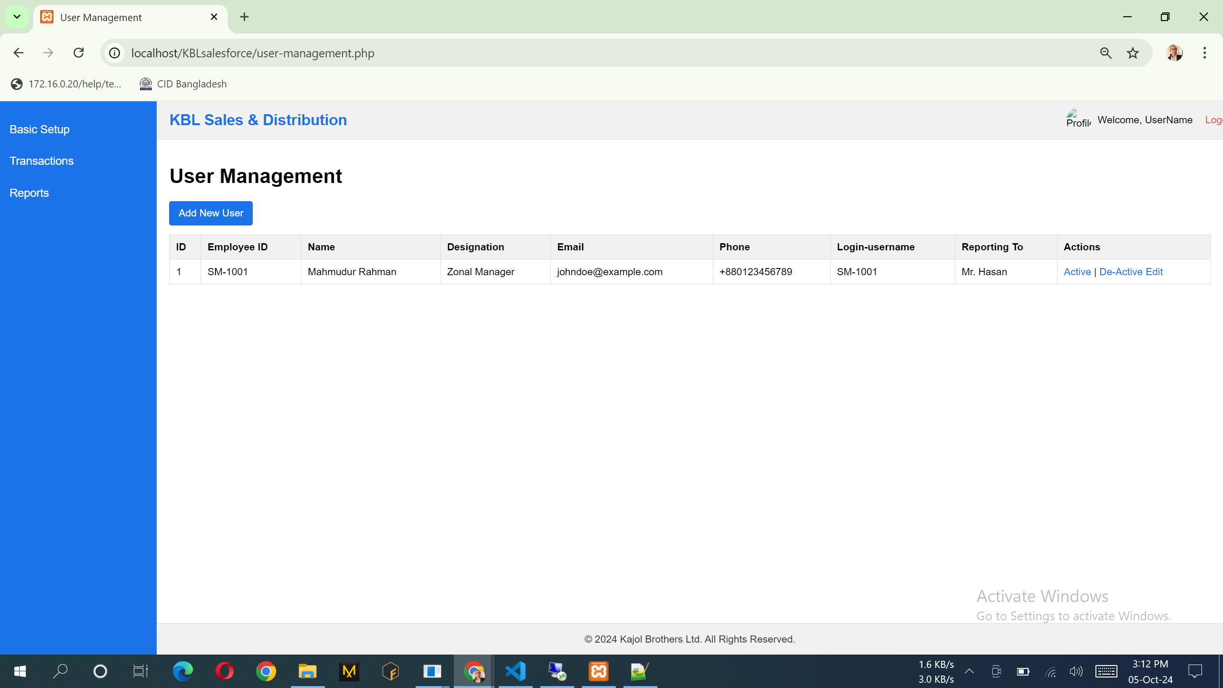

API:

1. <http://36.255.68.50:8080/DLogicKBL/salesforce_api.php?action=get_users>
2. <http://36.255.68.50:8080/DLogicKBL/salesforce_api.php?action=get_user&UserID=1>
3. <http://36.255.68.50:8080/DLogicKBL/salesforce_api.php?action=update_user&UserID=1>

SQL: For Update:  
$sql = "UPDATE sndUsers SET EmployeeID = ?, EmpName = ?, DesignationID = ?, Username = ?, Password = ?, Email = ?, Phone = ?, Address = ?, ReportingToUserID = ?, ModifiedAt = GETDATE() WHERE UserID = ?";

$params = [

$input['EmployeeID'],

$input['EmpName'],

$input['DesignationID'],

$input['Username'],

$input['Password'],

$input['Email'],

$input['Phone'] ?? null,

$input['Address'] ?? null,

$input['ReportingToUserID'] ?? null,

$UserID

];

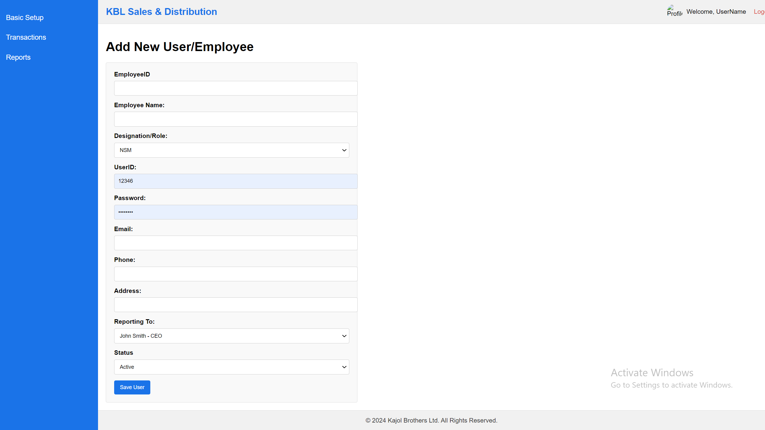

Note:

1. Reporting To: Load all of the employee including their designation.
2. Data can be add, edit & view. No delete option over here. Only can active/de-active option.

API:

1. http://36.255.68.50:8080/DLogicKBL/salesforce_api.php?action=create_user

SQL:

INSERT INTO [dbo].[sndUsers]

([DesignationID]

,[EmpName]

,[Email]

,[Phone]

,[Address]

,[AssignedRegionID]

,[ReportingToUserID]

,[CreatedAt]

,[ModifiedAt]

,[Username]

,[Password]

,[EmployeeID])

VALUES

(<DesignationID, varchar(50),>

,<EmpName, varchar(150),>

,<Email, varchar(100),>

,<Phone, varchar(15),>

,<Address, varchar(255),>

,<AssignedRegionID, int,>

,<ReportingToUserID, int,>

,<CreatedAt, datetime,>

,<ModifiedAt, datetime,>

,<Username, varchar(100),>

,<Password, varchar(100),>

,<EmployeeID, varchar(50),>)

GO

## **Region Type**

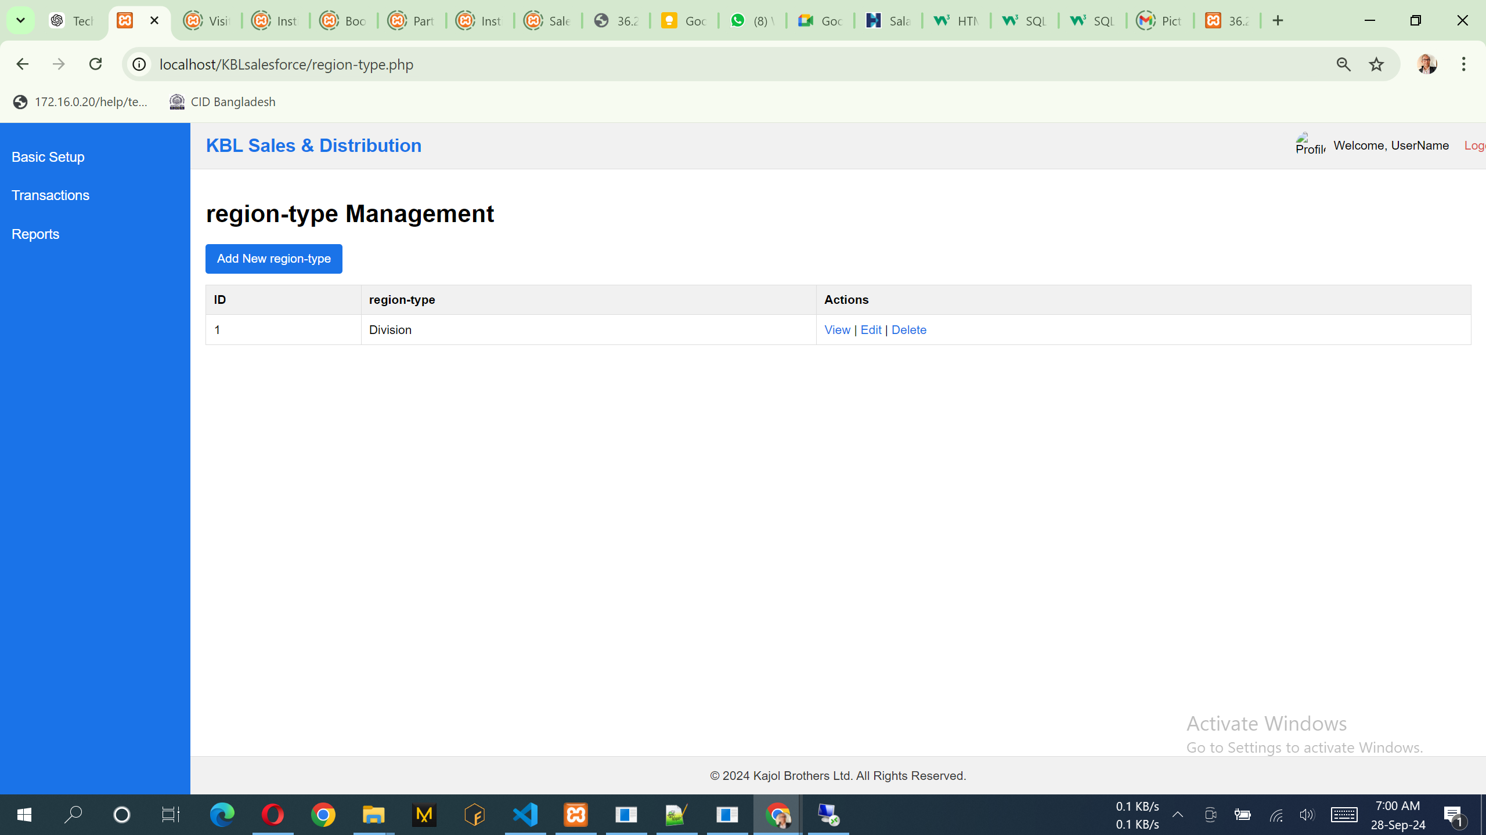

SQL: select id, CategoryName from sndCategorydata where CategoryType = 'Region'

API:

1. <http://36.255.68.50:8080/DLogicKBL/salesforce_api.php?action=get_regiontype>s
2. <http://36.255.68.50:8080/DLogicKBL/salesforce_api.php?action=get_regiontype&ID=1>
3. <http://36.255.68.50:8080/DLogicKBL/salesforce_api.php?action=update_regiontype&ID=1>

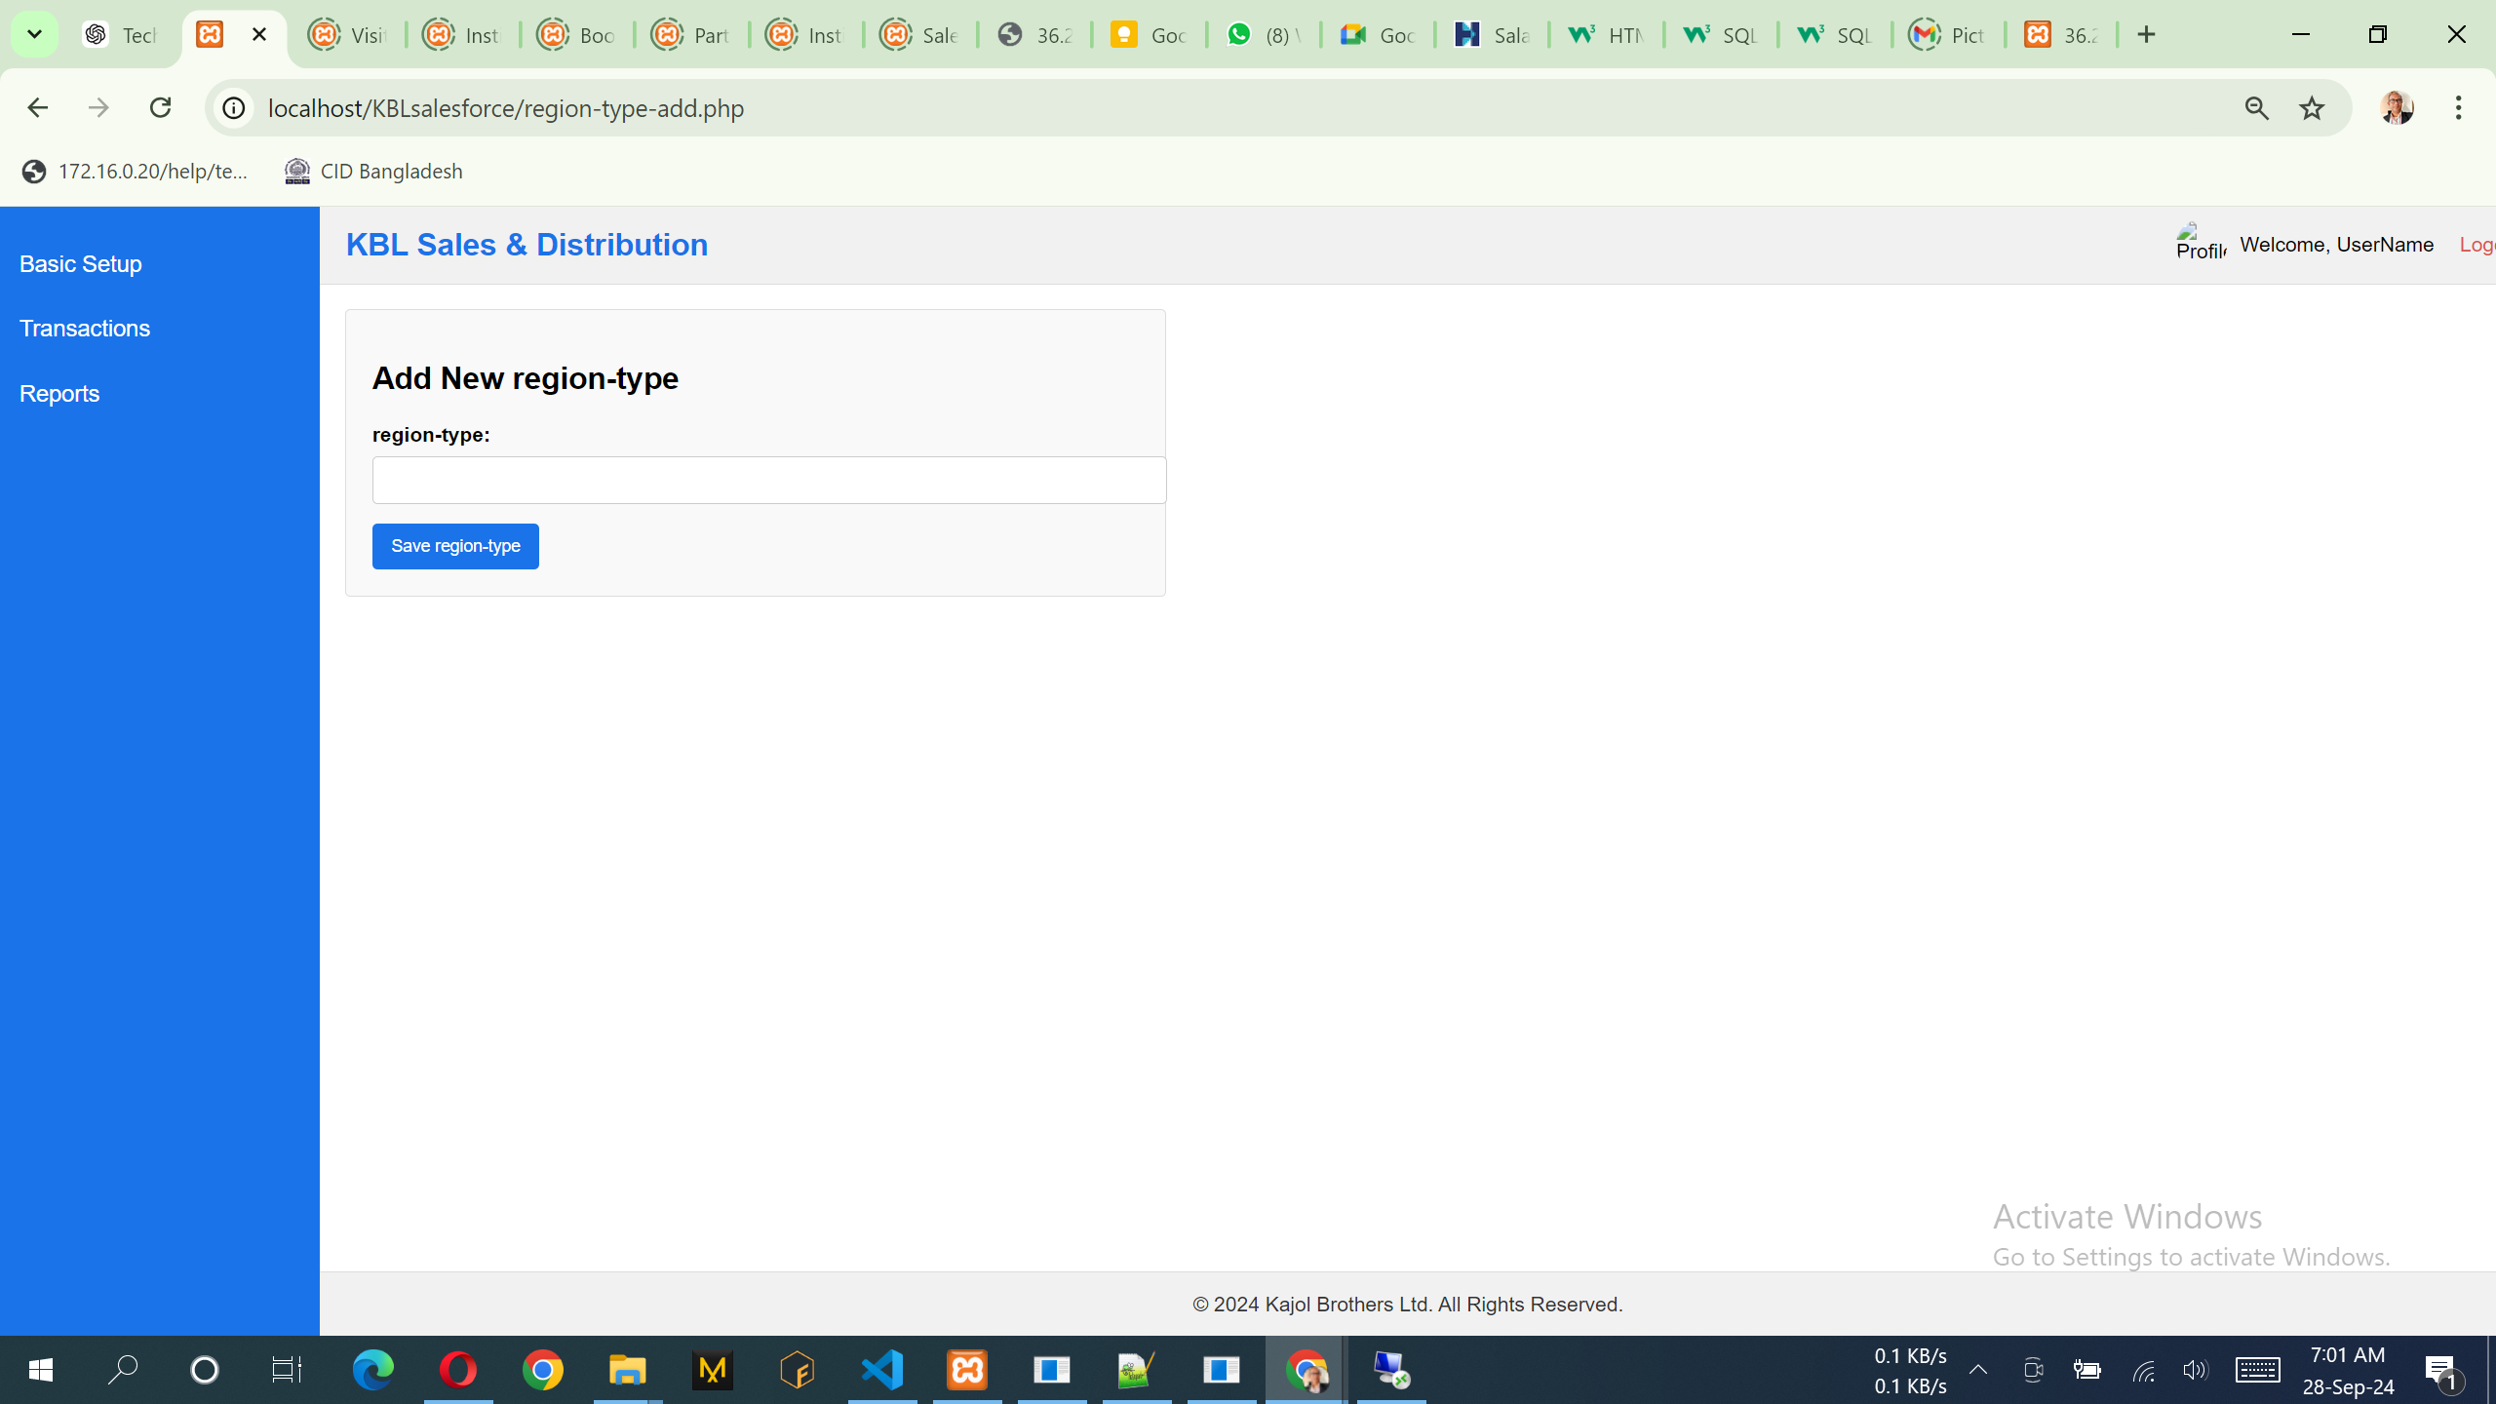

Notes:

1. List of the data can add, view & edit. No delete option.

API:

1. <http://36.255.68.50:8080/DLogicKBL/salesforce_api.php?action=create_regiontype>

SQL:

INSERT INTO [dbo].[sndCategorydata]

([CategoryType]

,[CategoryName])

VALUES

(<CategoryType, varchar(100),>

,<CategoryName, varchar(150),>)

## **Region/Area**

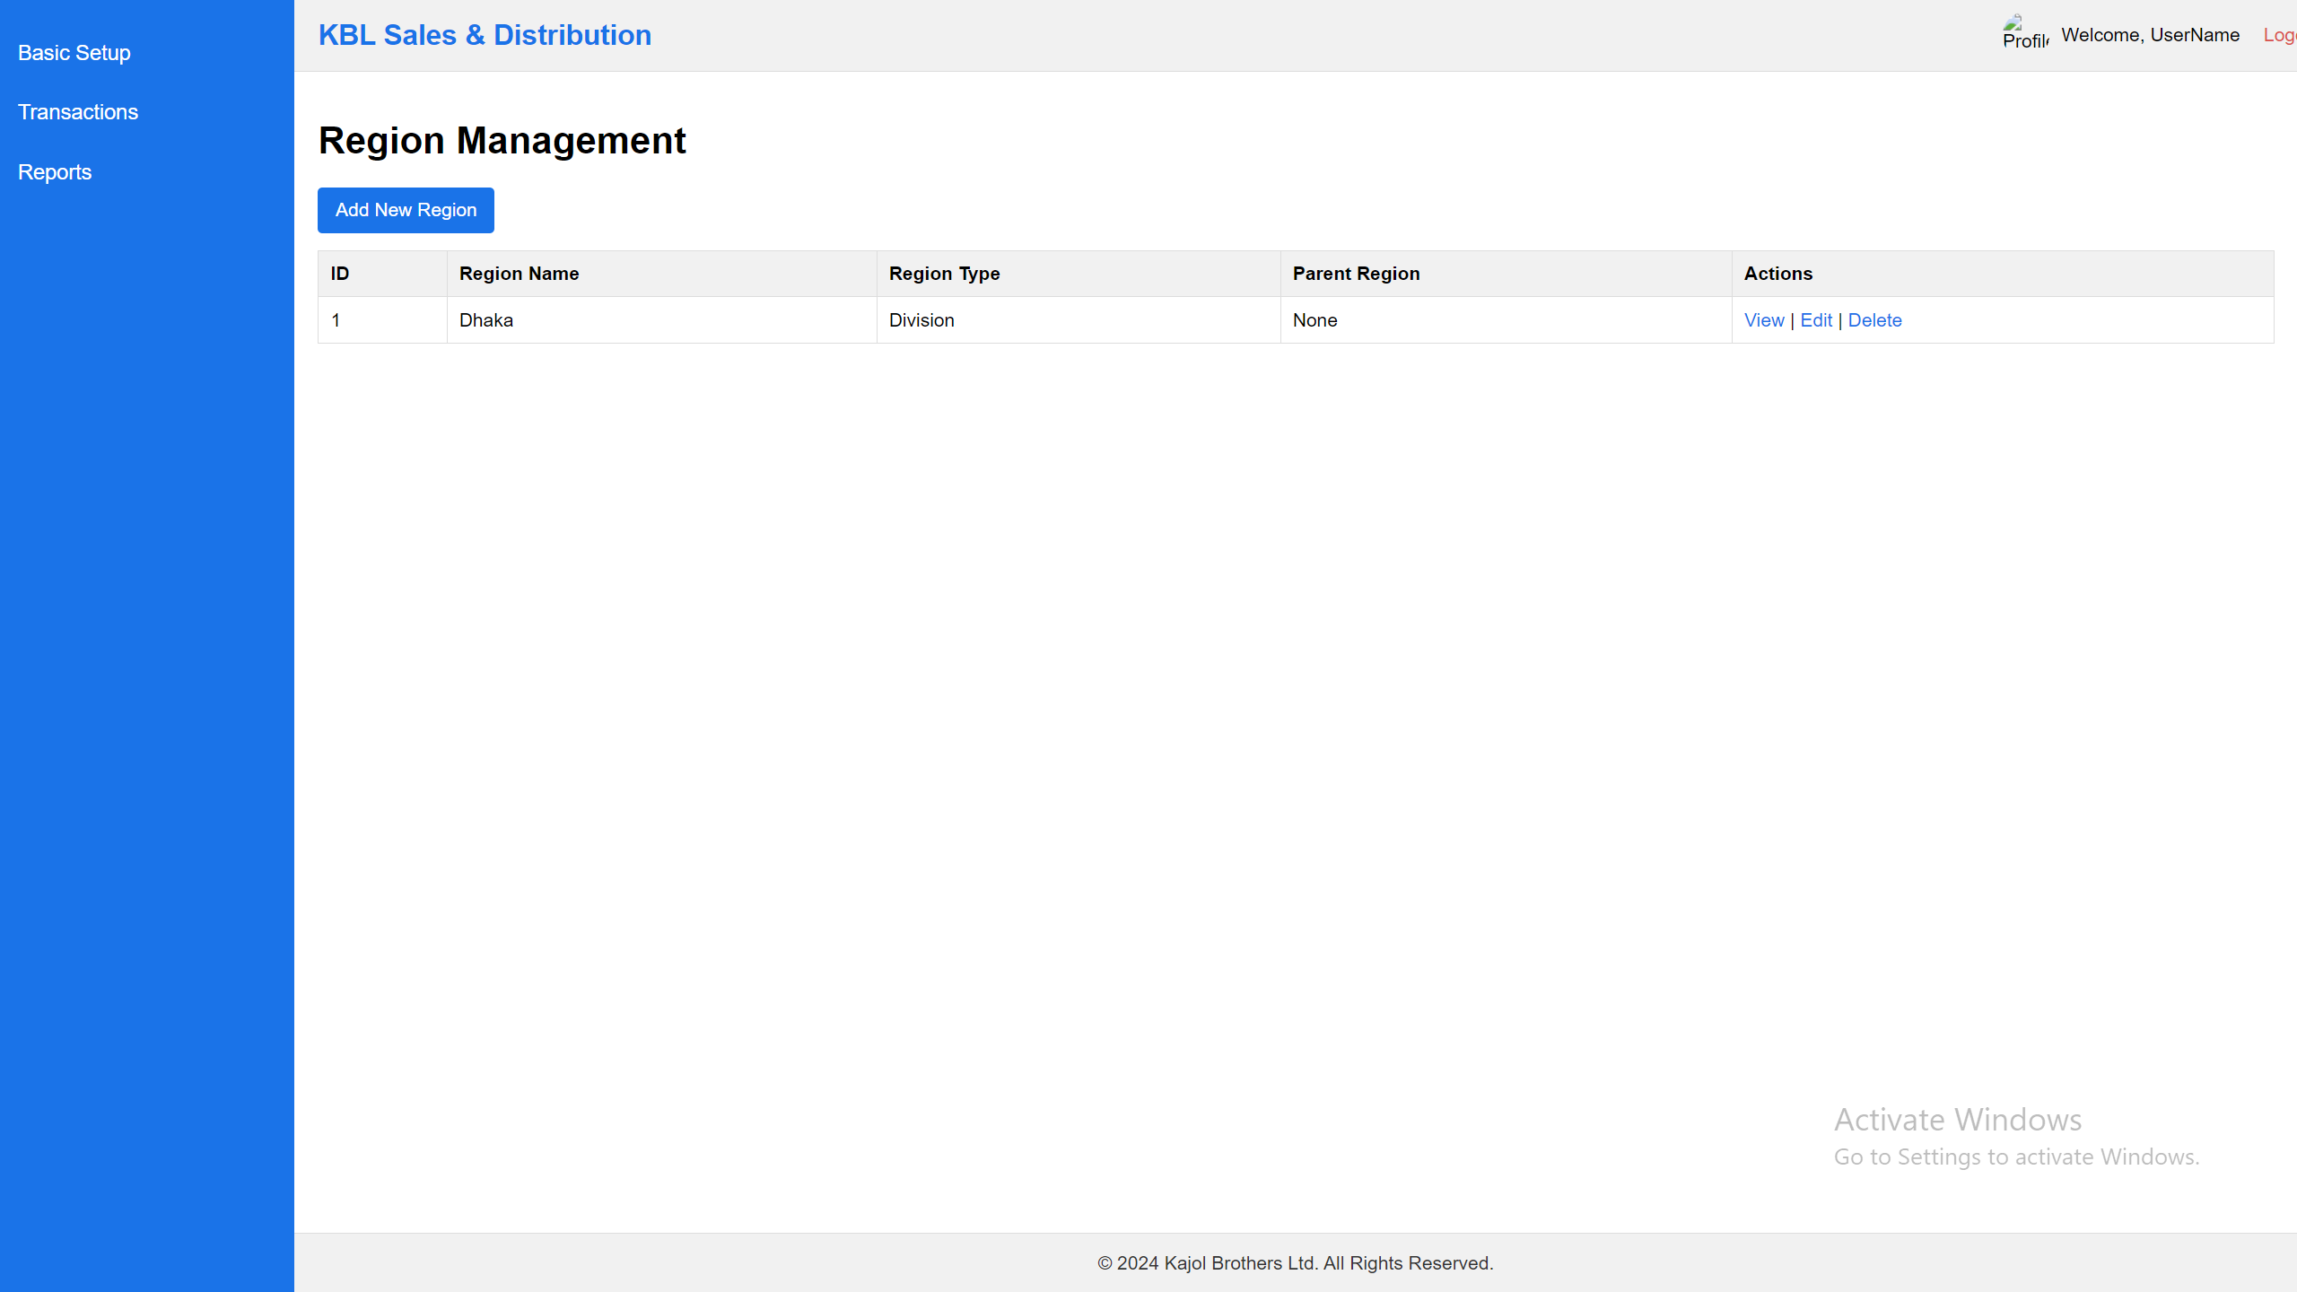

API:

<http://36.255.68.50:8080/DLogicKBL/salesforce_api.php?action=get_regions>

<http://36.255.68.50:8080/DLogicKBL/salesforce_api.php?action=get_region&RegionID=1>

SQL: SELECT [RegionID]

,[RegionName]

,[RegionType]

,[ParentRegionID]

,[CreatedAt]

,[ModifiedAt]

FROM [dbo].[sndRegions]

GO

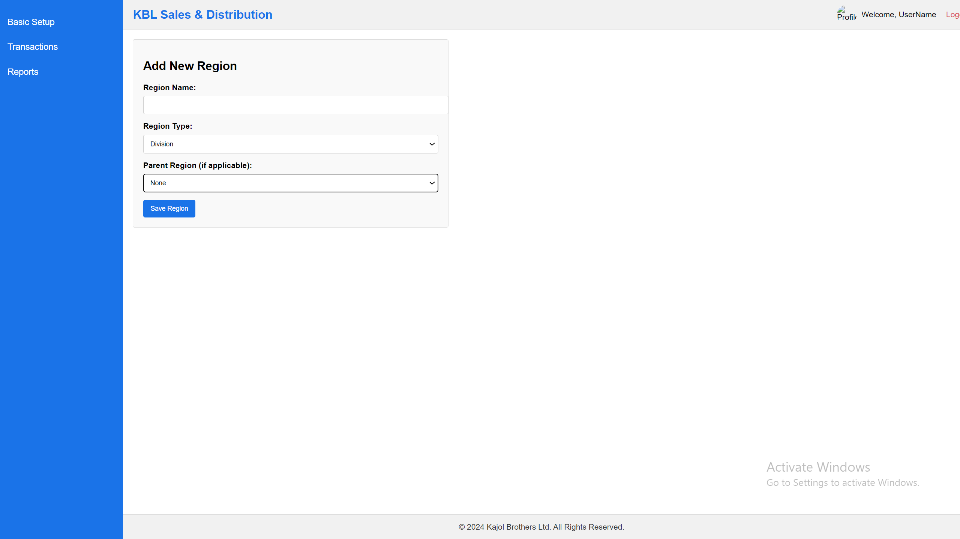

Notes:

1. Region Type: Division, District, Thana, Area [Load those data]
2. Parent Region: Only Top Head like not need to select Parent, but all the other like Division, District, Thana, Area name must be need to select parent Region like:
3. Bangladesh -> Dhaka Division, Dhaka District -> Mohammadpur Thana -> Katashur Area.
4. List of the data can add view & edit. No delete option.

SQL: INSERT INTO [dbo].[sndRegions]

([RegionName]

,[RegionType]

,[ParentRegionID]

,[CreatedAt]

,[ModifiedAt])

VALUES

(<RegionName, varchar(100),>

,<RegionType, varchar(50),>

,<ParentRegionID, int,>

,<CreatedAt, datetime,>

,<ModifiedAt, datetime,>)

GO

API: <http://36.255.68.50:8080/DLogicKBL/salesforce_api.php?action=create_region>

## **Institution Type**

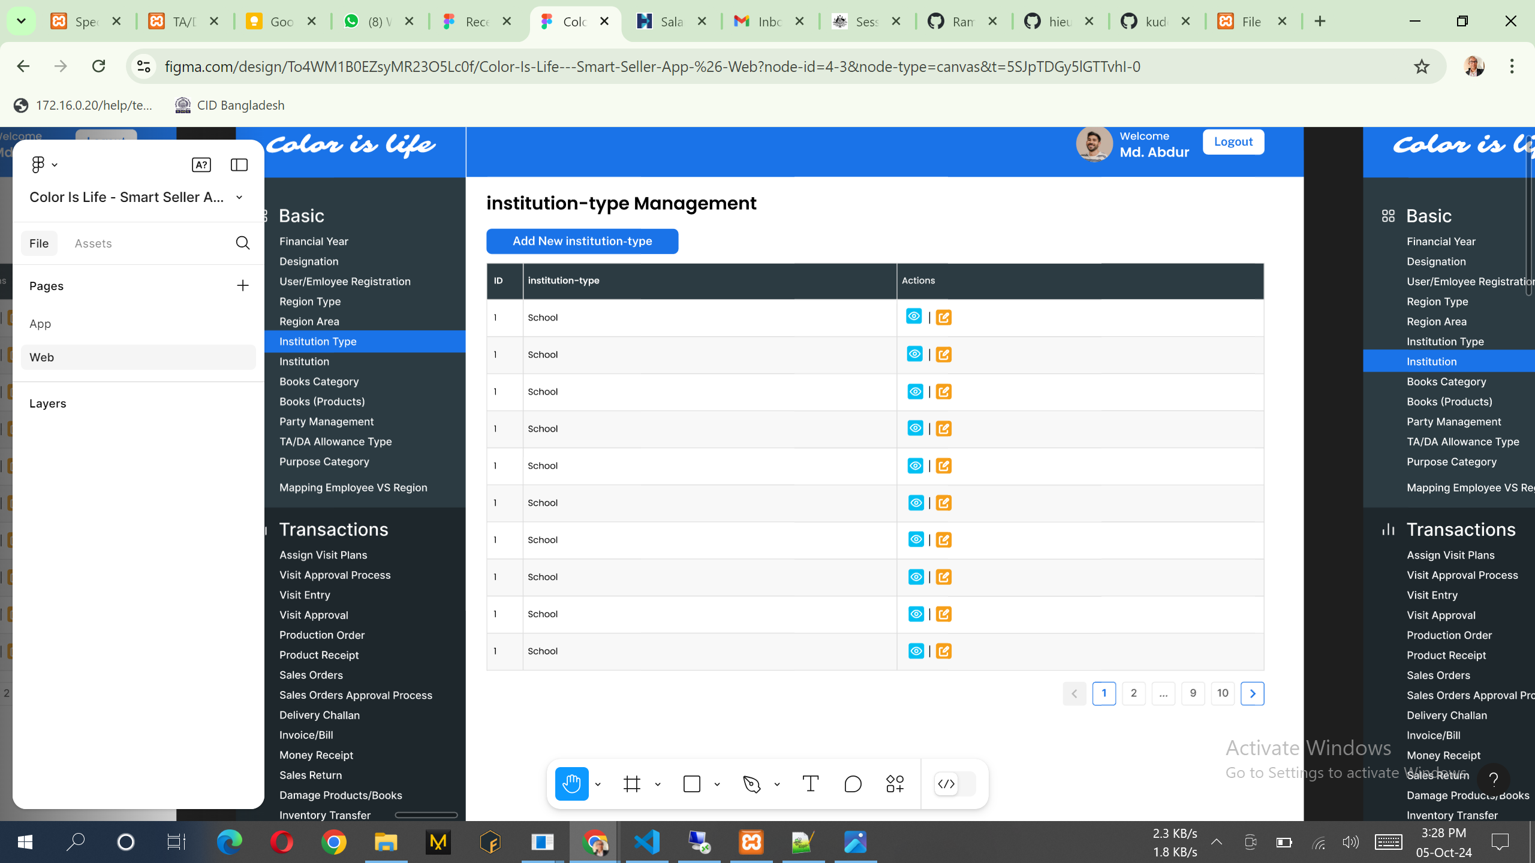

Need to change Capital Letter of all the word 1st letter same changes needed Add new institution.

SQL: select id, CategoryName from sndCategorydata where CategoryType = 'institution-type'

API:

1. <http://36.255.68.50:8080/DLogicKBL/salesforce_api.php?action=get_institutiontype>s
2. <http://36.255.68.50:8080/DLogicKBL/salesforce_api.php?action=get_institutiontype&ID=1>
3. <http://36.255.68.50:8080/DLogicKBL/salesforce_api.php?action=update_institutiontype&ID=1>

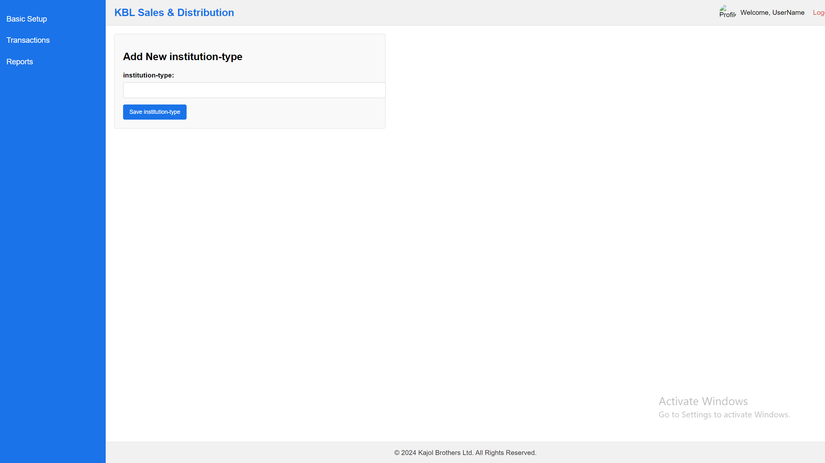

Notes:

1. List of the data can add, view & edit. No delete option.

API:

1. <http://36.255.68.50:8080/DLogicKBL/salesforce_api.php?action=create_institutiontype>

SQL:

INSERT INTO [dbo].[sndCategorydata]

([CategoryType]

,[CategoryName])

VALUES

(<CategoryType, varchar(100),>

,<CategoryName, varchar(150),>)

## **Institution**

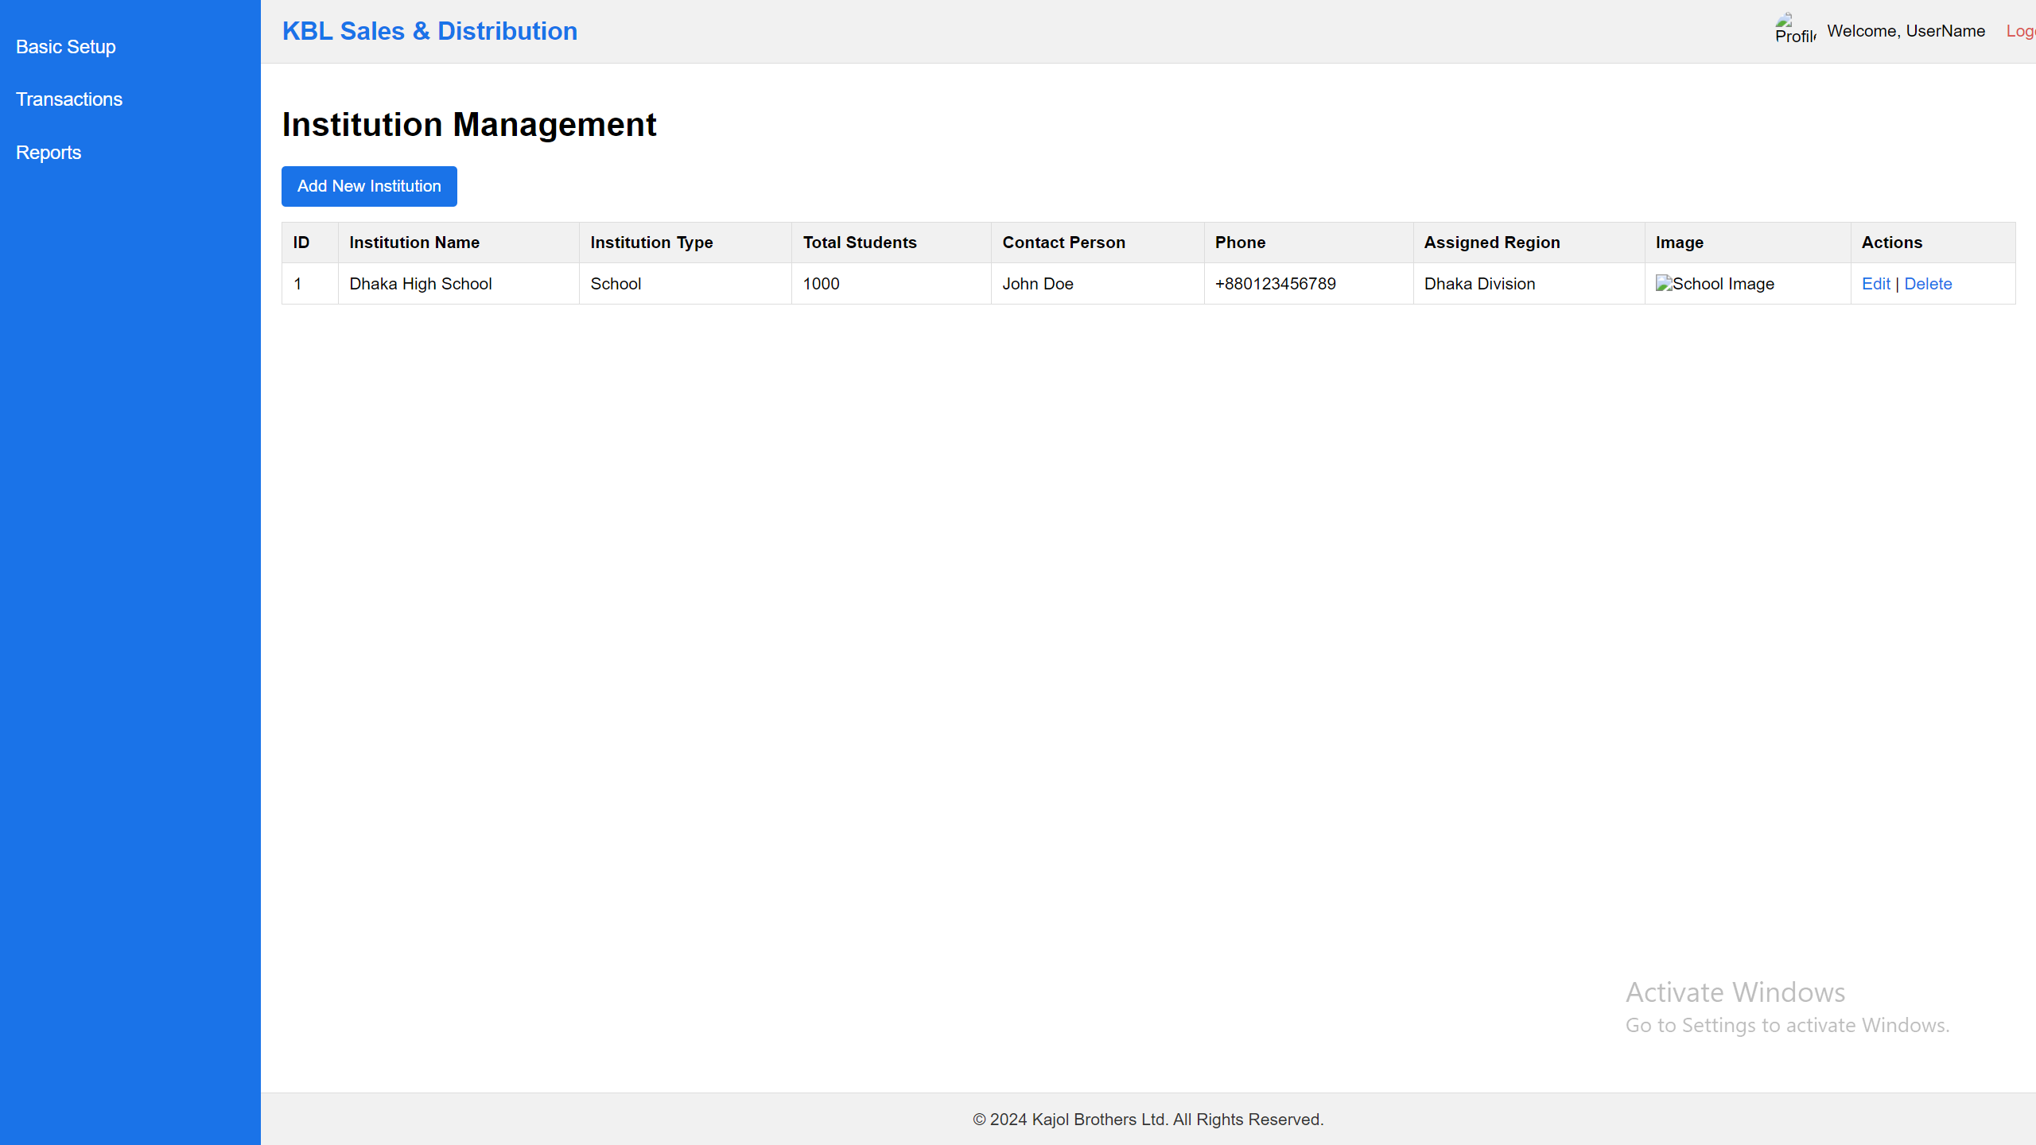

SQL: SELECT [InstitutionID],[InstitutionName],[InstitutionType],[TotalStudents]

,[Address],[ContactPersonName],[ContactPhone],[InstitutionScanImagePath]

,[RegionID],[CreatedAt],[ModifiedAt]

FROM [dbo].[sndInstitutions]

Here [InstitutionType] combobox data will be load from Institution Type and insert here institution type ID.

API:

1. <http://36.255.68.50:8080/DLogicKBL/salesforce_api.php?action=get_institutions>
2. <http://36.255.68.50:8080/DLogicKBL/salesforce_api.php?action=get_institution&ID=1>
3. <http://36.255.68.50:8080/DLogicKBL/salesforce_api.php?action=update_institution&ID=1>

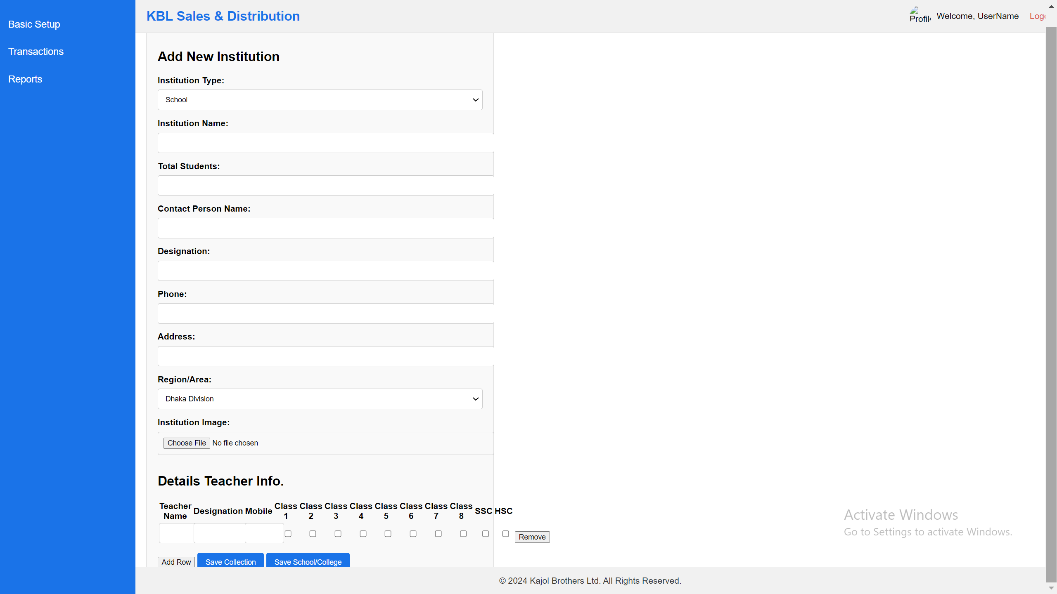

Notes:

1. Region/Area: Load all the region Area
2. Details Teacher Info: Here one teacher may can take multiple classes and also can add multiple teacher here.
3. List of the data can add, view & edit. No delete option.

Notes:

1. List of the data can add, view & edit. No delete option.

API:

1. http://36.255.68.50:8080/DLogicKBL/salesforce_api.php?action=create_institution

SQL:

INSERT INTO [dbo].[sndInstitutionDetails]

([InstitutionID]

,[TeacherName]

,[Designation]

,[ContactPhone]

,[Class1]

,[Class2]

,[Class3]

,[Class4]

,[Class5]

,[Class6]

,[Class7]

,[Class8]

,[SSC]

,[HSC])

VALUES

(<InstitutionID, int,>

,<TeacherName, varchar(255),>

,<Designation, varchar(50),>

,<ContactPhone, varchar(15),>

,<Class1, int,>

,<Class2, int,>

,<Class3, int,>

,<Class4, int,>

,<Class5, int,>

,<Class6, int,>

,<Class7, int,>

,<Class8, int,>

,<SSC, int,>

,<HSC, int,>)

## **Books Category**

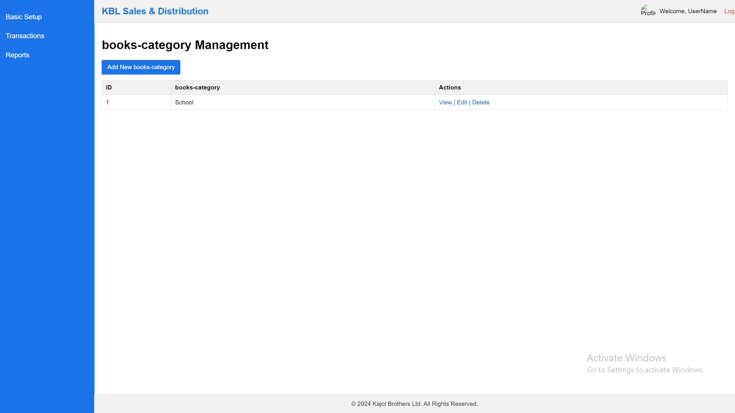

SQL: select id, CategoryName from sndCategorydata where CategoryType = 'books-category'

API:

1. <http://36.255.68.50:8080/DLogicKBL/salesforce_api.php?action=get_bookscategorys>
2. <http://36.255.68.50:8080/DLogicKBL/salesforce_api.php?action=get_bookscategory&ID=1>
3. <http://36.255.68.50:8080/DLogicKBL/salesforce_api.php?action=update_bookscategory&ID=1>

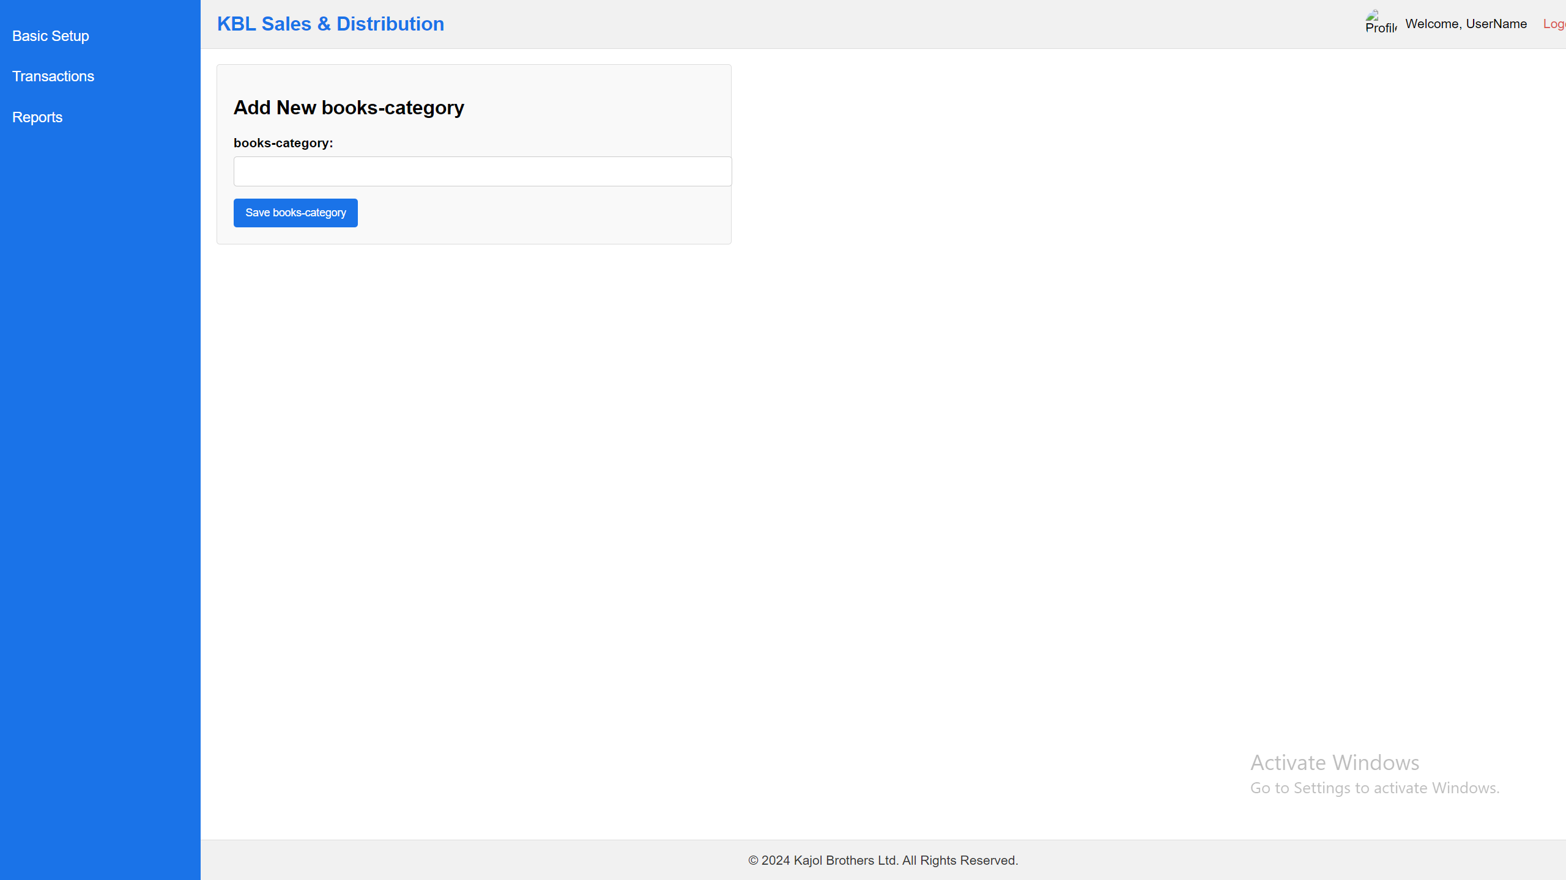

Notes:

1. List of the data can add, view & edit. No delete option.

API:

1. <http://36.255.68.50:8080/DLogicKBL/salesforce_api.php?action=create_bookscategory>

SQL:

INSERT INTO [dbo].[sndCategorydata]

([CategoryType]

,[CategoryName])

VALUES

(<CategoryType, varchar(100),>

,<CategoryName, varchar(150),>)

## **Books (Products)**

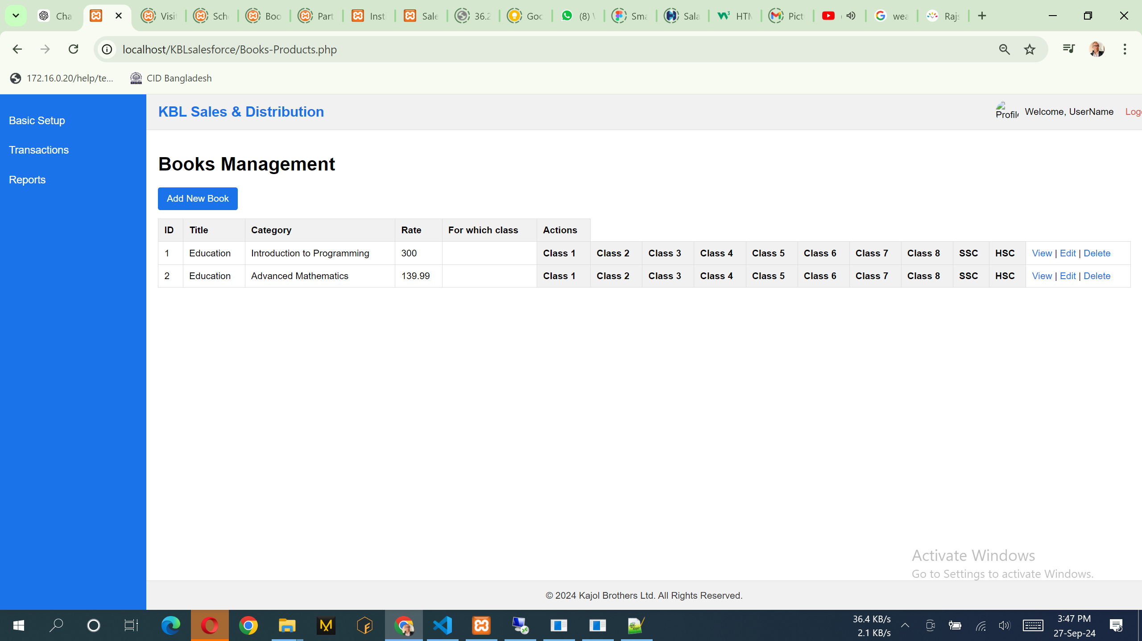

SQL: SELECT [ProductID],[ProductName],[Category],[Price],[Class1],[Class2],[Class3],[Class4],[Class5],[Class6],[Class7],[Class8],[SSC],[HSC],[CreatedAt],[ModifiedAt]

FROM [dbo].[sndProducts]

API:

1. <http://36.255.68.50:8080/DLogicKBL/salesforce_api.php?action=get_products>
2. <http://36.255.68.50:8080/DLogicKBL/salesforce_api.php?action=get_product&ID=1>
3. <http://36.255.68.50:8080/DLogicKBL/salesforce_api.php?action=update_product&ID=1>

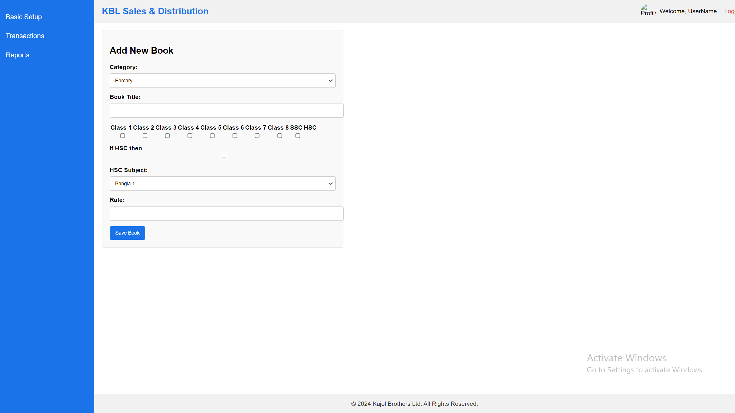

Notes:

1. List of the data can add, view & edit. No delete option.
2. Category: Data will come from the Books Category.
3. One Book can serve multiple classes and that time you can select more than one classes.
4. If select HSC then HSC Subject can be select any one from the combo box.

API:

1. <http://36.255.68.50:8080/DLogicKBL/salesforce_api.php?action=create_product>

SQL:

INSERT INTO [dbo].[sndProducts]

([ProductName]

,[Category]

,[Price]

,[Class1]

,[Class2]

,[Class3]

,[Class4]

,[Class5]

,[Class6]

,[Class7]

,[Class8]

,[SSC]

,[HSC]

,[CreatedAt]

,[ModifiedAt]

)

VALUES

(<ProductName, varchar(255),>

,<Category, varchar(100),>

,<Price, decimal(10,2),>

,<Class1, int,>

,<Class2, int,>

,<Class3, int,>

,<Class4, int,>

,<Class5, int,>

,<Class6, int,>

,<Class7, int,>

,<Class8, int,>

,<SSC, int,>

,<HSC, int,>

,<CreatedAt, datetime,>

,<ModifiedAt, datetime,>

)

GO

## **TA/DA Allowance Type**

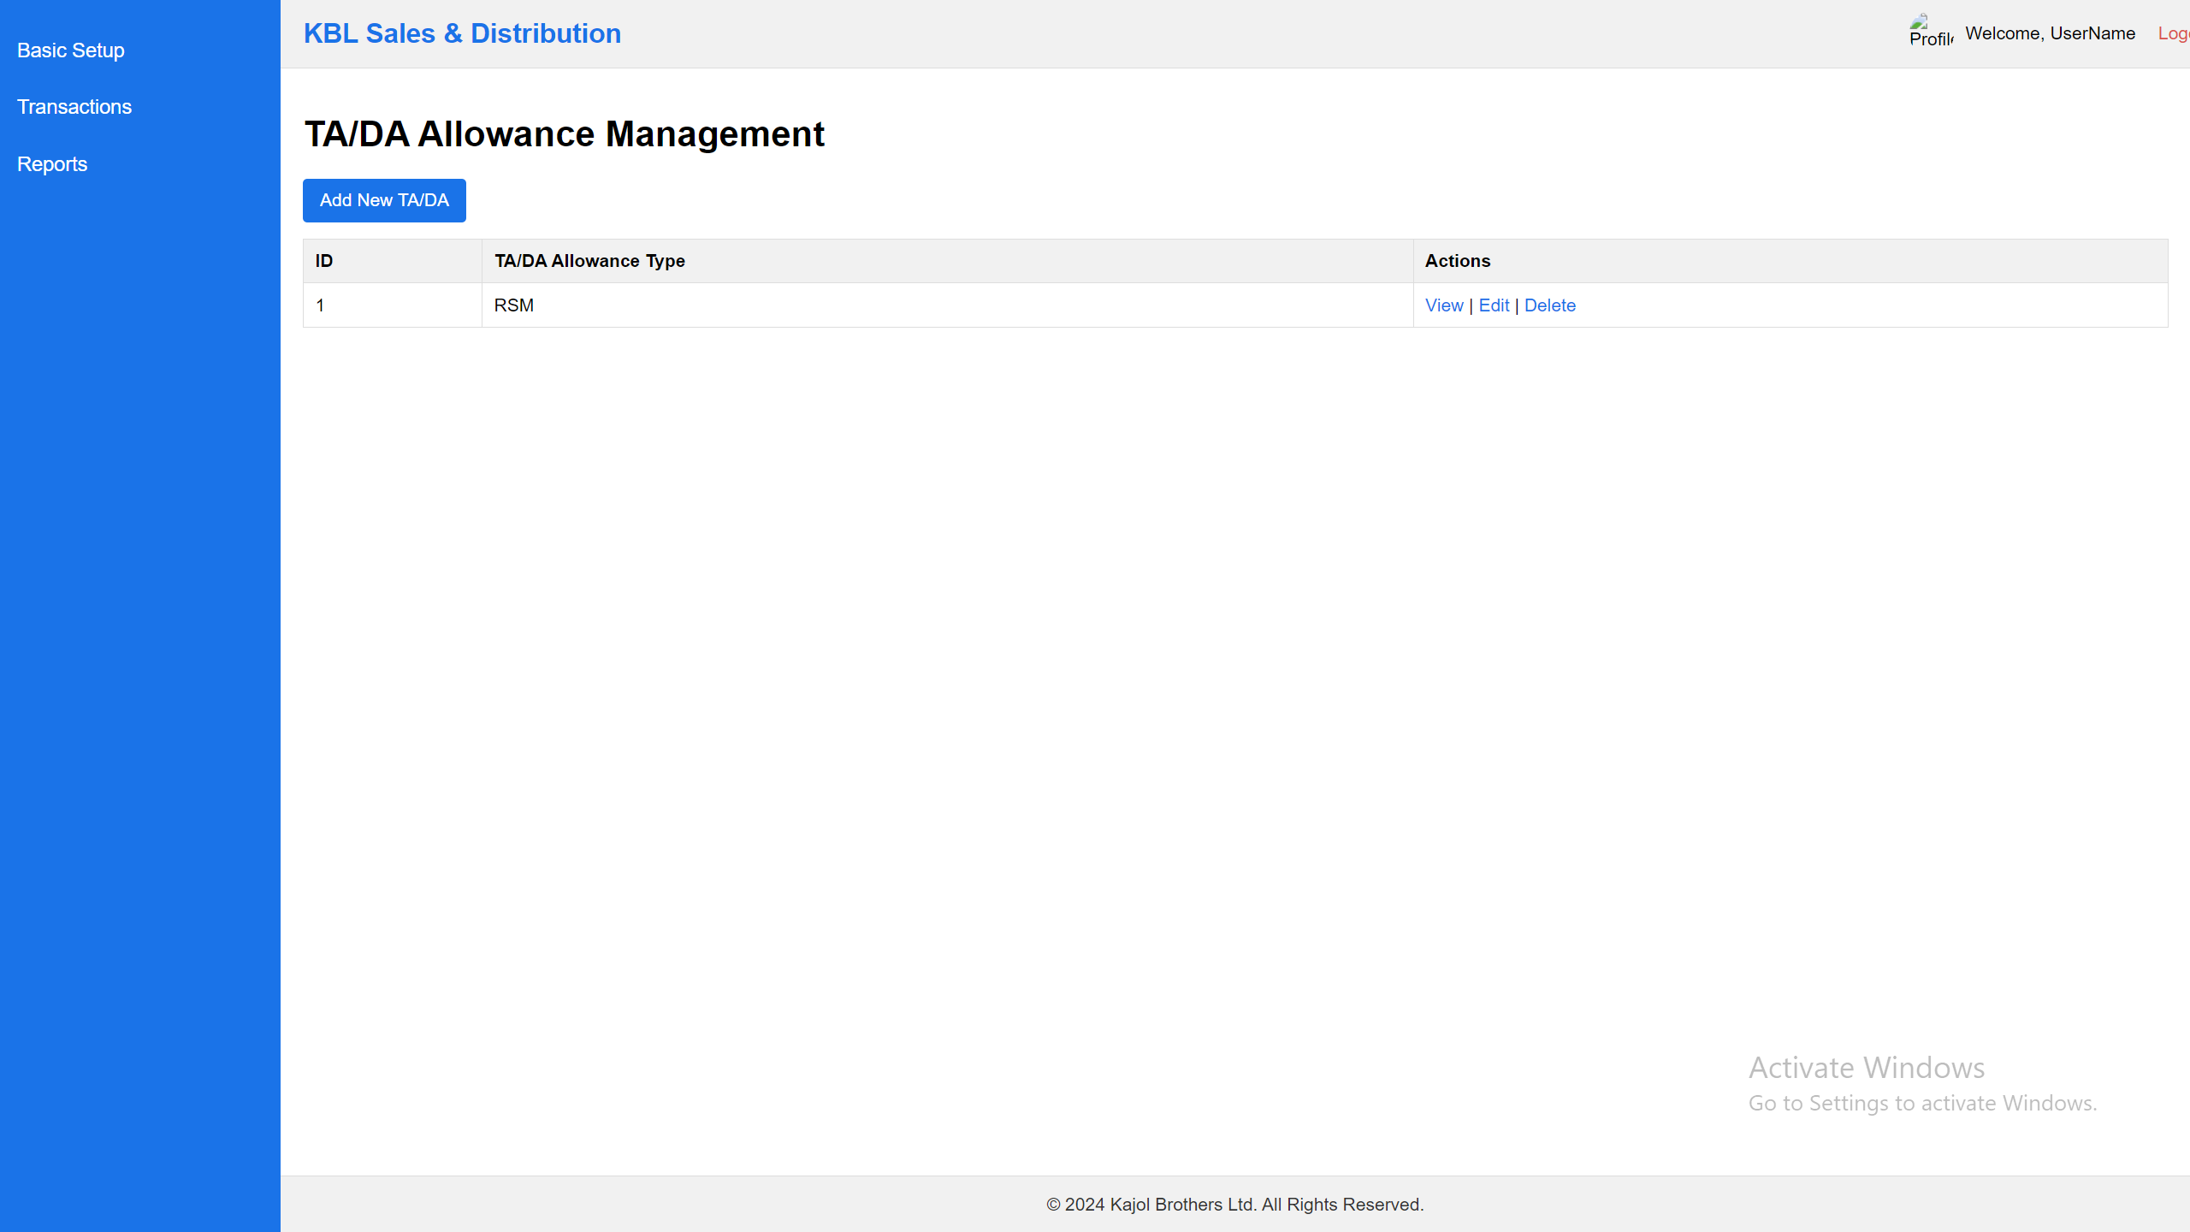

Here Name will be change “TA/DA & Others Allowance Management”

Also TA/DA add form:  
Add New TA/DA & Others Allowance.

SQL: select id, CategoryName from sndCategorydata where CategoryType = ‘TA/DA Allowance'

API:

1. <http://36.255.68.50:8080/DLogicKBL/salesforce_api.php?action=get_tada_allowances>
2. <http://36.255.68.50:8080/DLogicKBL/salesforce_api.php?action=get_tada_allowance&ID=1>
3. <http://36.255.68.50:8080/DLogicKBL/salesforce_api.php?action=update_tada_allowance&ID=1>

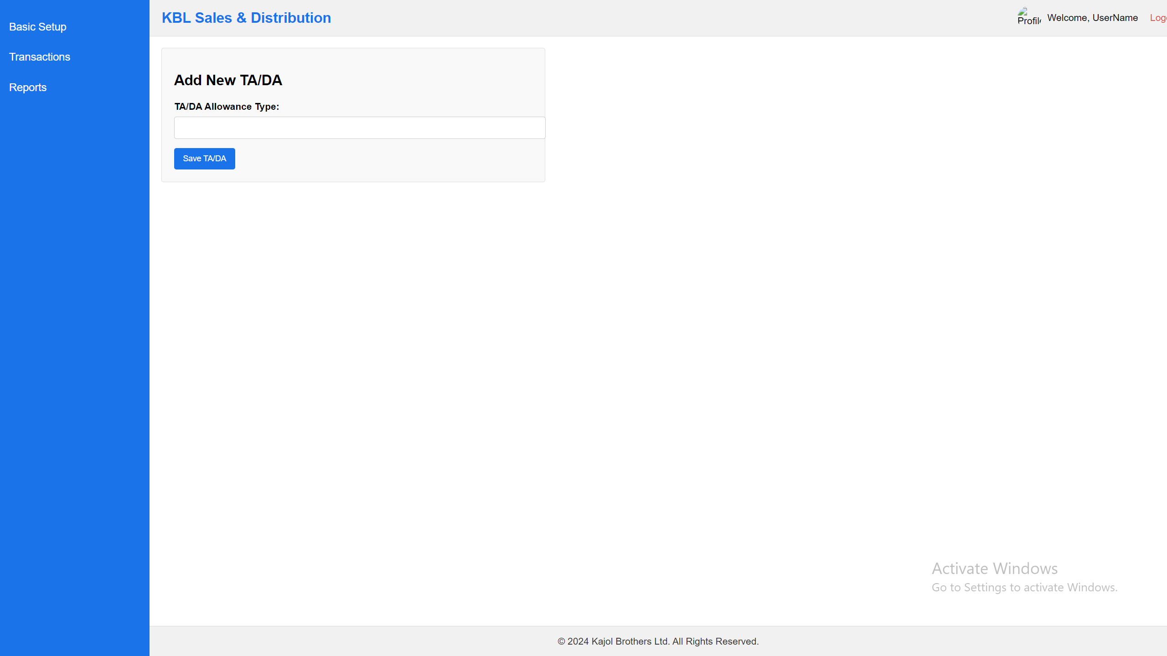

Notes:

1. List of the data can add, view & edit. No delete option.

API:

1. <http://36.255.68.50:8080/DLogicKBL/salesforce_api.php?action=create_tada_allowance>

SQL:

INSERT INTO [dbo].[sndCategorydata]

([CategoryType]

,[CategoryName])

VALUES

(<CategoryType, varchar(100),>

,<CategoryName, varchar(150),>)

## **Visit Purposes**

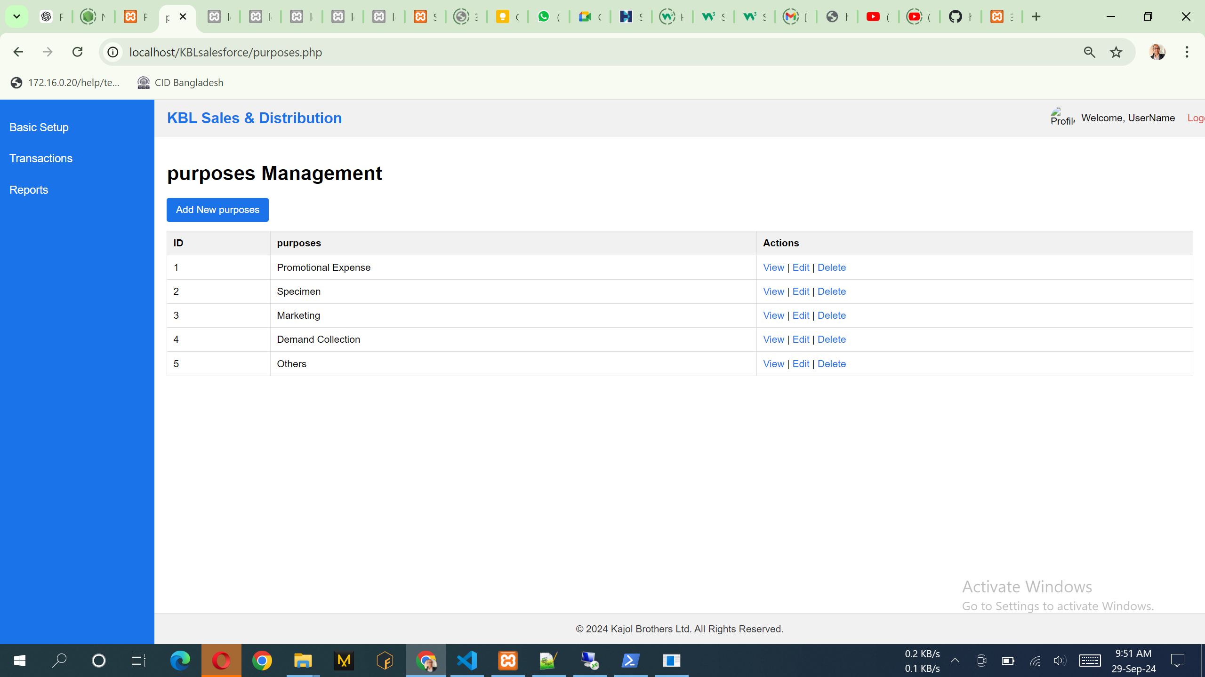

Notes:

1. List of the data can add, view & edit. No delete option.

SQL: select id, CategoryName from sndCategorydata where CategoryType = ‘visitpurpose

API:

1. <http://36.255.68.50:8080/DLogicKBL/salesforce_api.php?action=get_purposes>
2. <http://36.255.68.50:8080/DLogicKBL/salesforce_api.php?action=get_purpose&ID=1>
3. <http://36.255.68.50:8080/DLogicKBL/salesforce_api.php?action=update_purpose&ID=1>

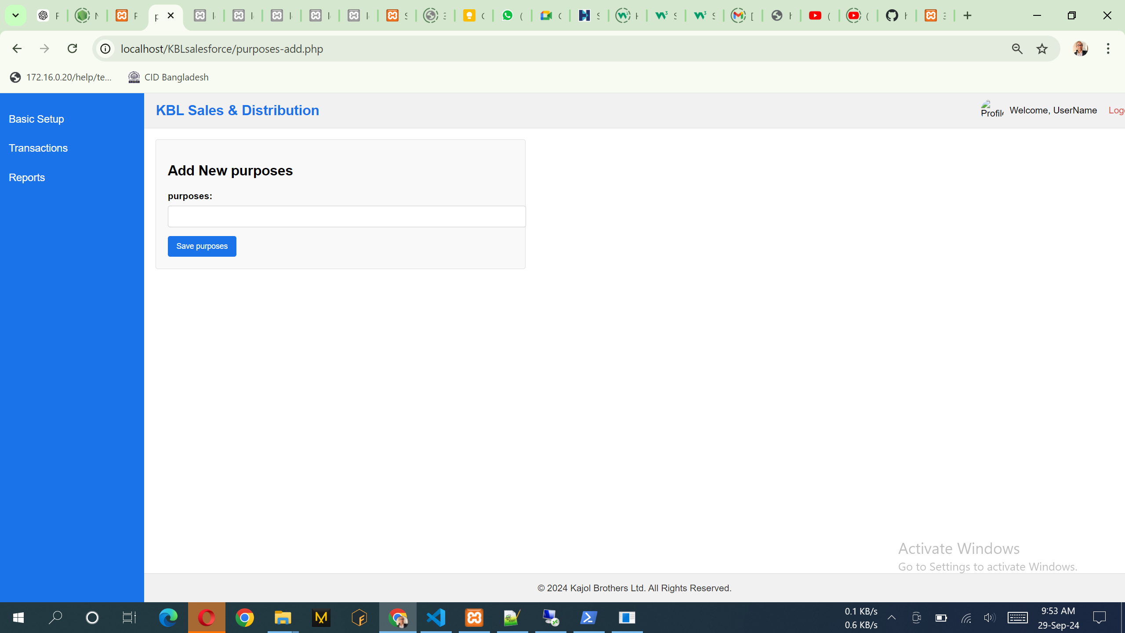

Notes:

1. Purpose can add in this form

API:

1. <http://36.255.68.50:8080/DLogicKBL/salesforce_api.php?action=create_purposes>

SQL:

INSERT INTO [dbo].[sndCategorydata]

([CategoryType]

,[CategoryName])

VALUES

(<CategoryType, varchar(100),>

,<CategoryName, varchar(150),>)

## **Mapping Employee VS Region**

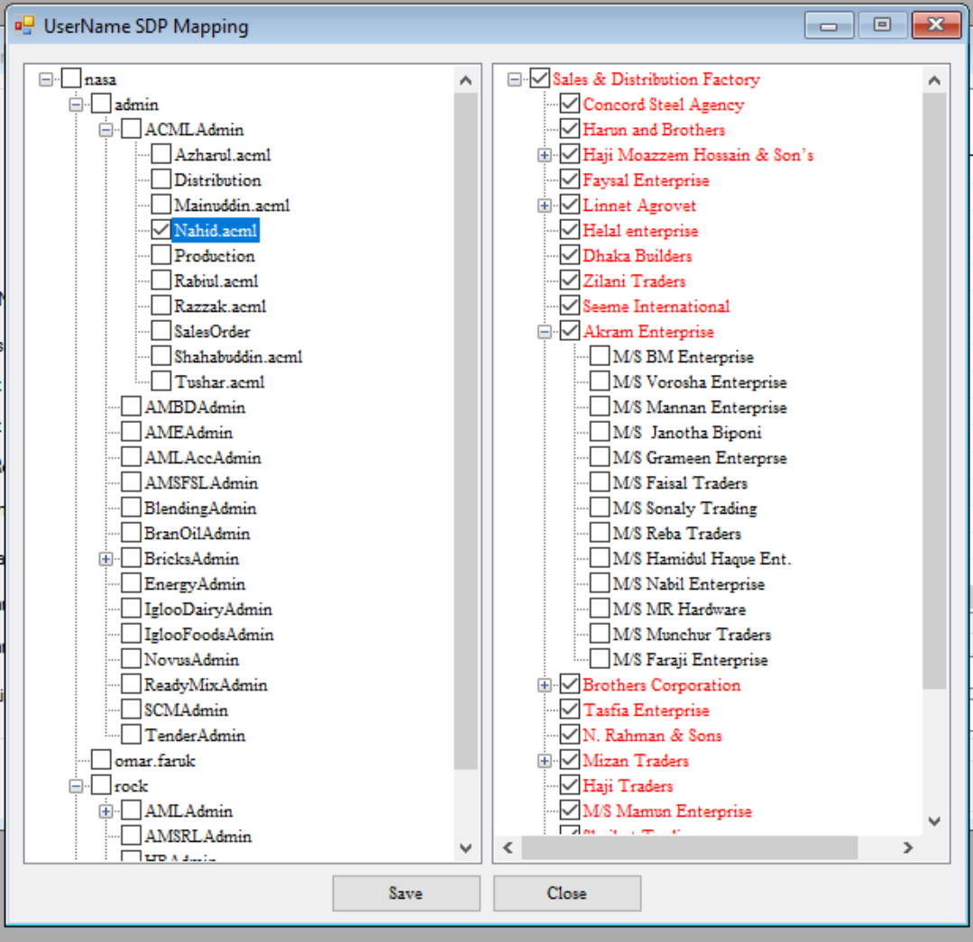

Note:

1. Load all the employee left site with radio button and loan all the Region like Tree with Check box
2. Here we will select one-to-many system.

The data can save & edit. No delete option.

## **Party Management**

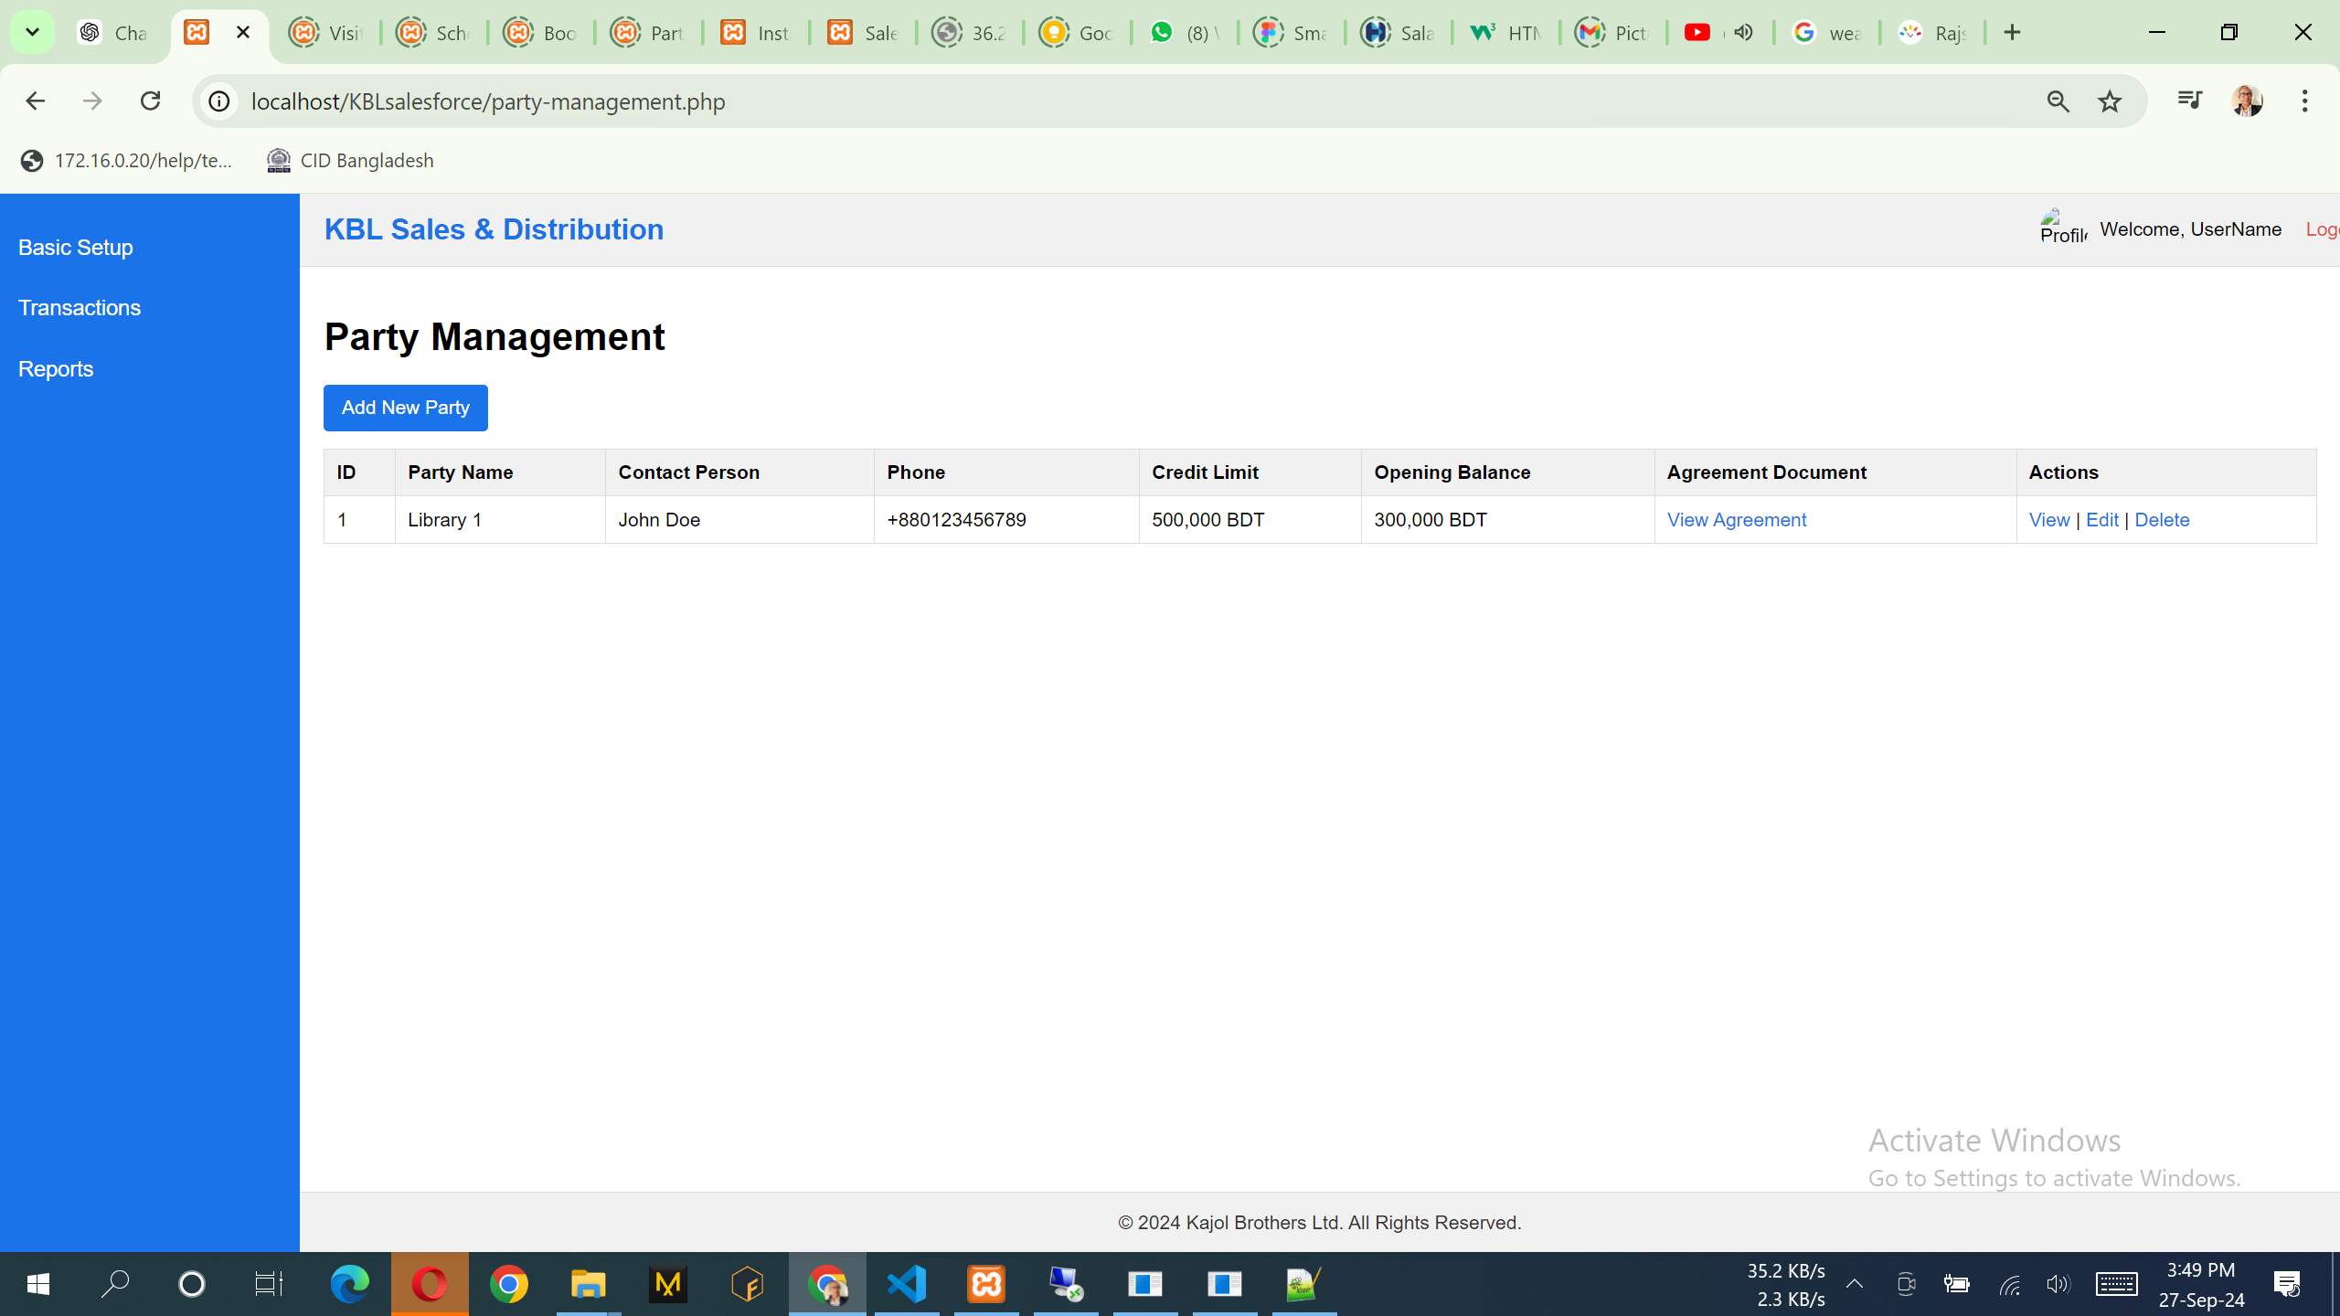

SQL:

SELECT [PartyID] ,[PartyName],[ContactPersonName],[ContactPhone],[Address] ,[CreditLimit],[DepositAmount] ,[OpeningBalance]

from sndParty

API:

1. <http://36.255.68.50:8080/DLogicKBL/salesforce_api.php?action=get_parties>
2. <http://36.255.68.50:8080/DLogicKBL/salesforce_api.php?action=get_party&PartyID=1>
3. <http://36.255.68.50:8080/DLogicKBL/salesforce_api.php?action=update_party&PartyID=1>

|  |  |
| --- | --- |
|  |  |
|  |  |
|  |  |

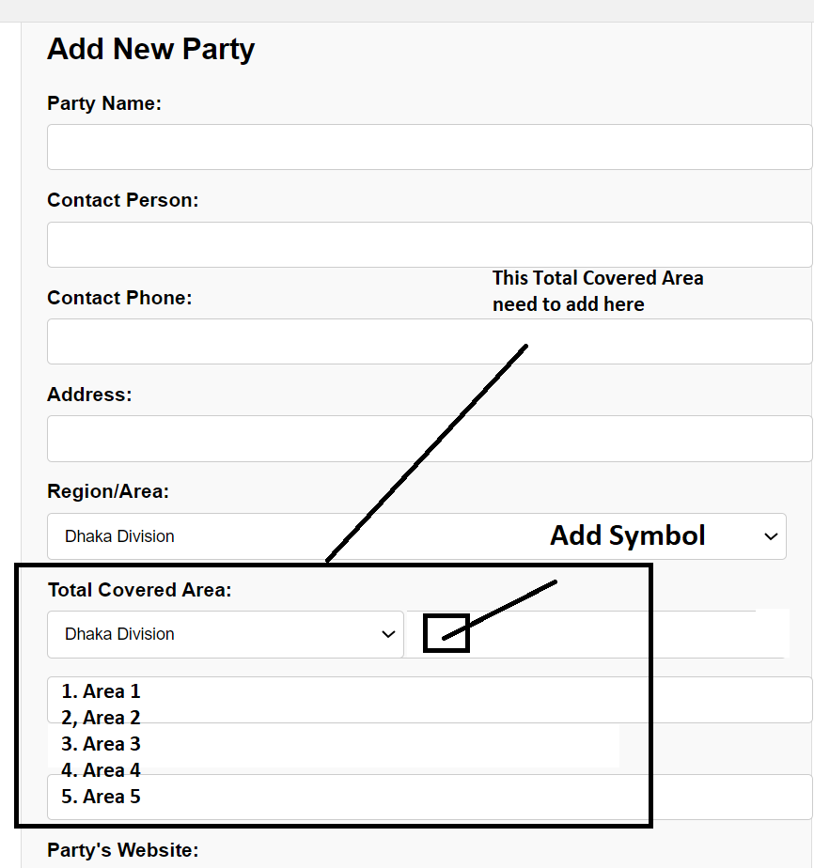

Notes:

1. Also in this design there should be two column system.
2. List of the data can add, view & edit. No delete option.
3. Region/Area: Data will come from the Region form of all area.
4. All the attached image or pdf is mandatory except TIN number. Attached document must have download option when client need. List of the data have a view option that can see the report with all the attached document in a single report and report can print.
5. Also in this design there should be two column system.

API:

1. <http://36.255.68.50:8080/DLogicKBL/salesforce_api.php?action=create_party>

SQL:

INSERT INTO [dbo].[sndParty]

([PartyName]

,[ContactPersonName]

,[ContactPhone]

,[Address]

,[RegionID]

,[Email]

,[Website]

,[CreditLimit]

,[DepositAmount]

,[OpeningBalance]

,[OwnerName]

,[OwnerContactNumber]

,[OwnerCurrentAddress]

,[OwnerPermanentAddress]

,[OwnerDateOfBirth]

,[BusinessStartYear]

,[NoOfThana]

,[NoOfDistrict]

,[IsSamityMember]

,[WayOfSendingLetters]

,[OwnerNIDDocumentPath]

,[TradeLicenseDocumentPath]

,[SamityMembershipCardPath]

,[TINCertificatePath]

,[DepositChequePath]

,[NonJudicialAgreementDocumentPath]

,[AgreementDocumentPath]

,[CreatedAt]

,[ModifiedAt])

VALUES

(<PartyName, varchar(255),

,<ContactPersonName, varchar(100),>

,<ContactPhone, varchar(15),>

,<Address, varchar(255),>

,<RegionID, int,>

,<Email, varchar(100),>

,<Website, varchar(100),>

,<CreditLimit, decimal(10,2),>

,<DepositAmount, decimal(10,2),>

,<OpeningBalance, decimal(10,2),>

,<OwnerName, varchar(100),>

,<OwnerContactNumber, varchar(15),>

,<OwnerCurrentAddress, varchar(255),>

,<OwnerPermanentAddress, varchar(255),>

,<OwnerDateOfBirth, date,>

,<BusinessStartYear, varchar(4),>

,<NoOfThana, int,>

,<NoOfDistrict, int,>

,<IsSamityMember, varchar(3),>

,<WayOfSendingLetters, varchar(50),>

,<OwnerPicturePath, varchar(255),>

,<OwnerNIDDocumentPath, varchar(255),>

,<TradeLicenseDocumentPath, varchar(255),>

,<SamityMembershipCardPath, varchar(255),>

,<TINCertificatePath, varchar(255),>

,<DepositChequePath, varchar(255),>

,<NonJudicialAgreementDocumentPath, varchar(255),>

,<AgreementDocumentPath, varchar(255),>

,<CreatedAt, datetime,>

,<ModifiedAt, datetime,>

)

# **Transactions**

## **Assign Visit Plans**

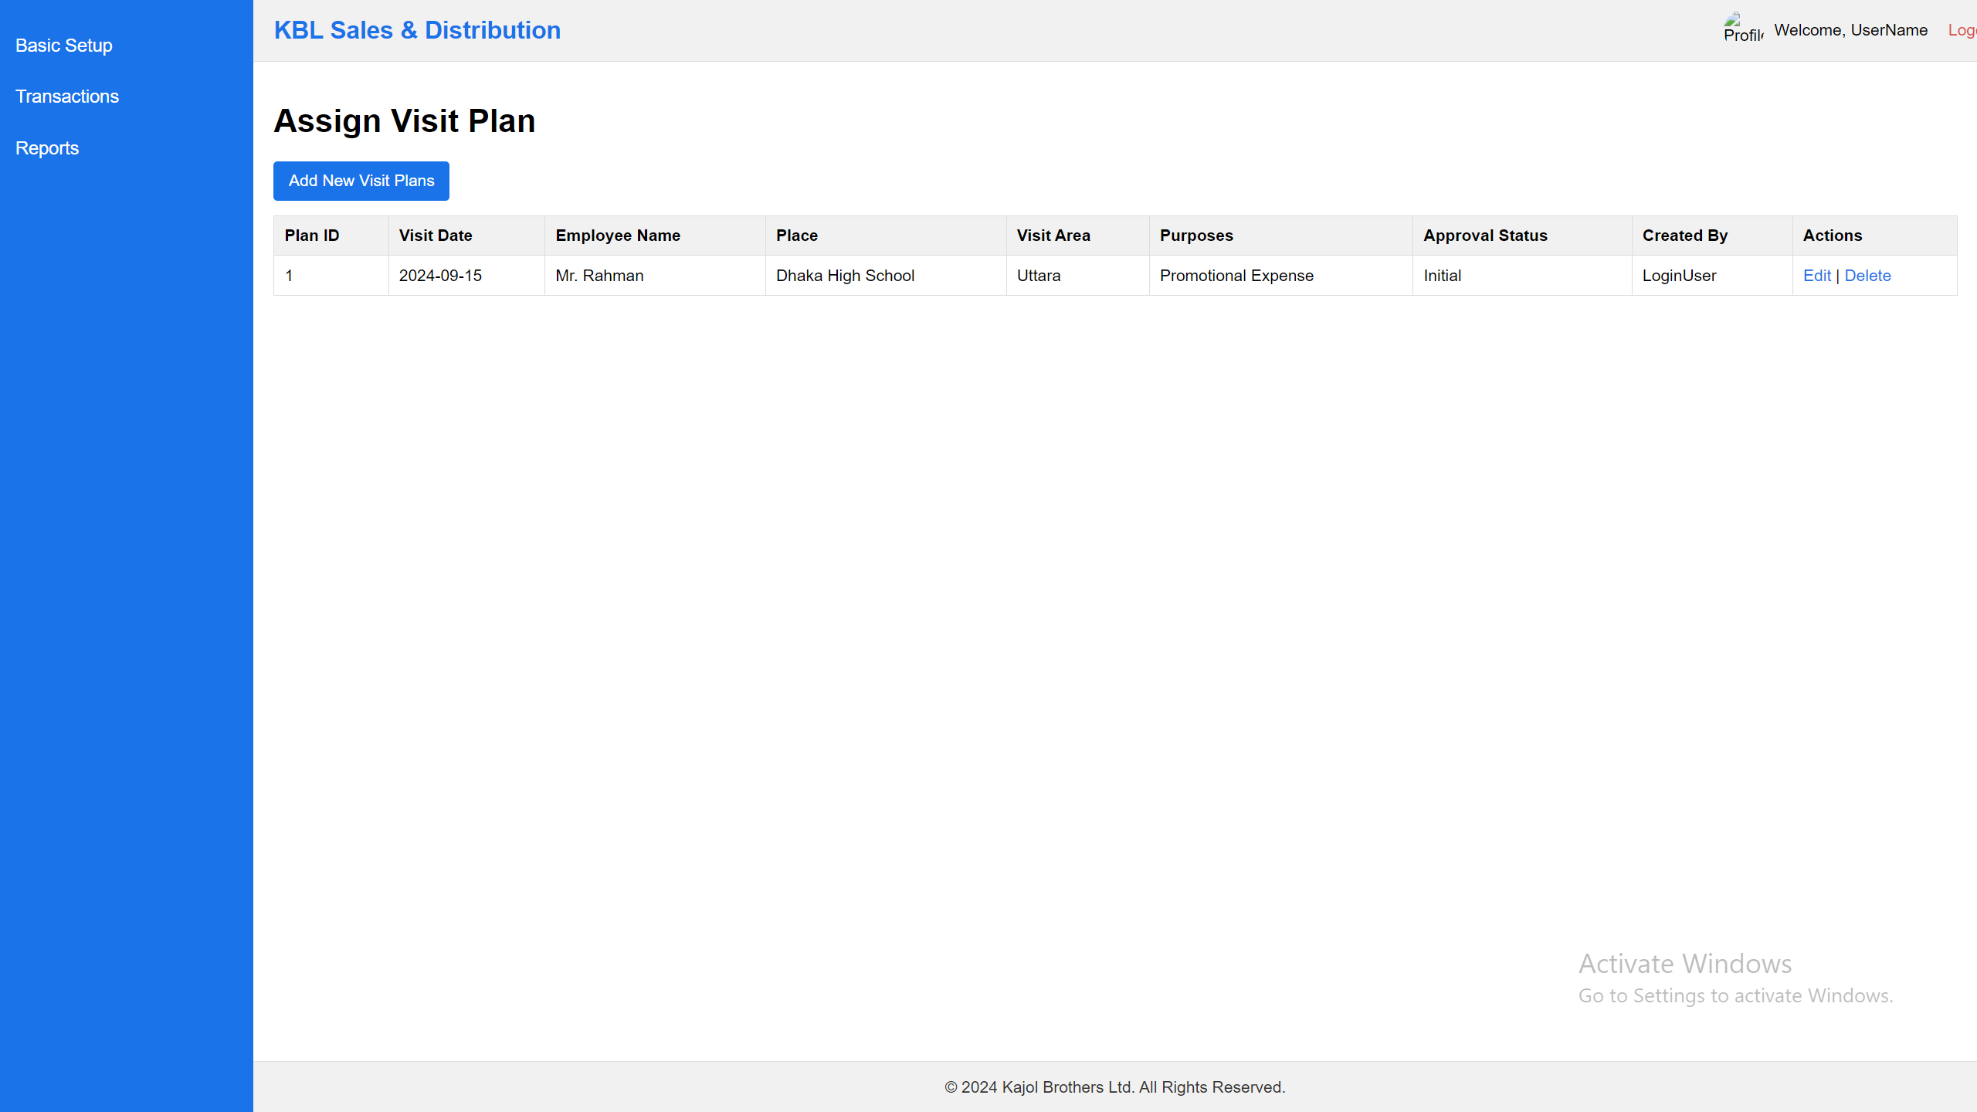

Notes:

1. List of the data can add, view & edit. No delete option.

SQL: SELECT [VisitPlanID],[VisitDate],[UserID],[InstitutionID],[PurposeID],[Purposes],[ApprovalStatus],[Status],[CreatedAt],[ModifiedAt]

FROM [dbo].[sndVisitPlans]

API:

1. <http://36.255.68.50:8080/DLogicKBL/salesforce_api.php?action=get_visit_plans>
2. <http://36.255.68.50:8080/DLogicKBL/salesforce_api.php?action=get_visit_plan&ID=1>
3. <http://36.255.68.50:8080/DLogicKBL/salesforce_api.php?action=update_visit_plan&ID=1>

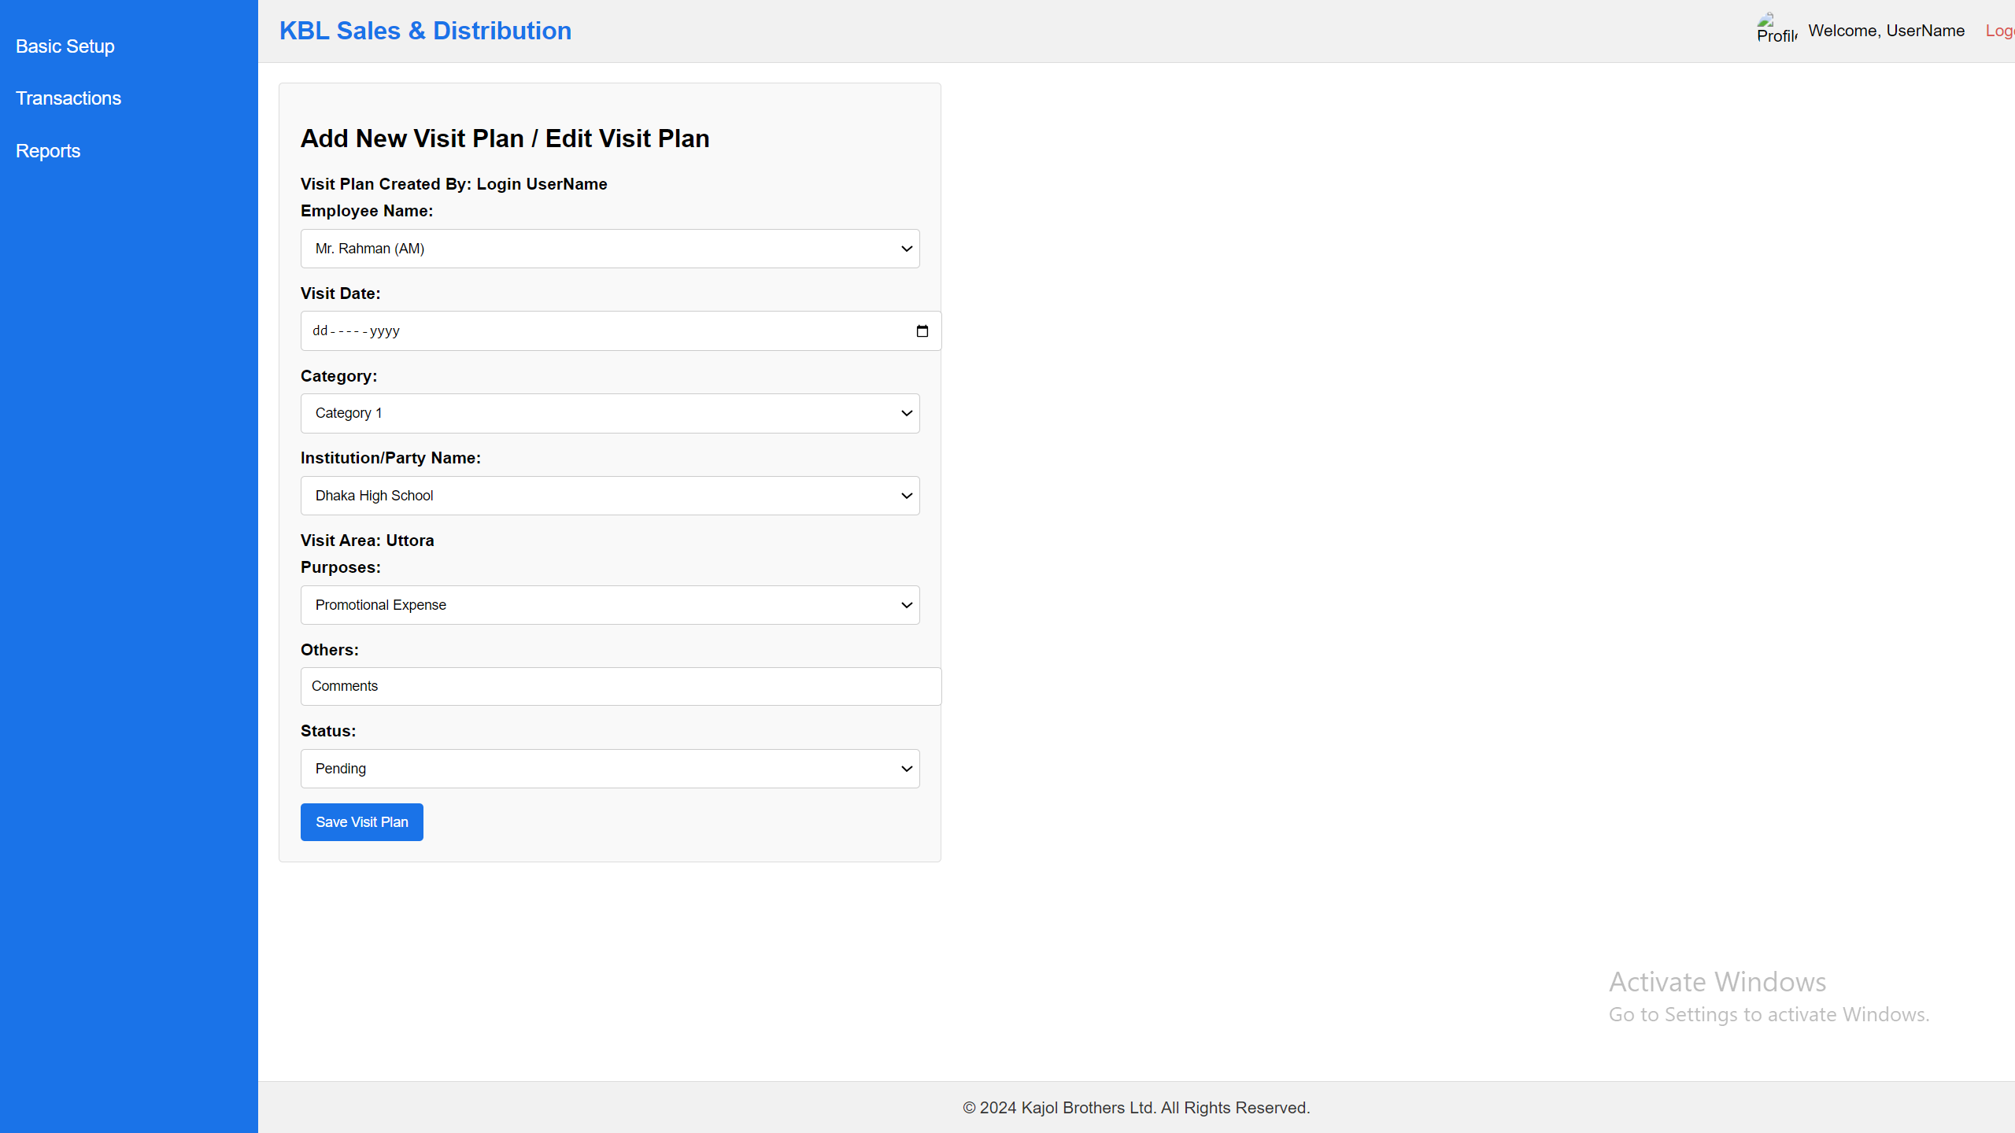

Notes:

1. Visit Plan can only create ZM/AM person who have the permission and one ZM/AM can’t see or load others ZM/AM person’s visit plan. It always depends on login user and login user data will load here.
2. List of the data can add, view & edit. No delete option.
3. Visit Area: Data will come from the party entry form previously set the area.
4. Purpose: Data will load Promotional Expense, Specimen, Marketing, Demand Collection, Others
5. Here when select purpose “Others” then Others next text box will come otherwise Others text box will not showing here.
6. Status will load two data pending & complete.
7. Initially ApprovalStatus = “pending”
8. Initially Status = “pending”

API:

1. <http://36.255.68.50:8080/DLogicKBL/salesforce_api.php?action=create_visit_plan>

SQL:

INSERT INTO [dbo].[sndVisitPlans]

([VisitDate]

,[UserID]

,[InstitutionID]

,[PurposeID]

,[Purposes]

,[ApprovalStatus]

,[Status]

,[CreatedAt]

,[ModifiedAt])

VALUES

(<VisitDate, date,>

,<UserID, int,>

,<InstitutionID, int,>

,<PurposeID, time(7),>

,<Purposes, time(7),>

,<ApprovalStatus, varchar(50),>

,<Status, varchar(50),>

,<CreatedAt, datetime,>

,<ModifiedAt, datetime,>)

GO

## **Visit Approval Process**

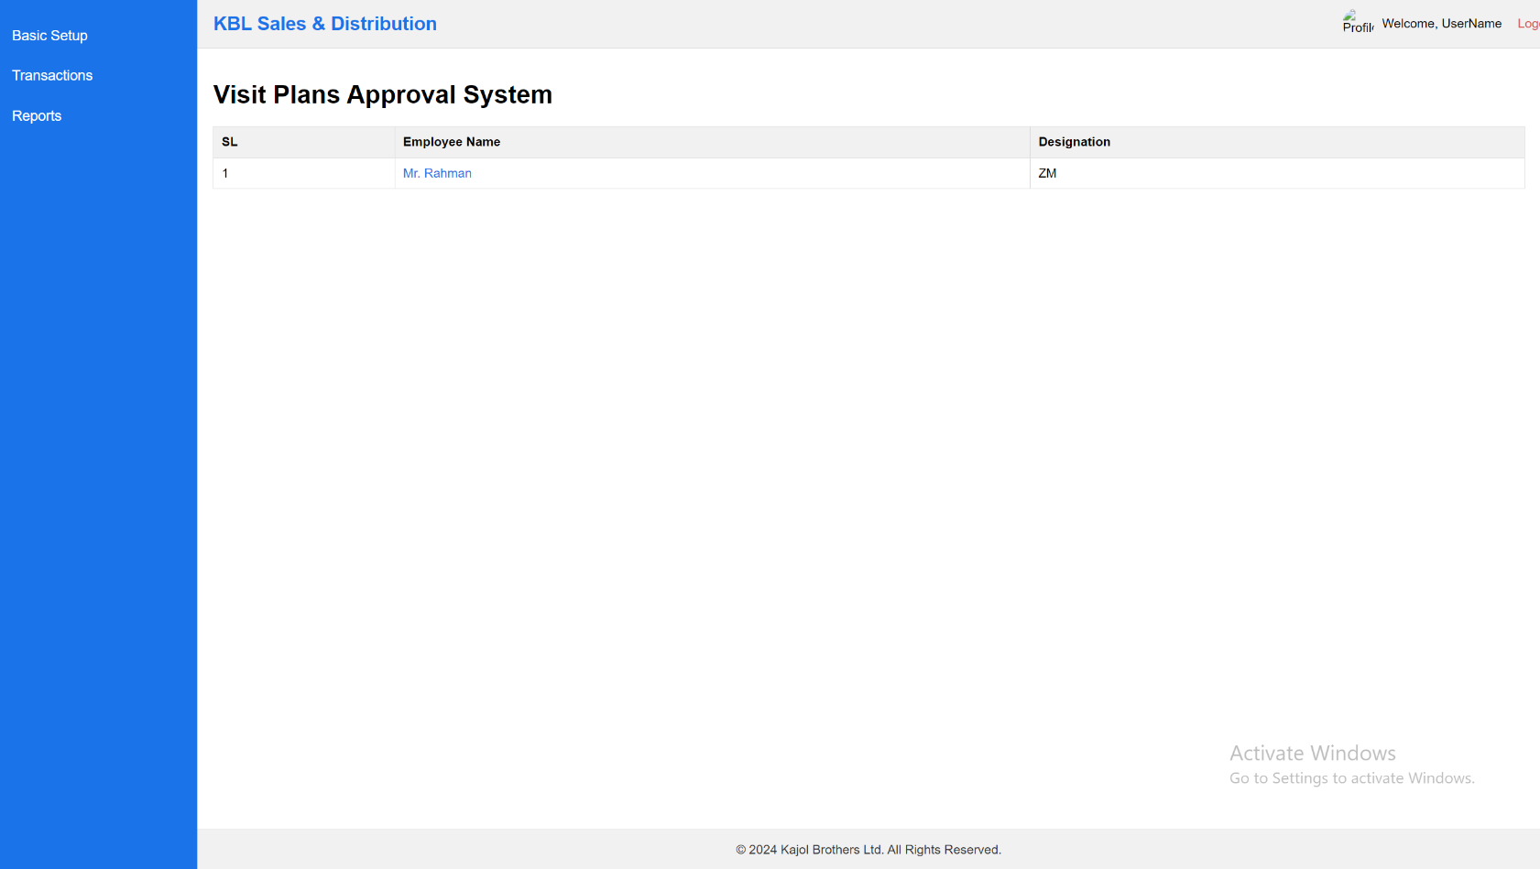  
Note:

1. Visit plan approval pending data only can show here and RSM can only approve the data as per his under AM/ZM created data and this reporting boss relation data will come from Employee Registration system.

SQL: SELECT [VisitPlanID],[VisitDate],[UserID],[InstitutionID],[PurposeID],[Purposes],[ApprovalStatus],[Status],[CreatedAt],[ModifiedAt]

FROM [dbo].[sndVisitPlans]

API:

1. <http://36.255.68.50:8080/DLogicKBL/salesforce_api.php?action=get_visit_plans>
2. <http://36.255.68.50:8080/DLogicKBL/salesforce_api.php?action=get_visit_plan&ID=1>

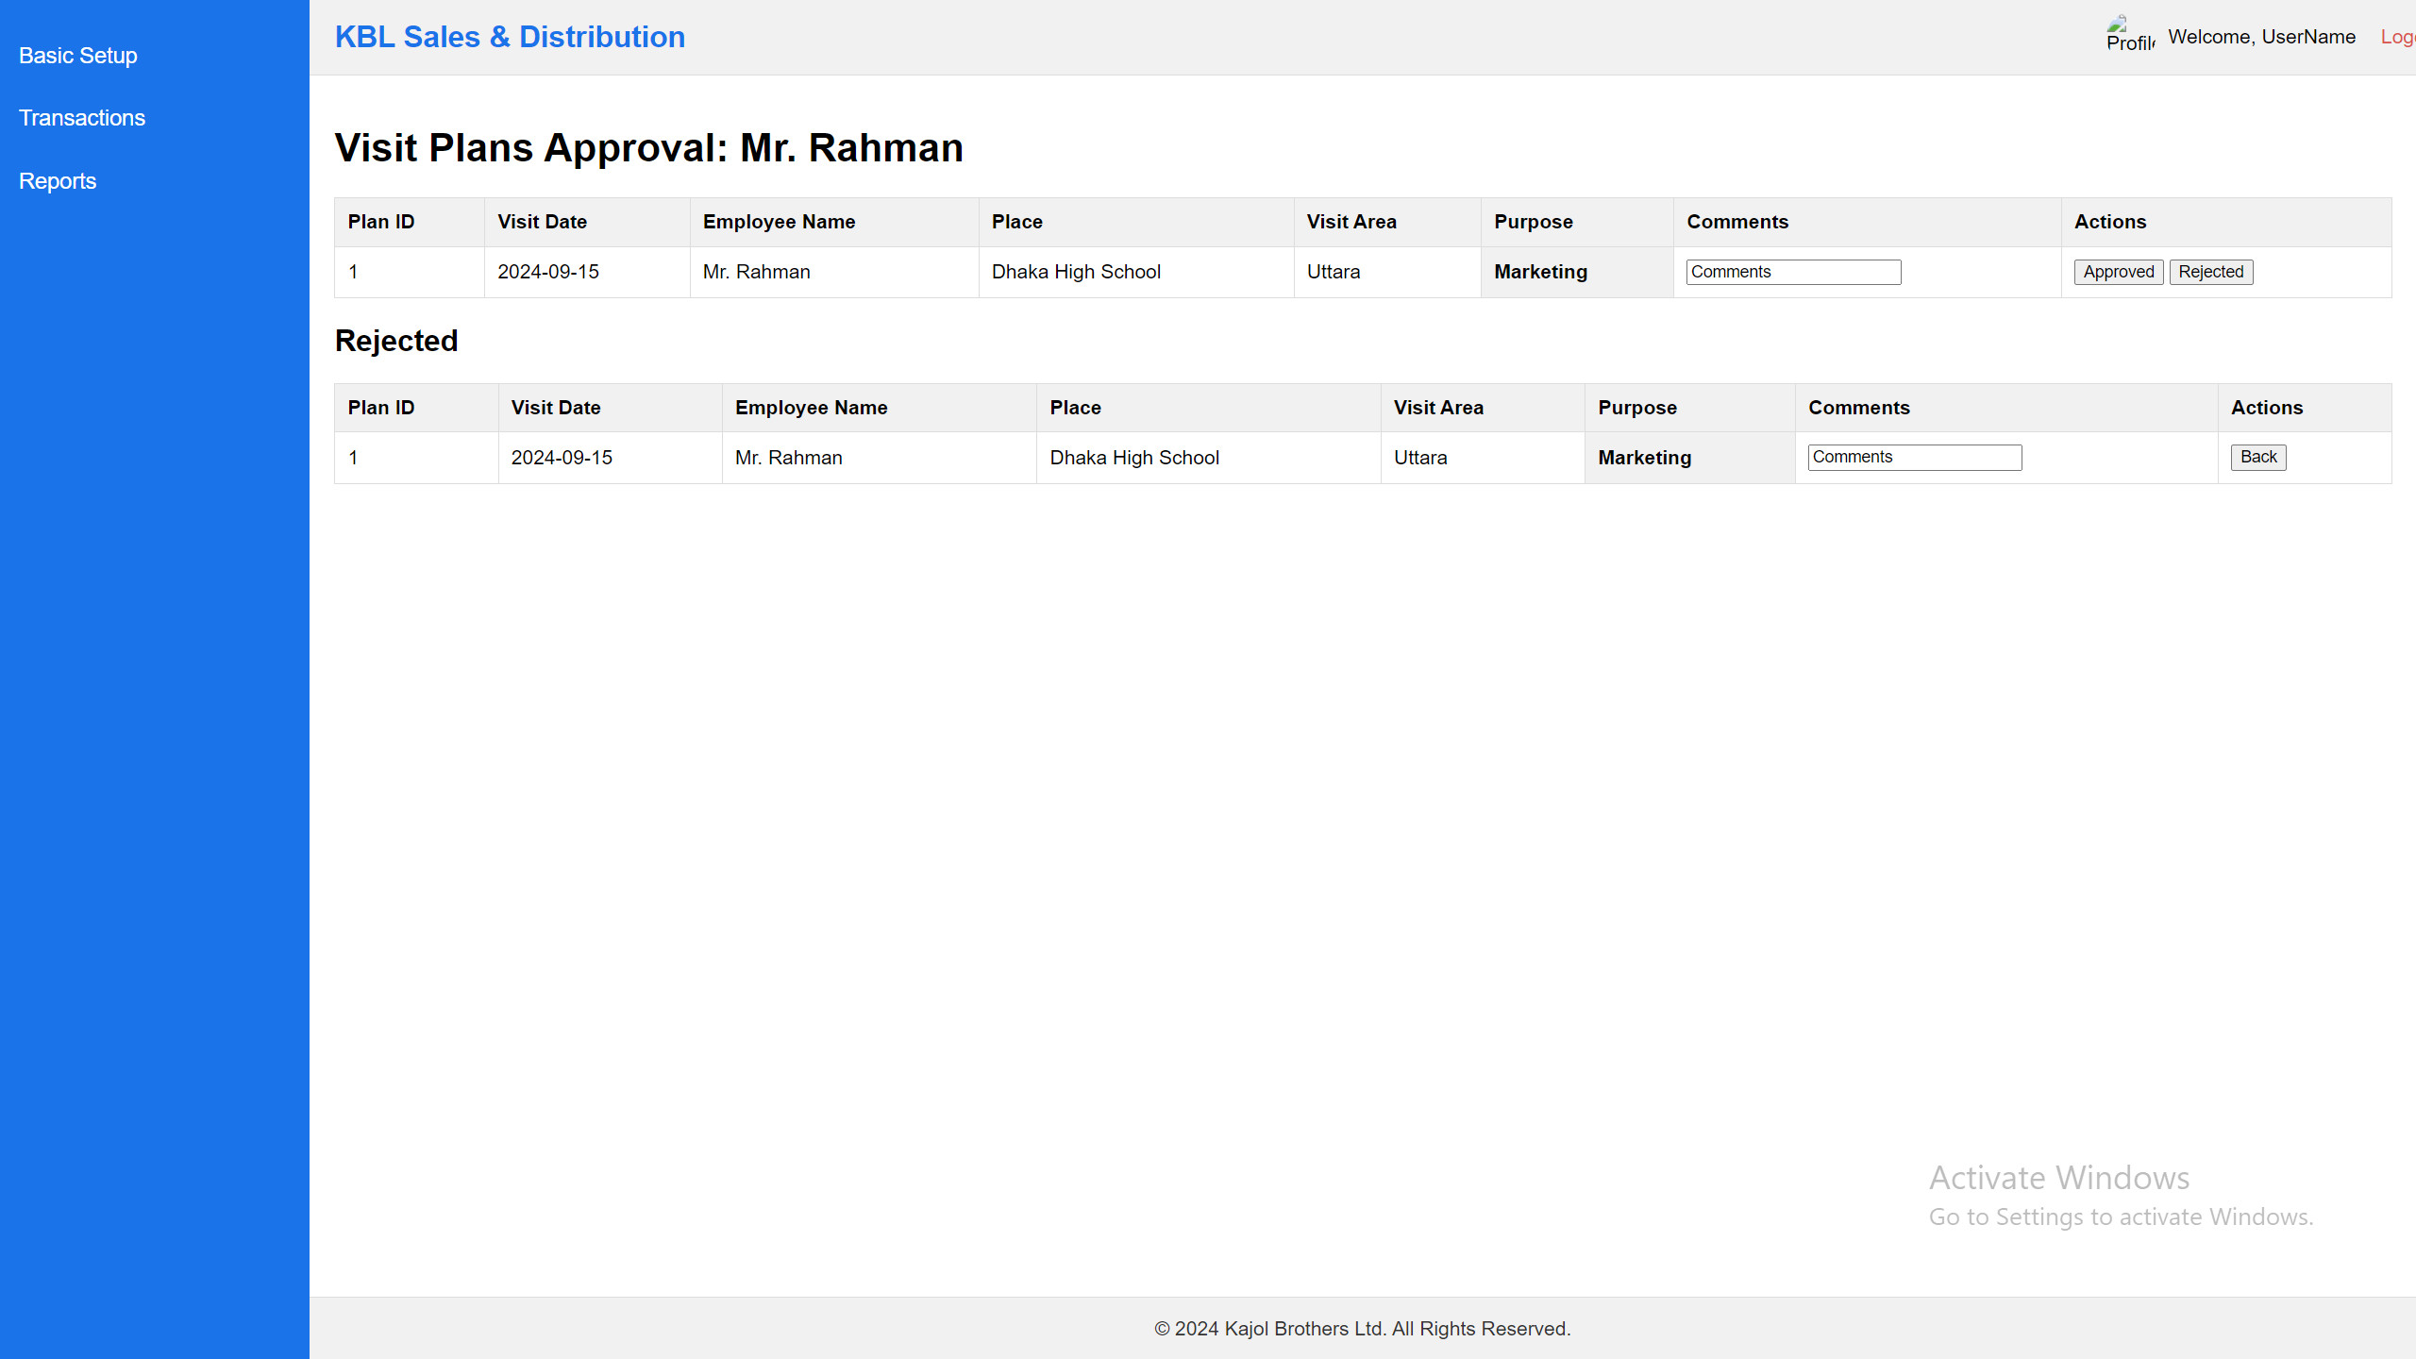

Note:

1. Visit Data when approved then data will automatically omit from here and also rejected data will auto goto Rejected list.
2. Initially ApprovalStatus = “Complete”
3. Initially Status = “pending”

API:

For list show:

SQL: SELECT [VisitPlanID],[VisitDate],[UserID],[InstitutionID],[PurposeID],[Purposes],[ApprovalStatus],[Status],[CreatedAt],[ModifiedAt], [ApprovalStatus] ,[Comments], ,[ApprovedbyUserID] FROM [dbo].[sndVisitPlans]

API:

1. <http://36.255.68.50:8080/DLogicKBL/salesforce_api.php?action=get_visit_plans>
2. <http://36.255.68.50:8080/DLogicKBL/salesforce_api.php?action=update_visit_plan_approval&ID=1>

SQL:

UPDATE [dbo].[sndVisitPlans]

SET [ApprovalStatus] = <ApprovalStatus, varchar(50),>

,[Comments] = <Comments, varchar(150),>

,[ApprovedbyUserID] = <ApprovedbyUserID, varchar(150),>

WHERE VisitPlanID = ?

GO

## **Visit Entry**

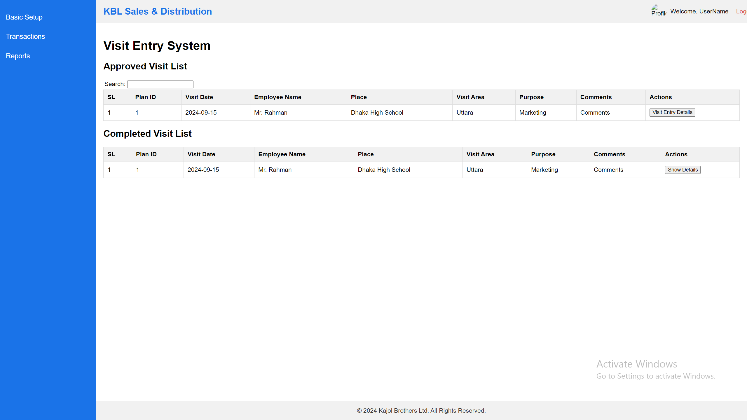

Note:

1. Visit Data Only can see those employee’s data who actually login here and he can enter Visit Entry Details.
2. “Show Details” button will show details report of the visit entry data.

API:

For list show:

SQL: SELECT [VisitPlanID],[VisitDate],[UserID],[InstitutionID],[PurposeID],[Purposes],[ApprovalStatus],[Status],[CreatedAt],[ModifiedAt], [ApprovalStatus] ,[Comments], ,[ApprovedbyUserID] FROM [dbo].[sndVisitPlans]

API:

1. <http://36.255.68.50:8080/DLogicKBL/salesforce_api.php?action=get_visit_plans>

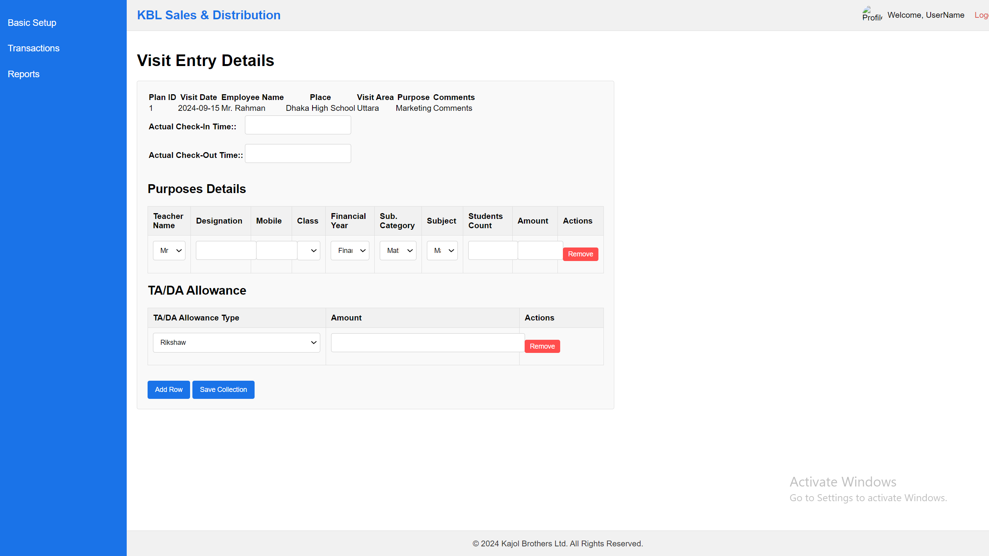

Note:

1. Visit Data must be enter from the visited location because geo-located data will auto save in the system and user enter check-in time and check-out time data.
2. Teacher combo data will load from the visit places school/college/coaching center entry form where initially enter all the teacher data.
3. Financial Year data will load from Financial Year Data.
4. Category data will load from product category data.
5. Subject will come from the product table all the data.
6. If the Purpose : Demand Collection then Student count & Amount will show here, but rest of the all purpose will not load this two column.
7. TA/DA Allowance data will load from the TA/DA Allowance type data.

API:

For list show:

SQL: SELECT [VisitPlanID],[VisitDate],[UserID],[InstitutionID],[PurposeID],[Purposes],[ApprovalStatus],[Status],[CreatedAt],[ModifiedAt], [ApprovalStatus] ,[Comments], ,[ApprovedbyUserID], CheckInTime, CheckOutTime, Latitude, Longitude FROM [dbo].[sndVisitPlans]

API:

1. <http://36.255.68.50:8080/DLogicKBL/salesforce_api.php?action=get_visit_plan&ID=1>

For Update visitplan master table

1. <http://36.255.68.50:8080/DLogicKBL/salesforce_api.php?action=update_visit_plan_entry&ID=1>

SQL:

UPDATE [dbo].[sndVisitPlans]

SET [CheckInTime] = <CheckInTime, datetime,>

,[CheckOutTime] = <CheckOutTime, datetime,>

,[Latitude] = <Latitude, decimal(9,6),>

,[Longitude] = <Longitude, decimal(9,6),>

WHERE VisitPlanID = ?

GO

For add data to visitplandetails table

1. <http://36.255.68.50:8080/DLogicKBL/salesforce_api.php?action=create_visit_plan_details>

SQL:

INSERT INTO [dbo].[sndVisitPlanDetails]

([VisitPlanID]

,[TeacherName]

,[Designation]

,[Phone]

,[Classes]

,[FinancialYearID]

,[ProductCategoryID]

,[ProductID]

,[StudentNo]

,[DonationAmount]

,[CreatedAt]

,[ModifiedAt])

VALUES

(<VisitPlanID, int,>

,<TeacherName, varchar(200),>

,<Designation, varchar(100),>

,<Phone, varchar(25),>

,<Classes, varchar(50),>

,<FinancialYearID, int,>

,<ProductCategoryID, int,>

,<ProductID, int,>

,<StudentNo, int,>

,<DonationAmount, decimal(10,2),>

,<CreatedAt, datetime,>

,<ModifiedAt, datetime,>)

For add data to visitplanTADAdetails table

1. [http://36.255.68.50:8080/DLogicKBL/salesforce_api.php?action=create_visit_plan_TADA_details](http://36.255.68.50:8080/DLogicKBL/salesforce_api.php?action=create_visit_plan_TADA_details%20)

SQL:

INSERT INTO [dbo].[sndVisitPlanTADADetails]

([VisitPlanID]

,[TADACategoryID]

,[Amount]

,[CreatedAt]

,[ModifiedAt])

VALUES

(<VisitPlanID, int,>

,<TADACategoryID, int,>

,<DonationAmount, decimal(10,2),>

,<CreatedAt, datetime,>

,<ModifiedAt, datetime,>)

## **Visit Approval**

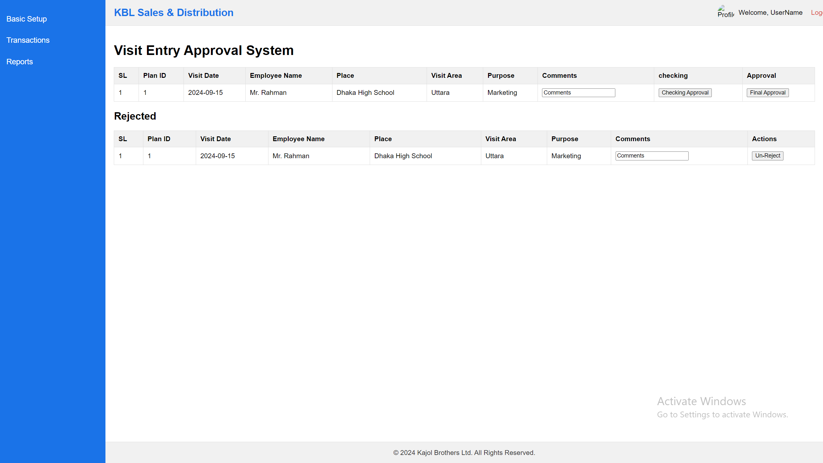

API:

For list show:

SQL: SELECT [VisitPlanID],[VisitDate],[UserID],[InstitutionID],[PurposeID],[Purposes],[ApprovalStatus],[Status],[CreatedAt],[ModifiedAt], [ApprovalStatus] ,[Comments], ,[ApprovedbyUserID], CheckInTime, CheckOutTime, Latitude, Longitude FROM [dbo].[sndVisitPlans]

API:

1. <http://36.255.68.50:8080/DLogicKBL/salesforce_api.php?action=get_visit_entries>

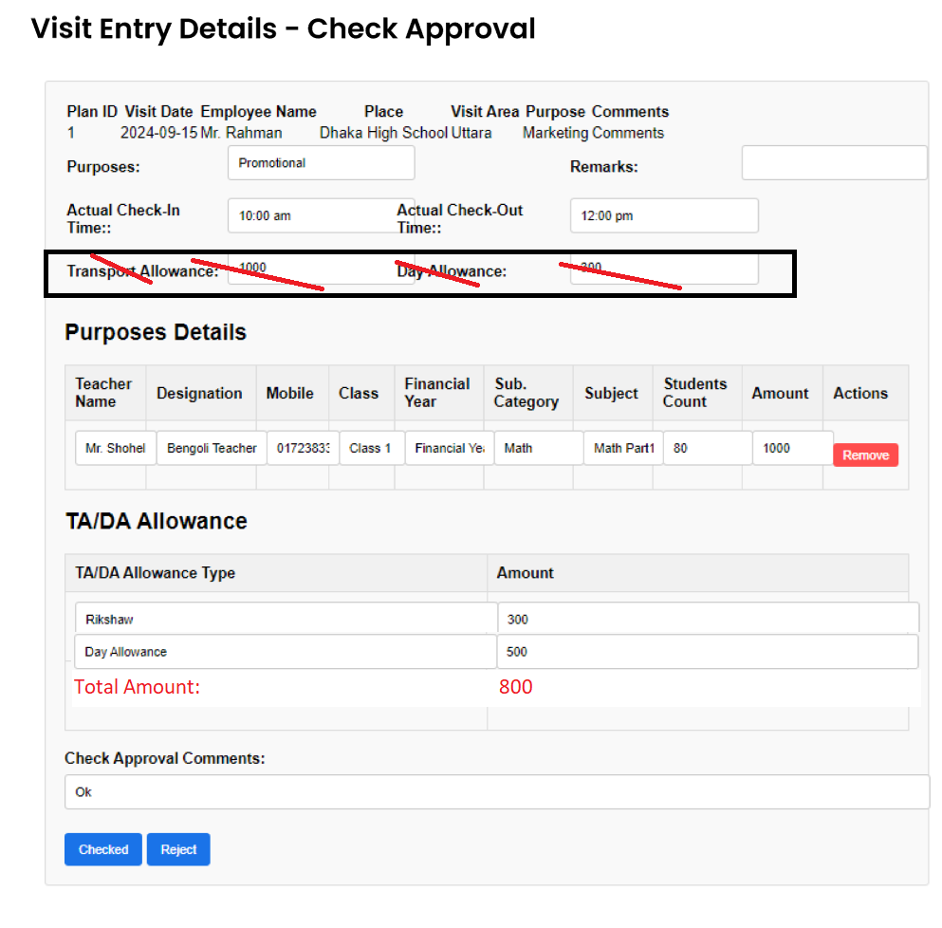

For Update visitplan master table

API

1. [http://36.255.68.50:8080/DLogicKBL/salesforce_api.php?action=update_visit_plan_entry_check&ID=1](http://36.255.68.50:8080/DLogicKBL/salesforce_api.php?action=update_visit_plan_entry&ID=1)

SQL:

UPDATE sndVisitPlans SET

VisitEntryApprovalCommentsCheck, varchar(200),>

VisitApprovalStatusCheck = 'Checked',

VisitEntryApprovalDateCheck = GETDATE()

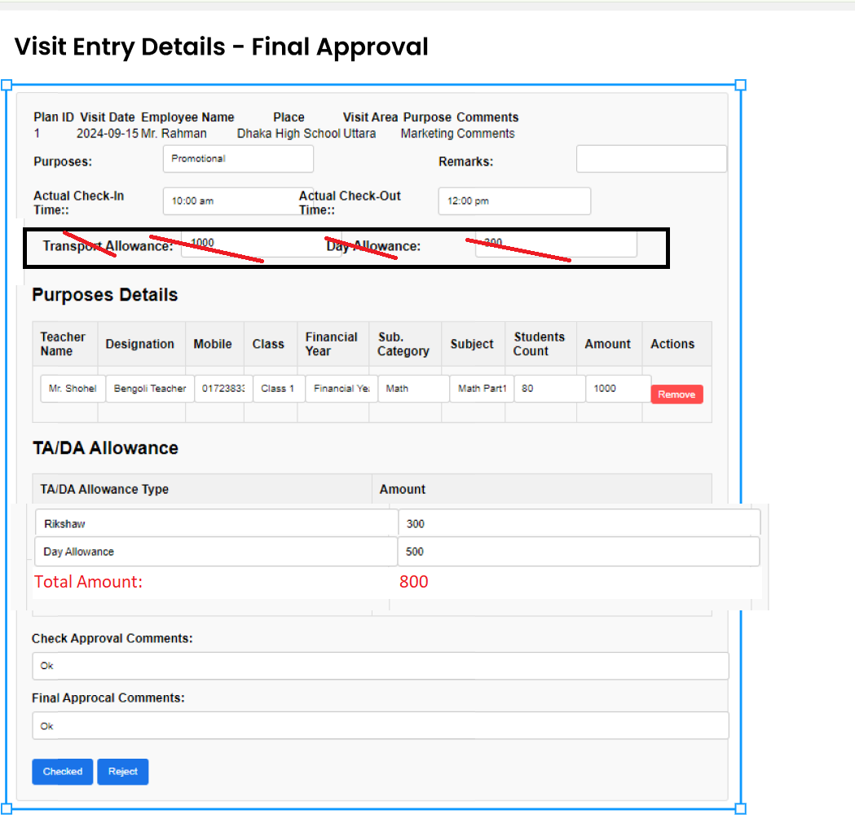

For Update visitplan master table

API

1. <http://36.255.68.50:8080/DLogicKBL/salesforce_api.php?action=update_visit_plan_entry_approved&ID=1>

SQL:

UPDATE sndVisitPlans SET

VisitEntryAppCommentsApproved, varchar(200),>

VisitAppStatusApproved = 'Approved',

VisitEntryAppDateApproved = GETDATE()

## **Production Order**

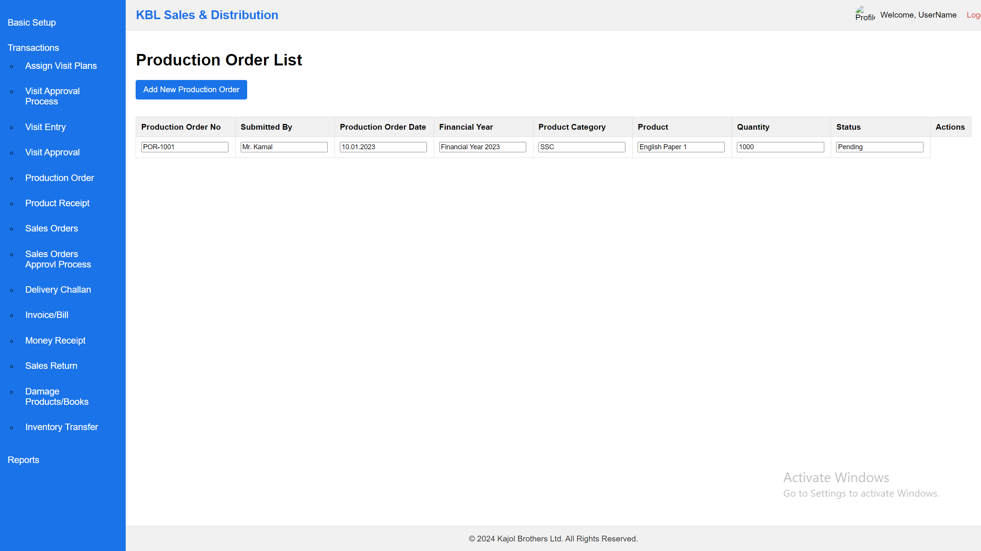

Notes:

1. List of the data can add, view & edit. No delete option.

SQL:

SELECT [ProductionOrderID]

,[ProductionOrderNo]

,[SubmittedByUserID]

,[ProductGroupID]

,[ProductID]

,[Quantity]

,[ProductionDemandQty]

,[UnitPrice]

,[TotalPrice]

,[ProductionOrderDate]

,[FinancialYearID]

,[Status]

,[CreatedAt]

,[ModifiedAt]

FROM [dbo].[sndProductionOrder]

API:

1. [http://36.255.68.50:8080/salesforce_api.php?action=get_production_orders](http://yourserver.com/sndProductionOrder_api.php?action=get_production_orders)
2. [http://36.255.68.50:8080/salesforce_api.php?action=get_production_order&ProductionOrderID=1](http://36.255.68.50:8080/sndProductionOrder_api.php?action=get_production_order&ProductionOrderID=1)
3. [http://36.255.68.50:8080/salesforce_api.php?action=update_production_order&ProductionOrderID=1](http://36.255.68.50:8080/sndProductionOrder_api.php?action=update_production_order&ProductionOrderID=1)

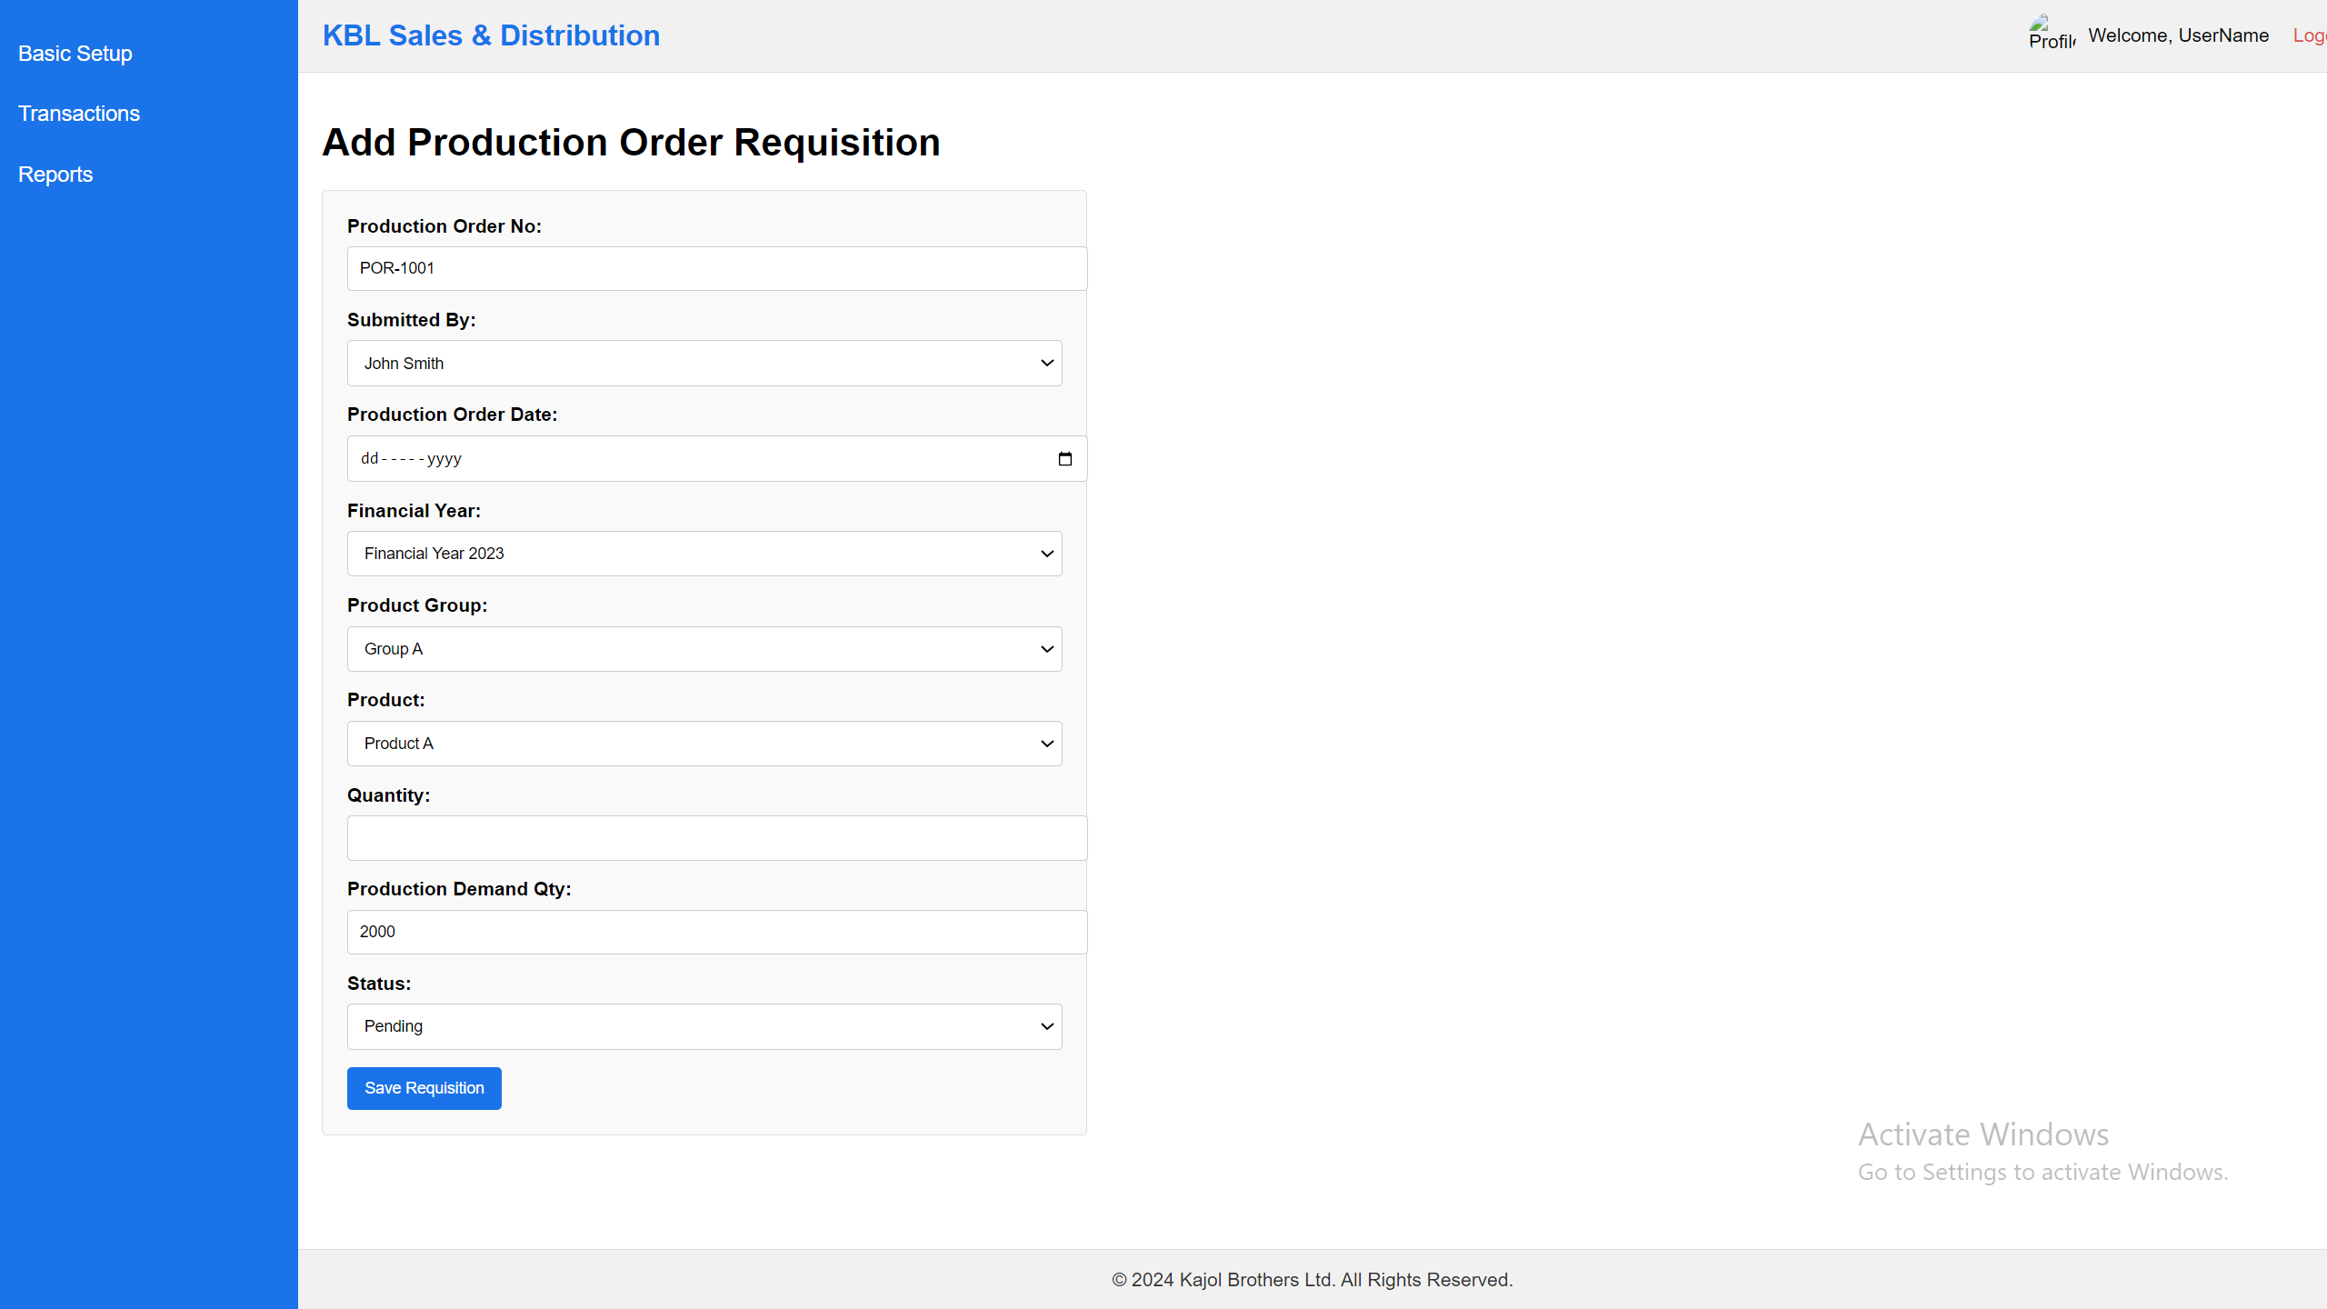

Notes:

1. ProductionOrderNo will auto generated
2. Production demand Qty will come from the previous demand collection.
3. Initially Status = “pending”, “On-progress”, “Complete”

API:

1. [http://yourserver.com/salesforce_api.php?action=create_production_order](http://yourserver.com/sndProductionOrder_api.php?action=create_production_order)

SQL:

INSERT INTO [dbo].[sndProductionOrder]

([ProductionOrderNo]

,[SubmittedByUserID]

,[ProductGroupID]

,[ProductID]

,[Quantity]

,[ProductionDemandQty]

,[UnitPrice]

,[ProductionOrderDate]

,[FinancialYearID]

,[Status]

,[CreatedAt]

,[ModifiedAt])

VALUES

(<ProductionOrderNo, varchar(50),>

,<SubmittedByUserID, int,>

,<ProductGroupID, int,>

,<ProductID, int,>

,<Quantity, int,>

,<ProductionDemandQty, int,>

,<UnitPrice, decimal(10,2),>

,<ProductionOrderDate, date,>

,<FinancialYearID, int,>

,<Status, varchar(100),>

,<CreatedAt, datetime,>

,<ModifiedAt, datetime,>)

## **Product Receipt**

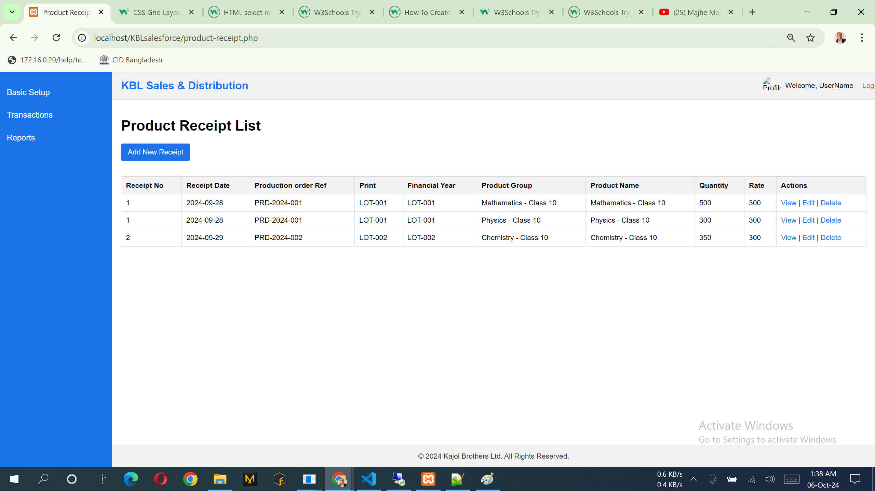

Notes:

1. List of the data can add, view & edit. No delete option.

SQL:

SELECT [ProductReceiptID]

,[ProductReceiptNo]

,[ReceiptDate]

,[ProductionOrderRef]

,[PrintEdition]

,[FinancialYearID]

,[ProductCategoryID]

,[ProductID]

,[Quantity]

,[ProductionOrderQty]

,[CreatedAt]

,[ModifiedAt]

FROM [dbo].[sndProductReceipt]

API:

1. [http://36.255.68.50:8080/DLogicKBL/salesforce_api.php?action=get_preceipts](http://36.255.68.50:8080/DLogicKBL/sndProductReceipt_api.php?action=get_preceipts)
2. [http://36.255.68.50:8080/DLogicKBL/salesforce_api.php?action=get_receipt&ProductReceiptID=1](http://36.255.68.50:8080/DLogicKBL/sndProductReceipt_api.php?action=get_receipt&ProductReceiptID=1)
3. [http://36.255.68.50:8080/DLogicKBL/salesforce_api.php?action=update_receipt&ProductReceiptID=1](http://36.255.68.50:8080/DLogicKBL/sndProductReceipt_api.php?action=update_receipt&ProductReceiptID=1)

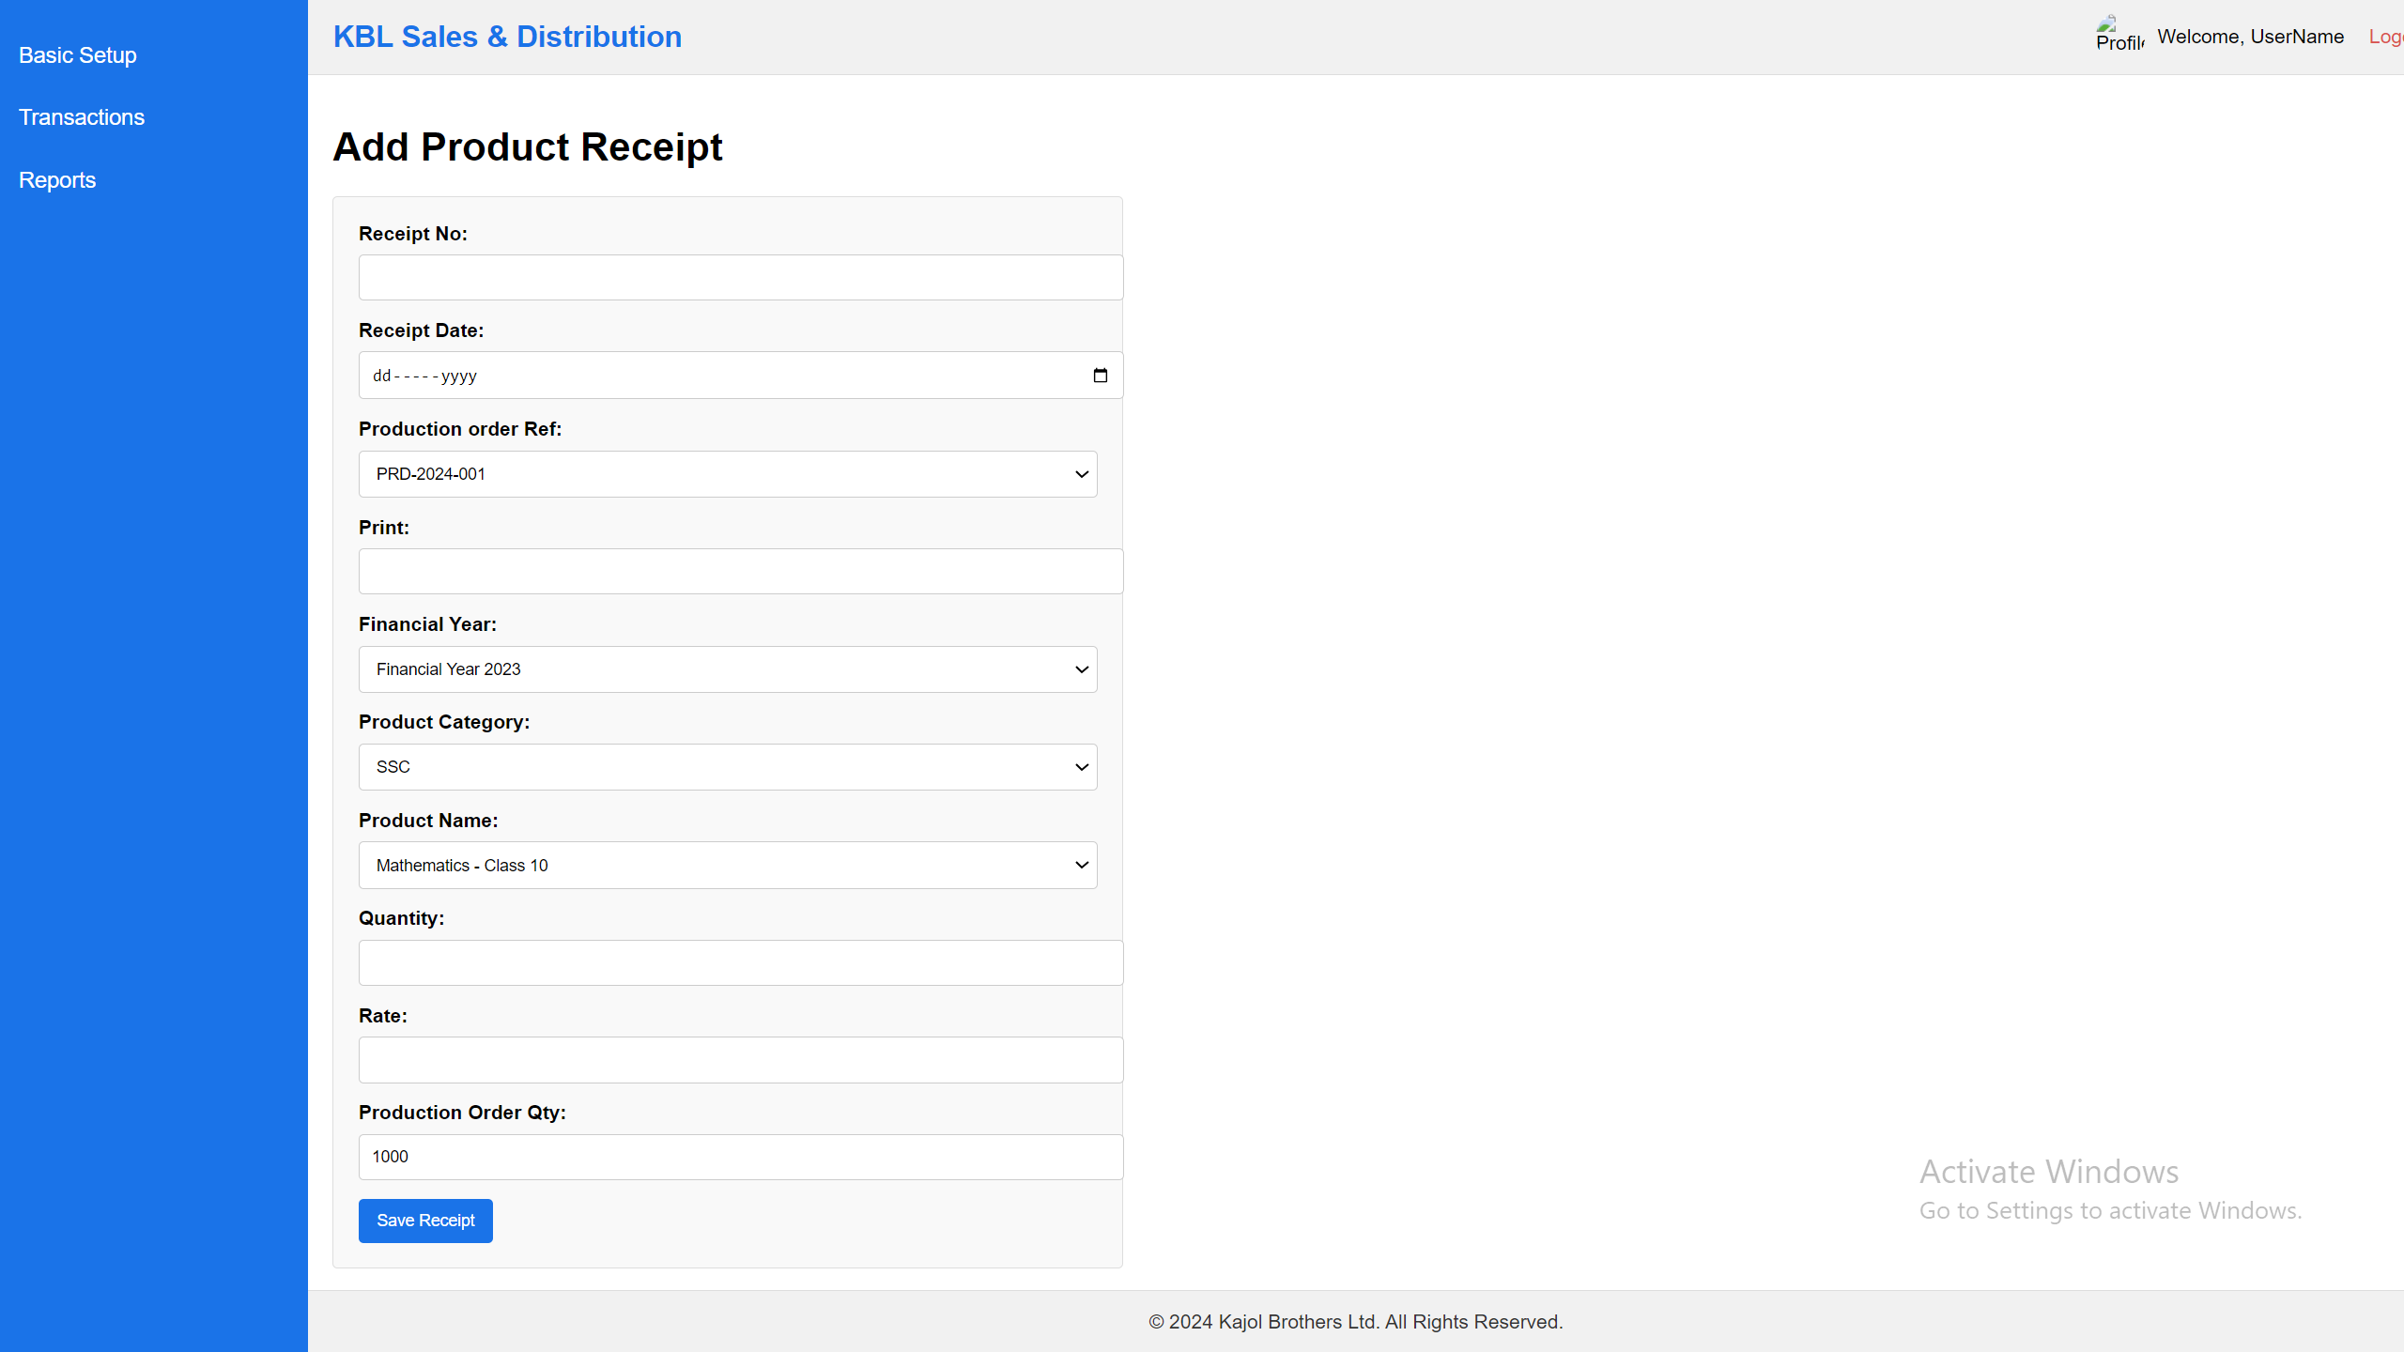

Notes:

1. Production Order Qty will auto come when select production order ref
2. production order ref combox data come from production order
3. Receipt Number will auto generate like PRT-1001

API:

1. [http://36.255.68.50:8080/DLogicKBL/salesforce_api.php?action=create_receipt](http://36.255.68.50:8080/DLogicKBL/sndProductReceipt_api.php?action=create_receipt)

SQL:

INSERT INTO [dbo].[sndProductReceipt]

([ProductReceiptNo]

,[ReceiptDate]

,[ProductionOrderRef]

,[PrintEdition]

,[FinancialYearID]

,[ProductCategoryID]

,[ProductID]

,[Quantity]

,[ProductionOrderQty]

,[CreatedAt]

,[ModifiedAt])

VALUES

(<ProductReceiptNo, varchar(100),>

,<ReceiptDate, date,>

,<ProductionOrderRef, varchar(100),>

,<PrintEdition, varchar(150),>

,<FinancialYearID, int,>

,<ProductCategoryID, int,>

,<ProductID, int,>

,<Quantity, int,>

,<ProductionOrderQty, int,>

,<CreatedAt, datetime,>

,<ModifiedAt, datetime,>)

## **Sales Orders**

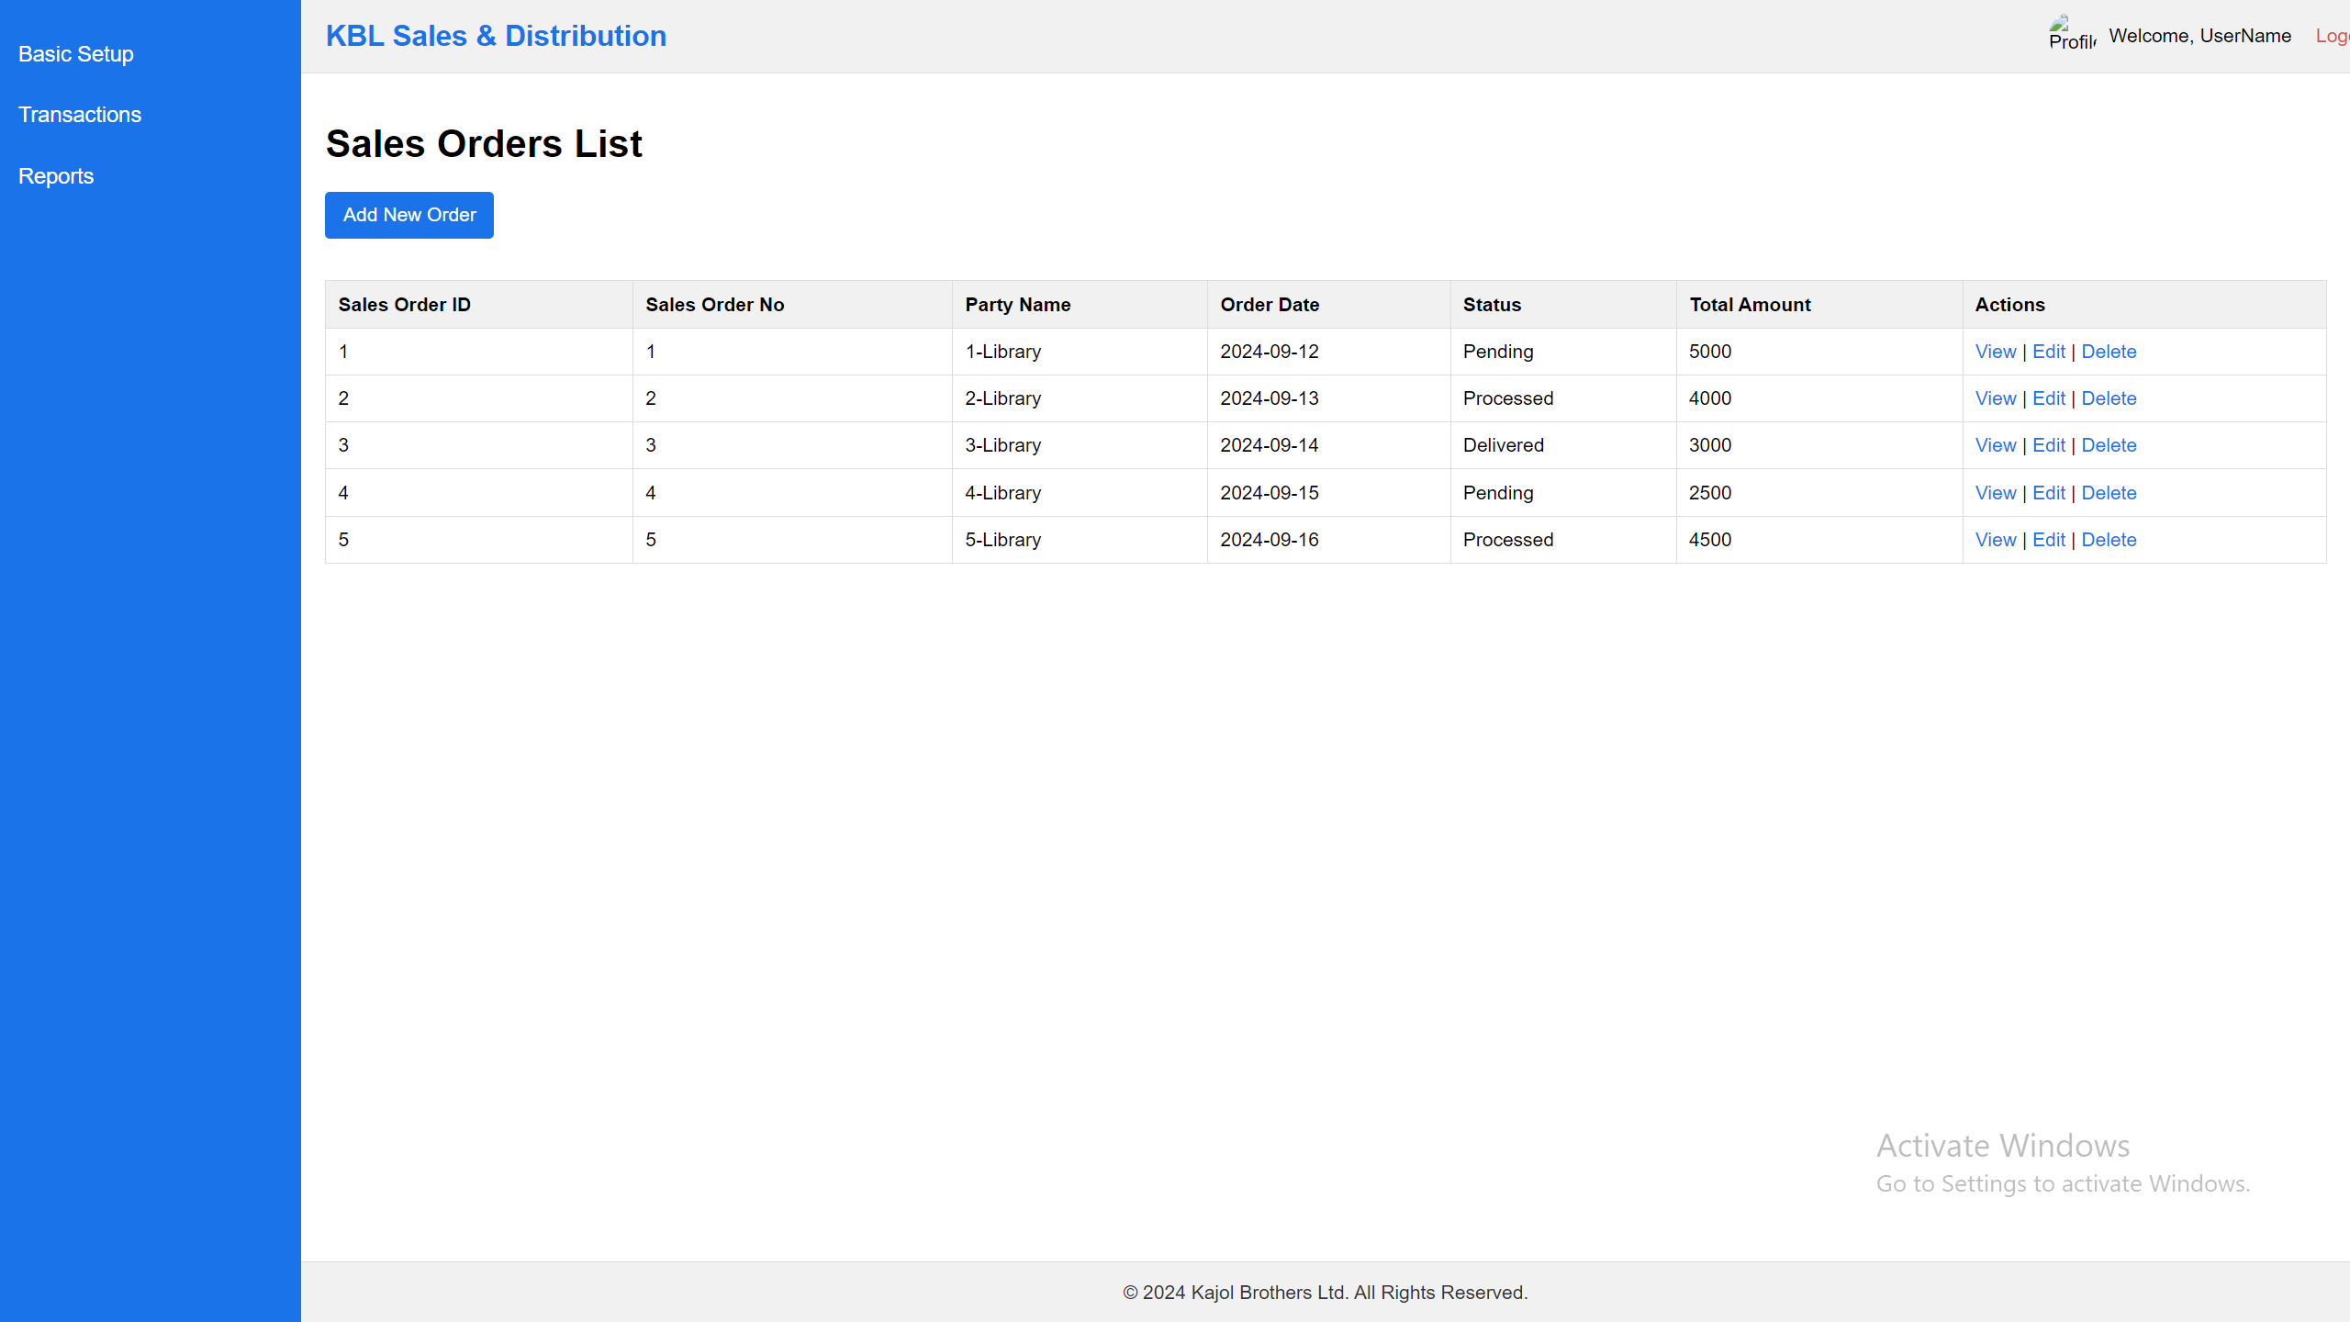

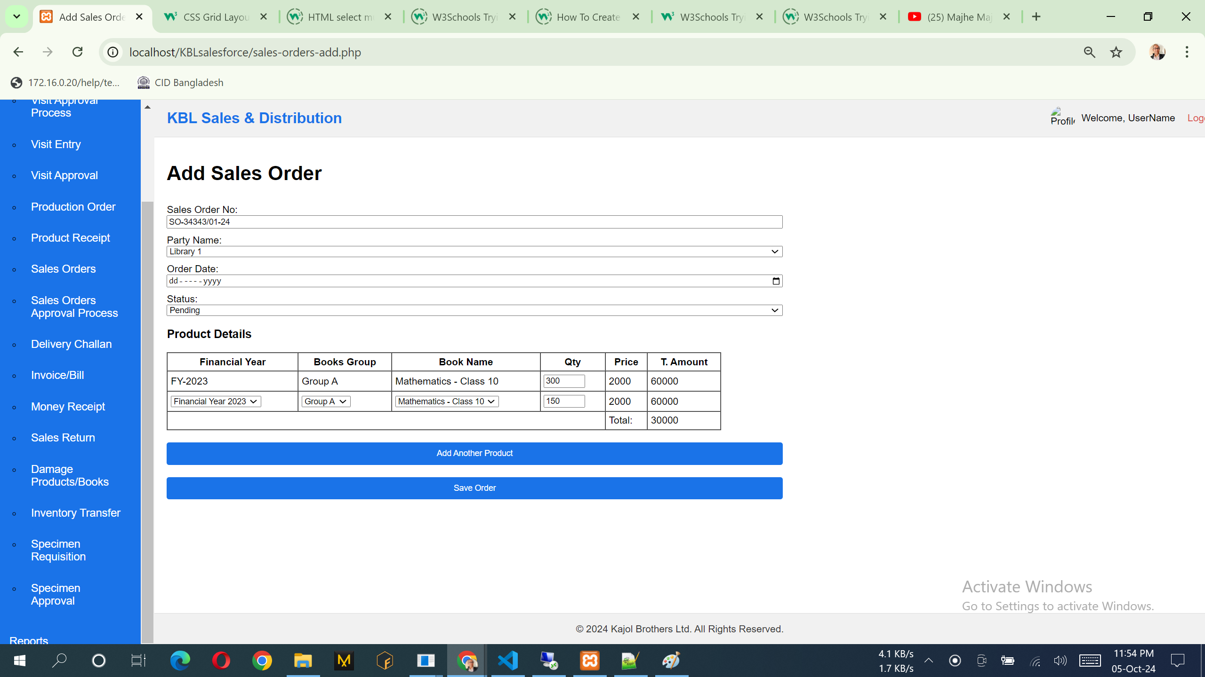

SQL:

INSERT INTO [dbo].[sndSalesOrders]

([SalesOrderNo]

,[PartyID]

,[OrderDate]

,[Status]

,[TotalAmount]

,[CollectedByUserID]

,[CreatedAt]

,[ModifiedAt])

VALUES

(<SalesOrderNo, varchar(100),>

,<PartyID, int,>

,<OrderDate, datetime,>

,<Status, varchar(100),>

,<TotalAmount, decimal(10,2),>

,<CollectedByUserID, int,>

,<CreatedAt, datetime,>

,<ModifiedAt, datetime,>)

INSERT INTO [dbo].[sndSalesOrderDetails]

([SalesOrderID]

,[FinancialYearID]

,[ProductCategoryID]

,[ProductID]

,[Quantity]

,[Price]

,[CreatedAt]

,[ModifiedAt])

VALUES

(<SalesOrderID, int,>

,<FinancialYearID, int,>

,<ProductCategoryID, int,>

,<ProductID, int,>

,<Quantity, int,>

,<Price, decimal(10,2),>

,<CreatedAt, datetime,>

,<ModifiedAt, datetime,>)

API:

1. salesforce_api.phpGet all orderssalesforce_api.php (GET):

- URL: `http://36.255.68.50:8080/salesforce_api.php?action=get_orders`

2. salesforce_api.phpGet a single ordersalesforce_api.php (GET):

- URL: `http://36.255.68.50:8080/salesforce_api.php?action=get_order&SalesOrderID=1`

3. salesforce_api.phpCreate an ordersalesforce_api.php (POST):

- URL: `http://36.255.68.50:8080/salesforce_api.php?action=create_order`

- Example Request Body (JSON):

```json

{

"PartyID": 1,

"CollectedByUserID": 2,

"OrderDate": "2024-01-15",

"Status": "Pending",

"TotalAmount": 15000.50,

"orderDetails": [

{

"ProductID": 1,

"Quantity": 5,

"Price": 200.00

},

{

"ProductID": 2,

"Quantity": 3,

"Price": 150.00

}

]

}

```

4. salesforce_api.phpUpdate an ordersalesforce_api.php (PUT):

- URL: `http://36.255.68.50:8080/salesforce_api.php?action=update_order&SalesOrderID=1`

- Example Request Body (JSON):

```json

{

"PartyID": 1,

"CollectedByUserID": 2,

"OrderDate": "2024-01-15",

"Status": "Processed",

"TotalAmount": 16000.75,

"orderDetails": [

{

"SalesOrderDetailID": 1,

"ProductID": 1,

"Quantity

": 5,

"Price": 210.00

},

{

"SalesOrderDetailID": 2,

"ProductID": 2,

"Quantity": 4,

"Price": 160.00

}

]

}

```

5. salesforce_api.phpDelete an ordersalesforce_api.php (DELETE):

- URL: `http://36.255.68.50:8080/salesforce_api.php?action=delete_order&SalesOrderID=1`

## **Money Receipt**

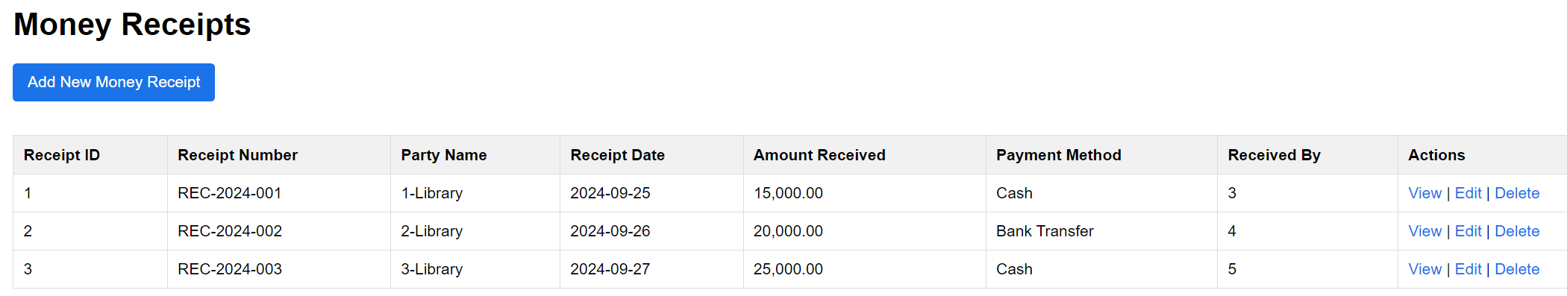

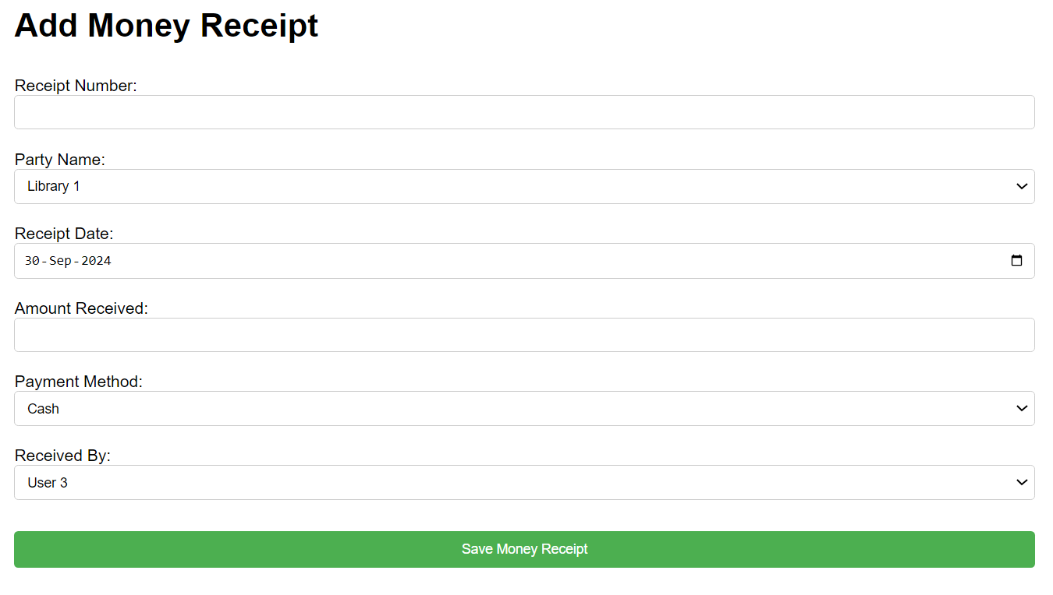

Here are some JSON examples using sample data for the `sndMoneyReceipt` API, covering various operations like creating, retrieving, updating, and deleting receipts.

### Sample Data for `sndMoneyReceipt`

Here’s some sample data that might be present in the `sndMoneyReceipt` table:

1. **Sample Data Entries**

- **Receipt 1**

- ReceiptNo: "REC-2024-001"

- InvoiceID: 101

- PartyID: 1

- ReceiptDate: "2024-09-15"

- AmountReceived: 500.00

- PaymentMethod: "Cash"

- ReceivedByUserID: 2

- **Receipt 2**

- ReceiptNo: "REC-2024-002"

- InvoiceID: 102

- PartyID: 2

- ReceiptDate: "2024-09-16"

- AmountReceived: 1500.00

- PaymentMethod: "Bank Transfer"

- ReceivedByUserID: 1

- **Receipt 3**

- ReceiptNo: "REC-2024-003"

- InvoiceID: 103

- PartyID: 3

- ReceiptDate: "2024-09-17"

- AmountReceived: 700.00

- PaymentMethod: "Cheque"

- ReceivedByUserID: 3

- **Receipt 4**

- ReceiptNo: "REC-2024-004"

- InvoiceID: 104

- PartyID: 4

- ReceiptDate: "2024-09-18"

- AmountReceived: 1200.00

- PaymentMethod: "Credit Card"

- ReceivedByUserID: 2

- **Receipt 5**

- ReceiptNo: "REC-2024-005"

- InvoiceID: 105

- PartyID: 5

- ReceiptDate: "2024-09-19"

- AmountReceived: 800.00

- PaymentMethod: "Cash"

- ReceivedByUserID: 1

### API Endpoint Examples Using Sample Data

#### 1. Create a New Receipt

**Endpoint:** `POST http://36.255.68.50:8080/DLogicKBL/sndMoneyReceipt_api.php?action=create_receipt`

**Request Body:**

```json

{

"ReceiptNo": "REC-2024-006",

"InvoiceID": 106,

"PartyID": 6,

"ReceiptDate": "2024-09-20",

"AmountReceived": 950.00,

"PaymentMethod": "Bank Transfer",

"ReceivedByUserID": 2

}

```

**Expected Response:**

```json

{

"success": "Receipt created successfully"

}

```

---

#### 2. Retrieve All Receipts

**Endpoint:** `GET http://36.255.68.50:8080/DLogicKBL/sndMoneyReceipt_api.php?action=get_receipts`

**Expected Response:**

```json

[

{

"ReceiptID": 1,

"ReceiptNo": "REC-2024-001",

"InvoiceID": 101,

"PartyID": 1,

"ReceiptDate": "2024-09-15",

"AmountReceived": 500.00,

"PaymentMethod": "Cash",

"ReceivedByUserID": 2,

"CreatedAt": "2024-09-15T12:00:00",

"ModifiedAt": "2024-09-15T12:00:00"

},

{

"ReceiptID": 2,

"ReceiptNo": "REC-2024-002",

"InvoiceID": 102,

"PartyID": 2,

"ReceiptDate": "2024-09-16",

"AmountReceived": 1500.00,

"PaymentMethod": "Bank Transfer",

"ReceivedByUserID": 1,

"CreatedAt": "2024-09-16T12:00:00",

"ModifiedAt": "2024-09-16T12:00:00"

}

]

```

---

#### 3. Retrieve a Specific Receipt

**Endpoint:** `GET http://36.255.68.50:8080/DLogicKBL/sndMoneyReceipt_api.php?action=get_receipt&ReceiptID=1`

**Expected Response:**

```json

{

"ReceiptID": 1,

"ReceiptNo": "REC-2024-001",

"InvoiceID": 101,

"PartyID": 1,

"ReceiptDate": "2024-09-15",

"AmountReceived": 500.00,

"PaymentMethod": "Cash",

"ReceivedByUserID": 2,

"CreatedAt": "2024-09-15T12:00:00",

"ModifiedAt": "2024-09-15T12:00:00"

}

```

---

#### 4. Update a Receipt

**Endpoint:** `PUT http://36.255.68.50:8080/DLogicKBL/sndMoneyReceipt_api.php?action=update_receipt&ReceiptID=1`

**Request Body:**

```json

{

"ReceiptNo": "REC-2024-001",

"InvoiceID": 101,

"PartyID": 1,

"ReceiptDate": "2024-09-15",

"AmountReceived": 550.00,

"PaymentMethod": "Cash",

"ReceivedByUserID": 2

}

```

**Expected Response:**

```json

{

"success": "Receipt updated successfully"

}

```

---

#### 5. Delete a Receipt

**Endpoint:** `DELETE http://36.255.68.50:8080/DLogicKBL/sndMoneyReceipt_api.php?action=delete_receipt&ReceiptID=1`

**Expected Response:**

```json

{

"success": "Receipt deleted successfully"

}

## **Sales Return**

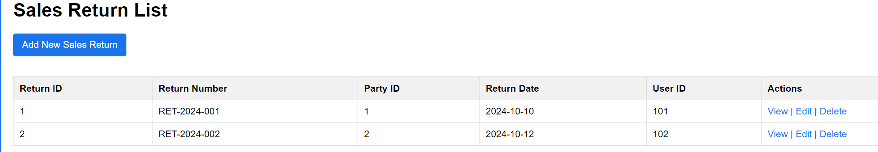

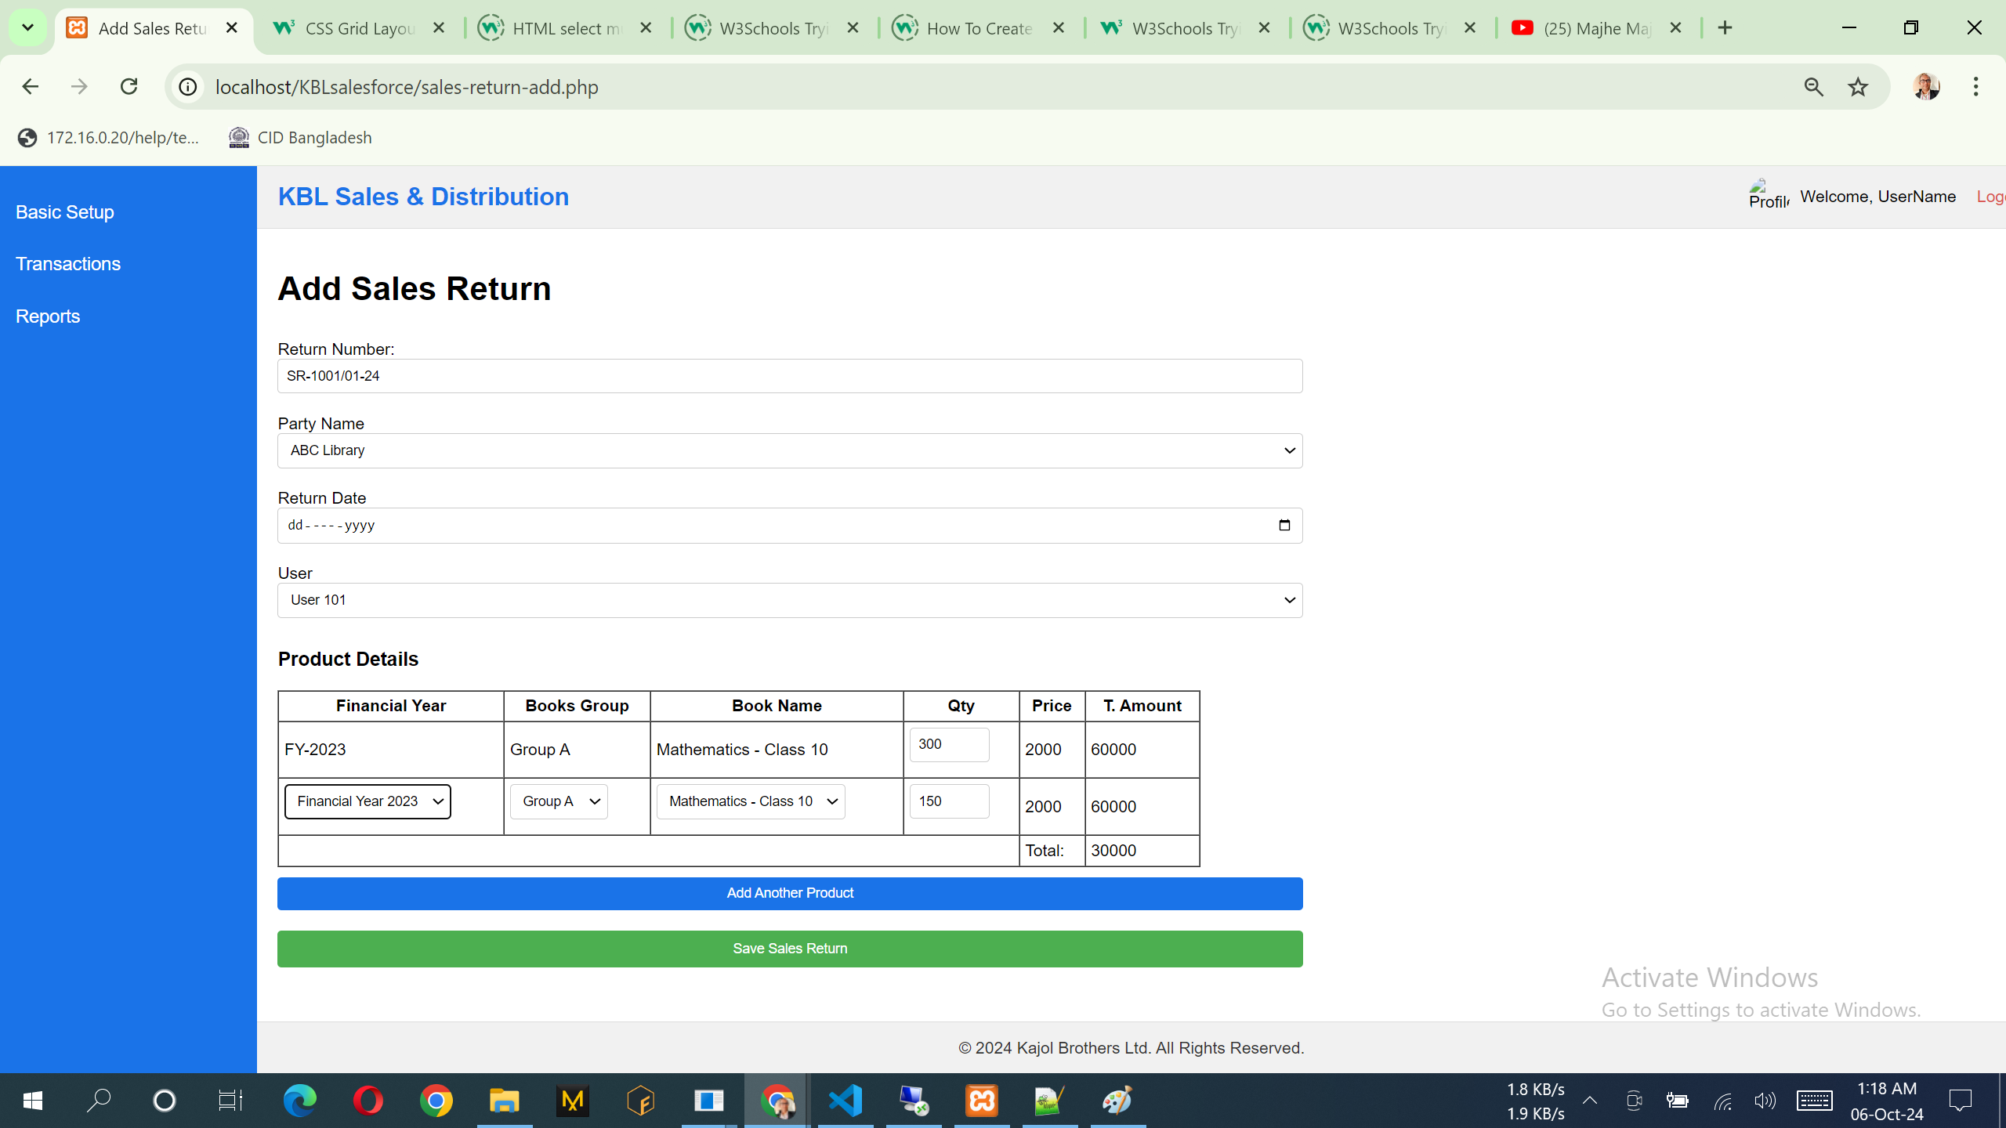

Explanation:

- The API supports the following actions:

- GET: Retrieve all sales returns or a specific sales return by ID.

- POST: Create a new sales return or sales return detail.

- PUT: Update an existing sales return or sales return detail.

- DELETE: Remove a sales return or sales return detail.

Here are some JSON examples of how to interact with the `sndSalesReturn_api.php` using sample data. These examples cover creating, retrieving, updating, and deleting sales returns and their details.

1. Create a New Sales Return

Endpoint: `POST http://36.255.68.50:8080/DLogicKBL/sndSalesReturn_api.php?action=create_return`

Request Body:

```json

{

"ReturnNumber": "RTN-2024-001",

"PartyID": 1,

"ReturnDate": "2024-09-18",

"UserID": 2

}

```

Expected Response:

```json

{

"success": "Sales return created successfully"

}

```

---

2. Create a New Sales Return Detail

Endpoint: `POST http://36.255.68.50:8080/DLogicKBL/sndSalesReturn_api.php?action=create_return_detail`

Request Body:

```json

{

"ReturnID": 1,

"FinancialYearID": 2023,

"ProductCategoryID": 1,

"ProductID": 2,

"ProductName": "Mathematics - Class 10",

"Quantity": 5,

"ReturnReason": "Damaged during shipping"

}

```

Expected Response:

```json

{

"success": "Sales return detail created successfully"

}

```

---

3. Retrieve All Sales Returns

Endpoint: `GET http://36.255.68.50:8080/DLogicKBL/sndSalesReturn_api.php?action=get_returns`

Expected Response:

```json

[

{

"ReturnID": 1,

"ReturnNumber": "RTN-2024-001",

"PartyID": 1,

"ReturnDate": "2024-09-18",

"UserID": 2,

"CreatedAt": "2024-09-18T12:00:00",

"ModifiedAt": "2024-09-18T12:00:00"

},

{

"ReturnID": 2,

"ReturnNumber": "RTN-2024-002",

"PartyID": 1,

"ReturnDate": "2024-09-19",

"UserID": 3,

"CreatedAt": "2024-09-19T12:00:00",

"ModifiedAt": "2024-09-19T12:00:00"

}

]

```

---

4. Retrieve a Specific Sales Return

Endpoint: `GET http://36.255.68.50:8080/DLogicKBL/sndSalesReturn_api.php?action=get_return&ReturnID=1`

Expected Response:

```json

{

"ReturnID": 1,

"ReturnNumber": "RTN-2024-001",

"PartyID": 1,

"ReturnDate": "2024-09-18",

"UserID": 2,

"CreatedAt": "2024-09-18T12:00:00",

"ModifiedAt": "2024-09-18T12:00:00"

}

```

---

5. Update a Sales Return

Endpoint: `PUT http://36.255.68.50:8080/DLogicKBL/sndSalesReturn_api.php?action=update_return&ReturnID=1`

Request Body:

```json

{

"ReturnNumber": "RTN-2024-001",

"PartyID": 1,

"ReturnDate": "2024-09-20",

"UserID": 2

}

```

Expected Response:

```json

{

"success": "Sales return updated successfully"

}

```

---

6. Delete a Sales Return

Endpoint: `DELETE http://36.255.68.50:8080/DLogicKBL/sndSalesReturn_api.php?action=delete_return&ReturnID=1`

Expected Response:

```json

{

"success": "Sales return deleted successfully"

}

```

---

7. Update a Sales Return Detail

Endpoint: `PUT http://36.255.68.50:8080/DLogicKBL/sndSalesReturn_api.php?action=update_return_detail&ReturnDetailID=1`

Request Body:

```json

{

"ReturnID": 1,

"FinancialYearID": 2023,

"ProductCategoryID": 1,

"ProductID": 2,

"ProductName": "Mathematics - Class 10",

"Quantity": 10,

"ReturnReason": "Incorrect item delivered"

}

```

Expected Response:

```json

{

"success": "Sales return detail updated successfully"

}

```

---

8. Delete a Sales Return Detail

Endpoint: `DELETE http://36.255.68.50:8080/DLogicKBL/sndSalesReturn_api.php?action=delete_return_detail&ReturnDetailID=1`

Expected Response:

```json

{

"success": "Sales return detail deleted successfully"

}

## **Damage Products/Books**

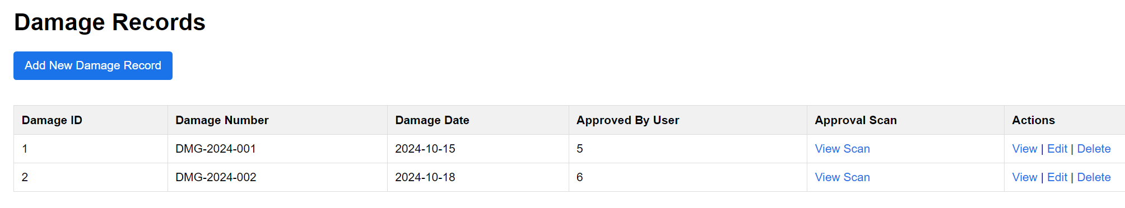

Notes:

1. List of the data can add, view & edit. No delete option.

API:

1. <http://36.255.68.50:8080/DLogicKBL/salesforce_api.php?action=get_damages>
2. <http://36.255.68.50:8080/DLogicKBL/salesforce_api.php?action=get_damage&DamageID=1>
3. <http://36.255.68.50:8080/DLogicKBL/salesforce_api.php?action=update_damage&DamageID=1>

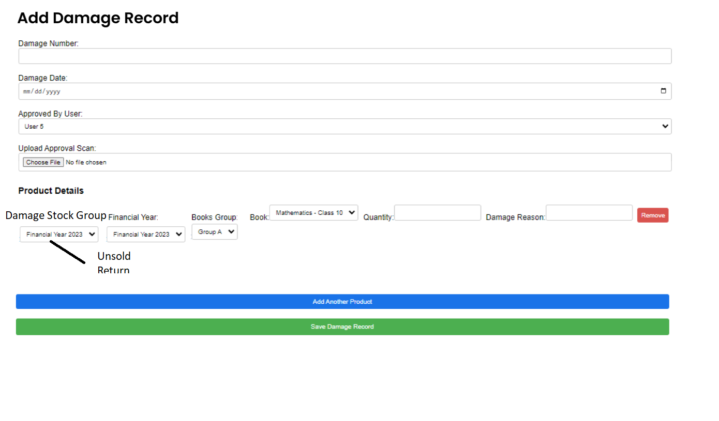

Notes:

API:

1. <http://36.255.68.50:8080/DLogicKBL/salesforce_api.php?action=create_damage>

Here are some sample JSON examples that can be used with the API endpoints of `sndDamage_api.php`:

1. Create a New Damage (`create_damage` endpoint)

Endpoint:

`POST http://36.255.68.50:8080/DLogicKBL/sndDamage_api.php?action=create_damage`

JSON Payload:

```json

{

"DamageNumber": "D-2024-001",

"DamageDate": "2024-09-10",

"ApprovedByUserID": 1

}

```

---

2. Create a New Damage Detail (`create_damage_detail` endpoint)

Endpoint:

`POST http://36.255.68.50:8080/DLogicKBL/sndDamage_api.php?action=create_damage_detail`

JSON Payload:

```json

{

"DamageID": 1,

"FinancialYearID": 2024,

"ProductCategoryID": 1,

"ProductID": 101,

"ProductName": "Mathematics - Class 10",

"Quantity": 50,

"DamageReason": "Water damage"

}

```

---

3. Update a Damage (`update_damage` endpoint)

Endpoint:

`PUT http://36.255.68.50:8080/DLogicKBL/sndDamage_api.php?action=update_damage&DamageID=1`

JSON Payload:

```json

{

"DamageNumber": "D-2024-002",

"DamageDate": "2024-09-12",

"ApprovedByUserID": 2

}

```

---

4. Update a Damage Detail (`update_damage_detail` endpoint)

Endpoint:

`PUT http://36.255.68.50:8080/DLogicKBL/sndDamage_api.php?action=update_damage_detail&DamageDetailID=1`

JSON Payload:

```json

{

"DamageID": 1,

"FinancialYearID": 2024,

"ProductCategoryID": 2,

"ProductID": 102,

"ProductName": "Physics - Class 9",

"Quantity": 100,

"DamageReason": "Packaging error"

}

```

---

5. Get All Damages (`get_damages` endpoint)

Endpoint:

`GET http://36.255.68.50:8080/DLogicKBL/sndDamage_api.php?action=get_damages`

Sample Response:

```json

[

{

"DamageID": 1,

"DamageNumber": "D-2024-001",

"DamageDate": "2024-09-10",

"ApprovedByUserID": 1,

"CreatedAt": "2024-09-10T14:30:00",

"ModifiedAt": null

},

{

"DamageID": 2,

"DamageNumber": "D-2024-002",

"DamageDate": "2024-09-12",

"ApprovedByUserID": 2,

"CreatedAt": "2024-09-12T10:15:00",

"ModifiedAt": null

}

]

```

---

6. Get a Single Damage (`get_damage` endpoint)

Endpoint:

`GET http://36.255.68.50:8080/DLogicKBL/sndDamage_api.php?action=get_damage&DamageID=1`

Sample Response:

```json

{

"damageMaster": {

"DamageID": 1,

"DamageNumber": "D-2024-001",

"DamageDate": "2024-09-10",

"ApprovedByUserID": 1,

"CreatedAt": "2024-09-10T14:30:00",

"ModifiedAt": null

},

"damageDetails": [

{

"DamageDetailID": 1,

"DamageID": 1,

"FinancialYearID": 2024,

"ProductCategoryID": 1,

"ProductID": 101,

"ProductName": "Mathematics - Class 10",

"Quantity": 50,

"DamageReason": "Water damage",

"CreatedAt": "2024-09-10T14:30:00",

"ModifiedAt": null

}

]

}

```

---

7. Delete a Damage (`delete_damage` endpoint)

Endpoint:

`DELETE http://36.255.68.50:8080/DLogicKBL/sndDamage_api.php?action=delete_damage&DamageID=1`

Sample Response:

```json

{

"success": "Damage deleted successfully"

}

```

---

8. Delete a Damage Detail (`delete_damage_detail` endpoint)

Endpoint:

`DELETE http://36.255.68.50:8080/DLogicKBL/sndDamage_api.php?action=delete_damage_detail&DamageDetailID=1`

Sample Response:

```json

{

"success": "Damage detail deleted successfully"

}

## **Inventory Transfer**

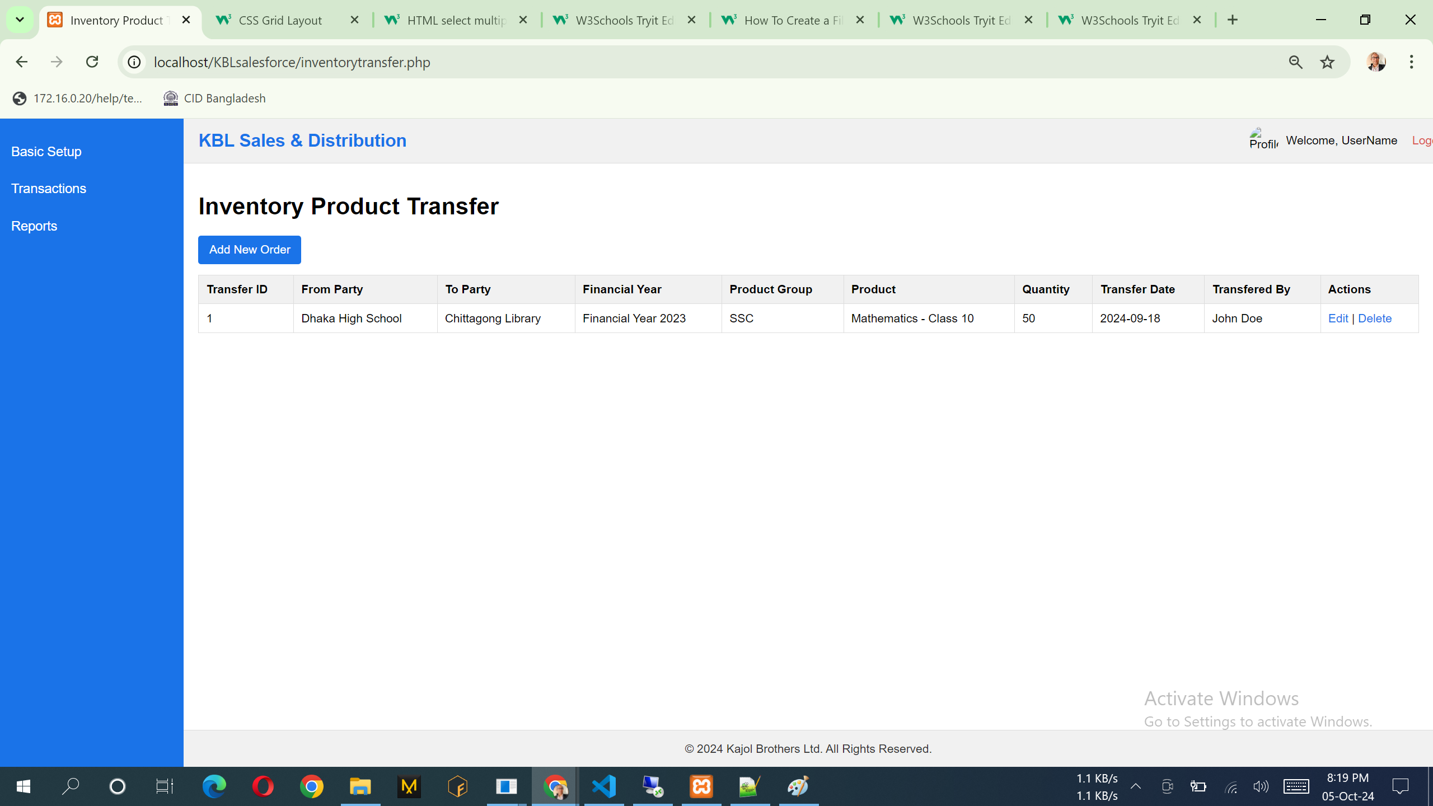

Notes:

1. List of the data can add, view & edit. No delete option.

SQL:

- PUT (update an existing transfer):

`PUT /salesforce_api.php?action=update_transfer&TransferID=1`

Example JSON data:

```json

{

"FromPartyID": 2,

"ToPartyID": 4,

"FinancialYearID": 2024,

"ProductCategoryID": 2,

"ProductID": 3,

"Quantity": 75,

"TransferDate": "2024-09-19",

"PerformedByUserID": 2

}

SELECT [TransferID]

,[FromPartyID]

,[ToPartyID]

,[FinancialYearID]

,[ProductCategoryID]

,[ProductID]

,[Quantity]

,[TransferDate]

,[PerformedByUserID]

,[CreatedAt]

,[ModifiedAt]

FROM [dbo].[sndInventoryProductTransfer]

API:

1. [http://36.255.68.50:8080/DLogicKBL/salesforce_api.php?action=get_transfers](http://36.255.68.50:8080/DLogicKBL/sndInventoryProductTransfer_api.php?action=get_transfers)
2. [http://36.255.68.50:8080/DLogicKBL/salesforce_api.php?action=get_transfer&TransferID=1](http://36.255.68.50:8080/DLogicKBL/sndProductReceipt_api.php?action=get_receipt&ProductReceiptID=1)
3. [http://36.255.68.50:8080/DLogicKBL/salesforce_api.php?action=update_transfer&TransferID=1](http://36.255.68.50:8080/DLogicKBL/sndProductReceipt_api.php?action=update_receipt&ProductReceiptID=1)

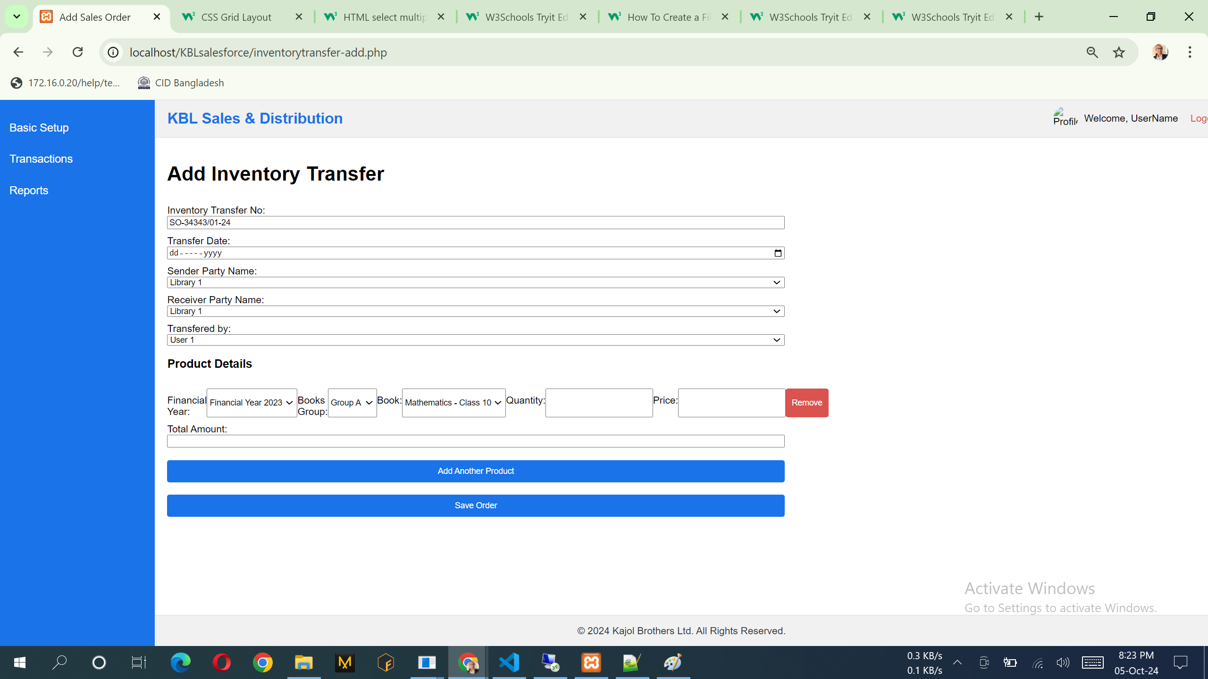

Notes:

1. Please follow the following design, This one is as like previous design… please try to understand business requirements
2. From Party – Party api, To Party – Party api, Financial Year – Financial Year api, Product Category - Product Category api, Product – product api, performed by: user api already discussed

API:

1. <http://36.255.68.50:8080/DLogicKBL/salesforce_api.php?action=create_transfer>

SQL:

Example JSON data:

```json

{

"FromPartyID": 1,

"ToPartyID": 3,

"FinancialYearID": 2023,

"ProductCategoryID": 1,

"ProductID": 2,

"Quantity": 50,

"TransferDate": "2024-09-18",

"PerformedByUserID": 1

}

INSERT INTO [dbo].[sndInventoryProductTransfer]

([FromPartyID]

,[ToPartyID]

,[FinancialYearID]

,[ProductCategoryID]

,[ProductID]

,[Quantity]

,[TransferDate]

,[PerformedByUserID]

,[CreatedAt]

,[ModifiedAt])

VALUES

(<FromPartyID, int,>

,<ToPartyID, int,>

,<FinancialYearID, int,>

,<ProductCategoryID, int,>

,<ProductID, int,>

,<Quantity, int,>

,<TransferDate, date,>

,<PerformedByUserID, int,>

,<CreatedAt, datetime,>

,<ModifiedAt, datetime,>)

## **Sales Orders Approval Process**

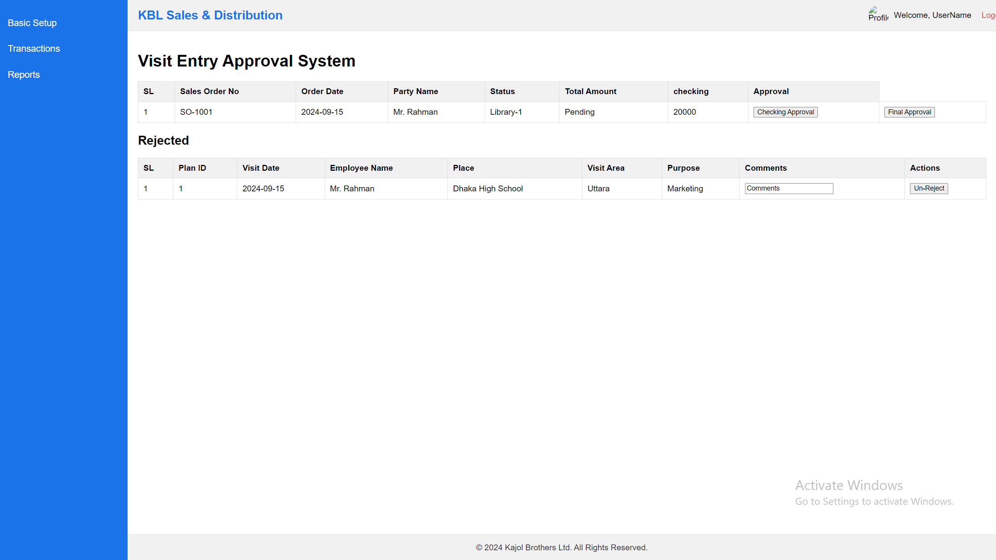

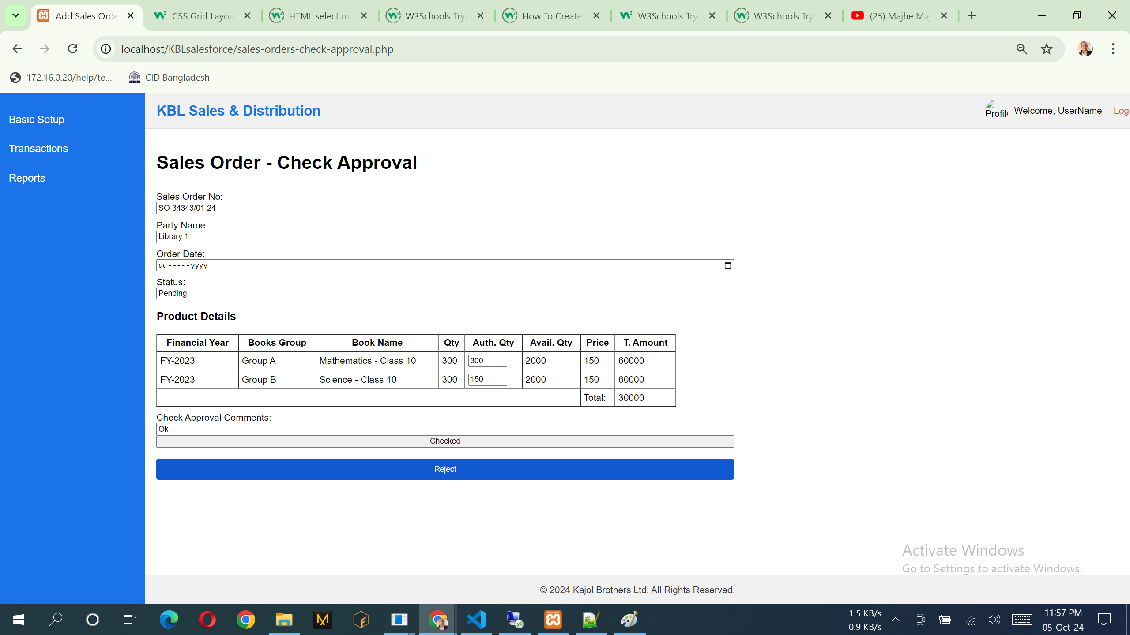

Notes: Here user can put Auth Qty and also see the avatilable stock in the design.

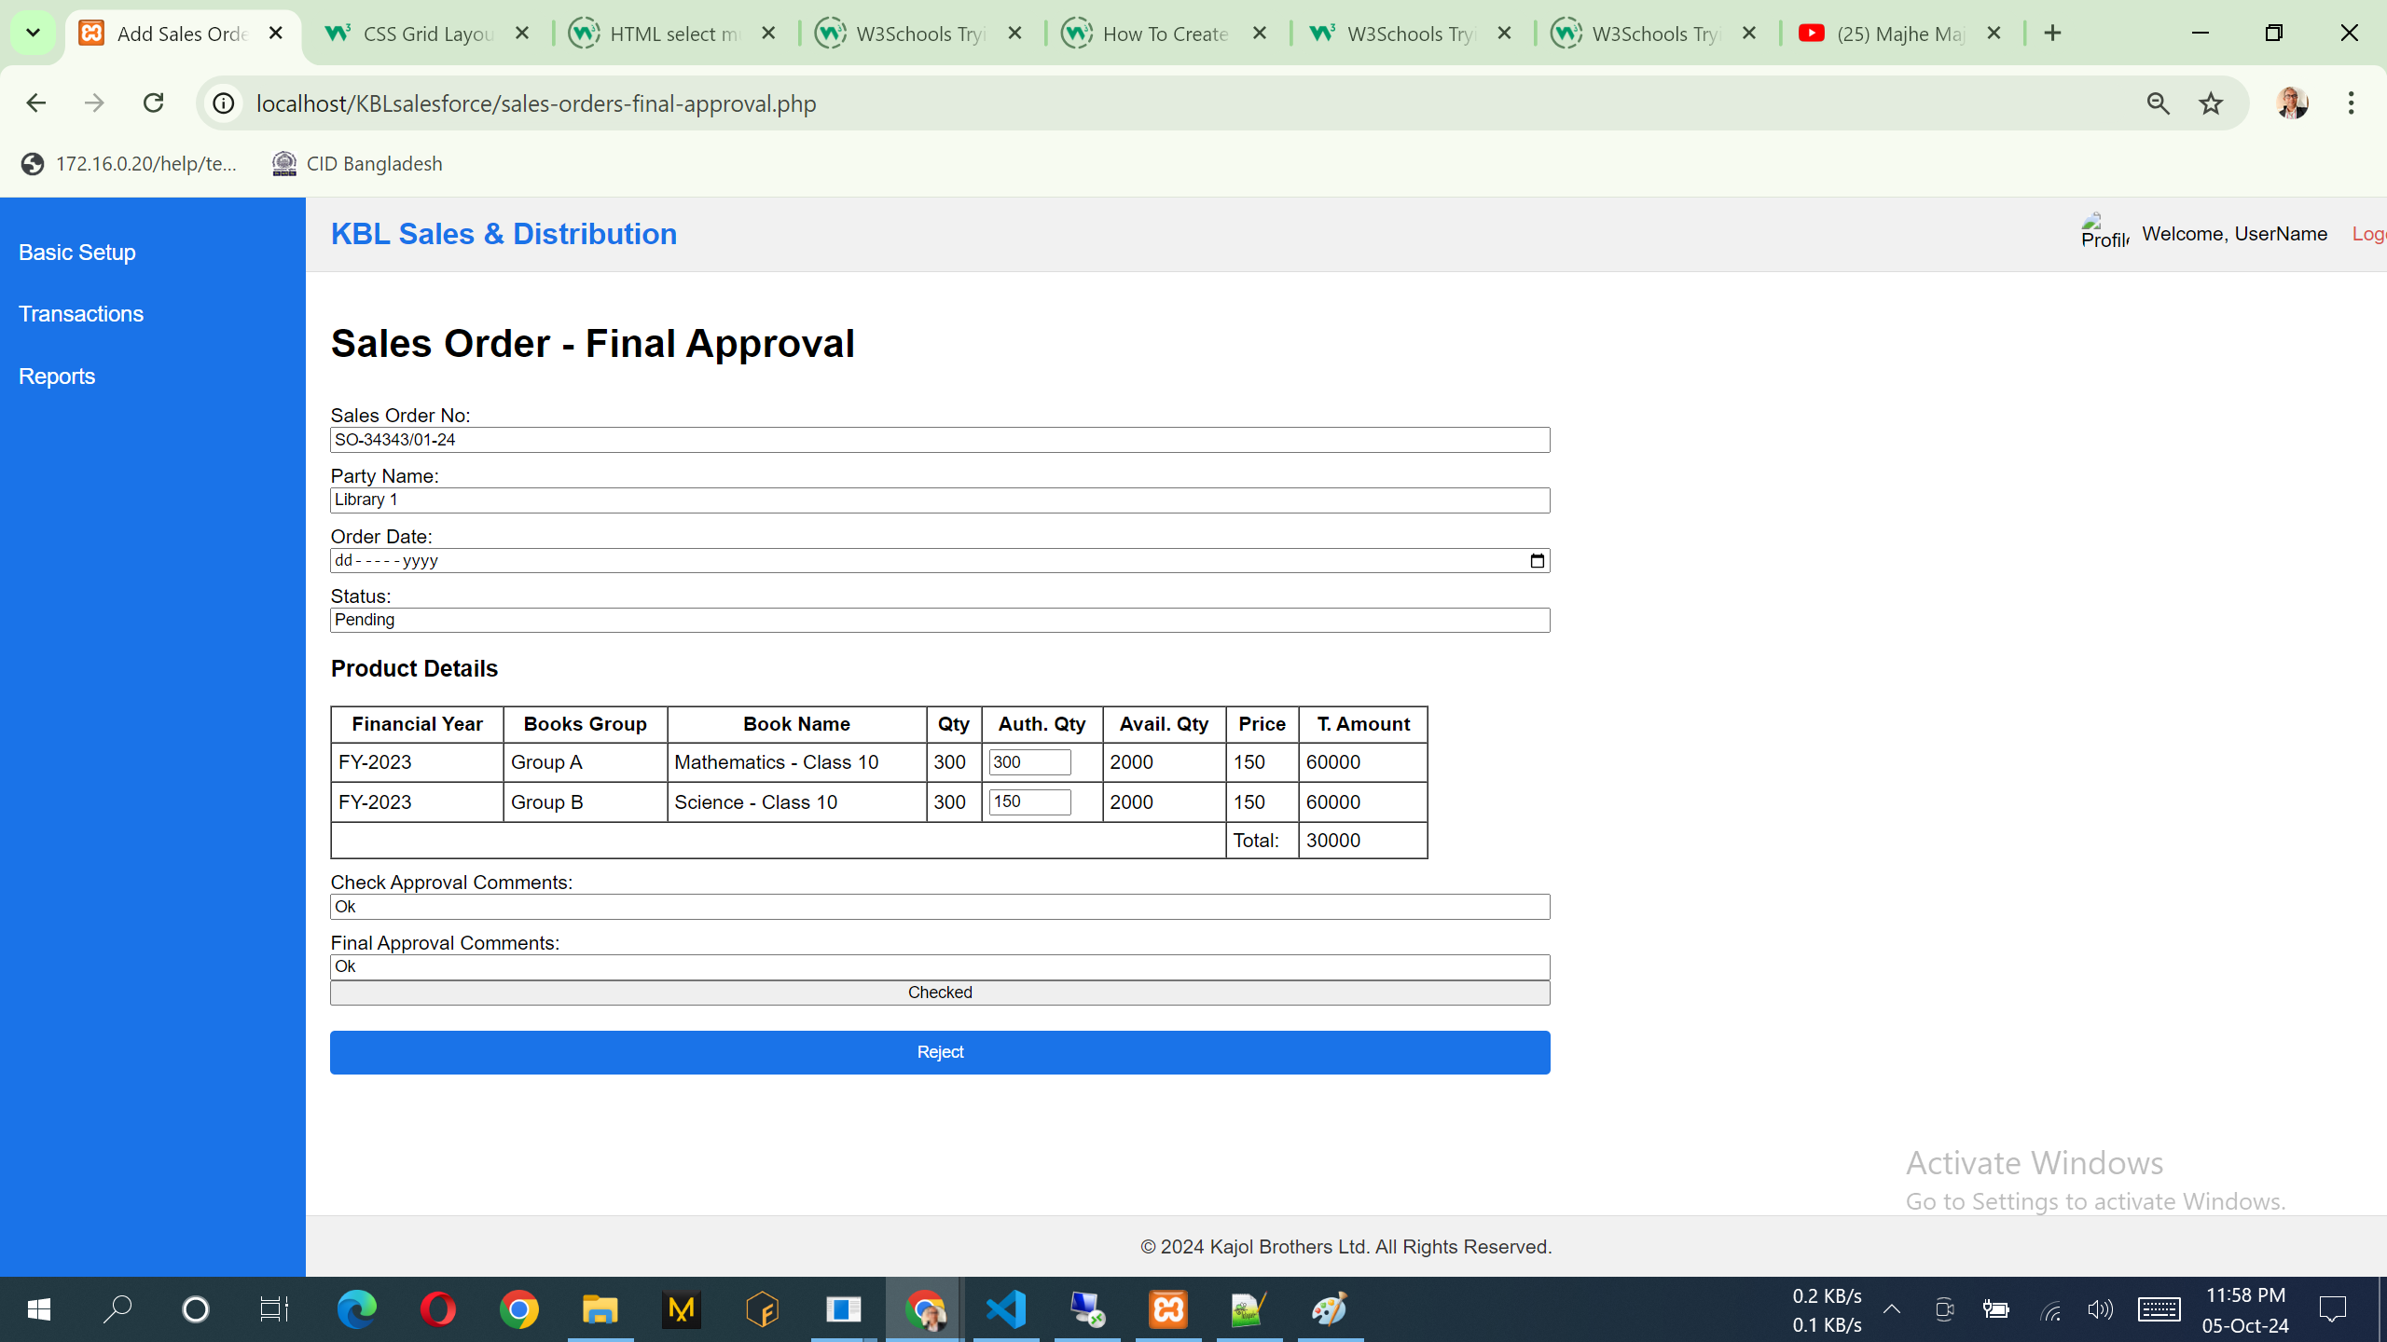

Notes: Here user can edit Auth Qty and also see the avatilable stock in the design.

## **Delivery Challan**

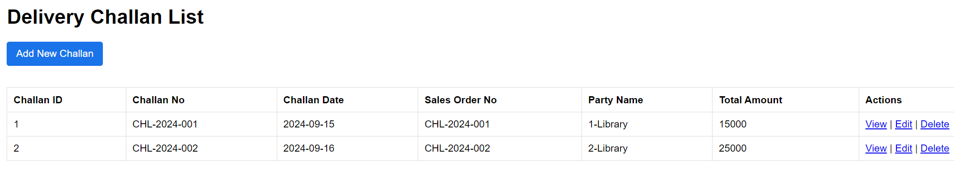

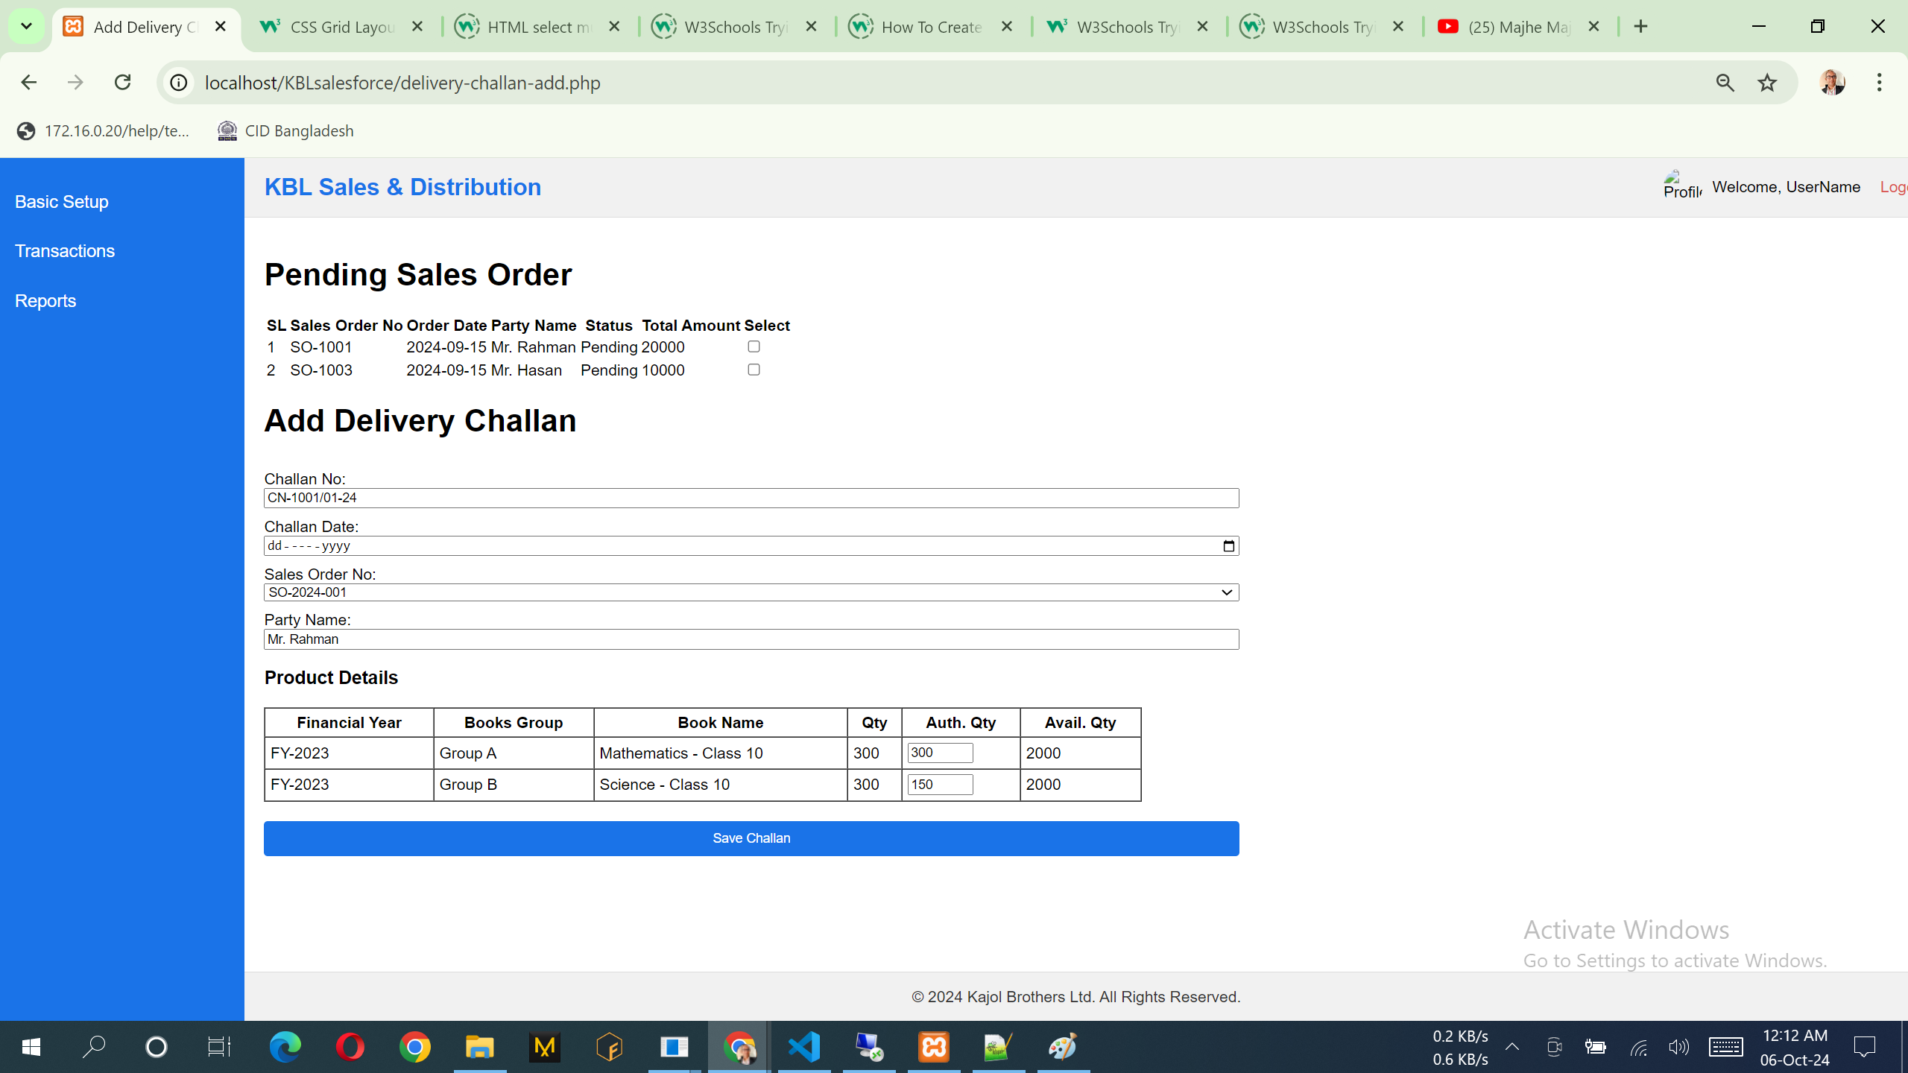

## **Invoice/Bill**

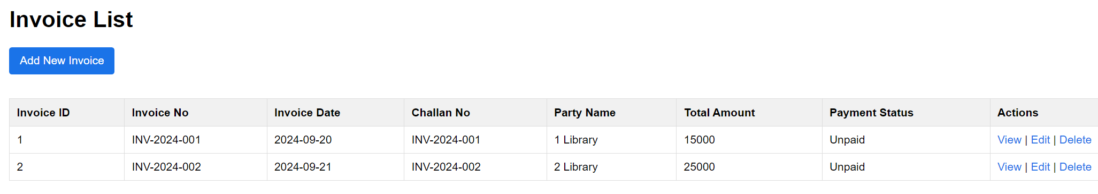

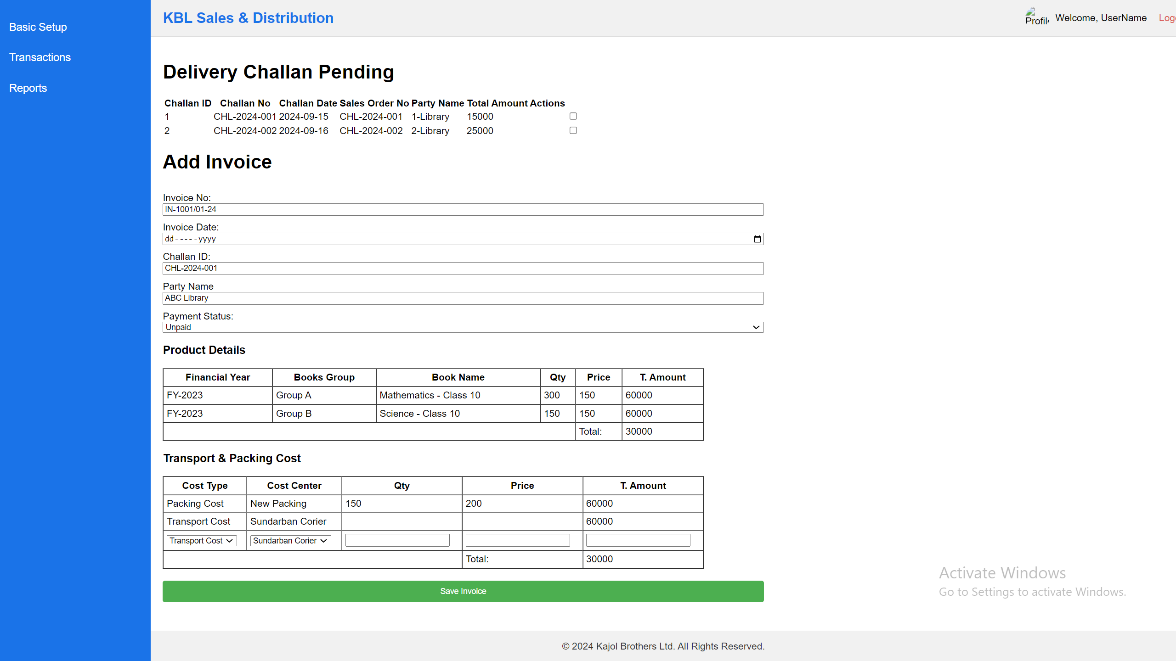

## **Specimen Requisition**

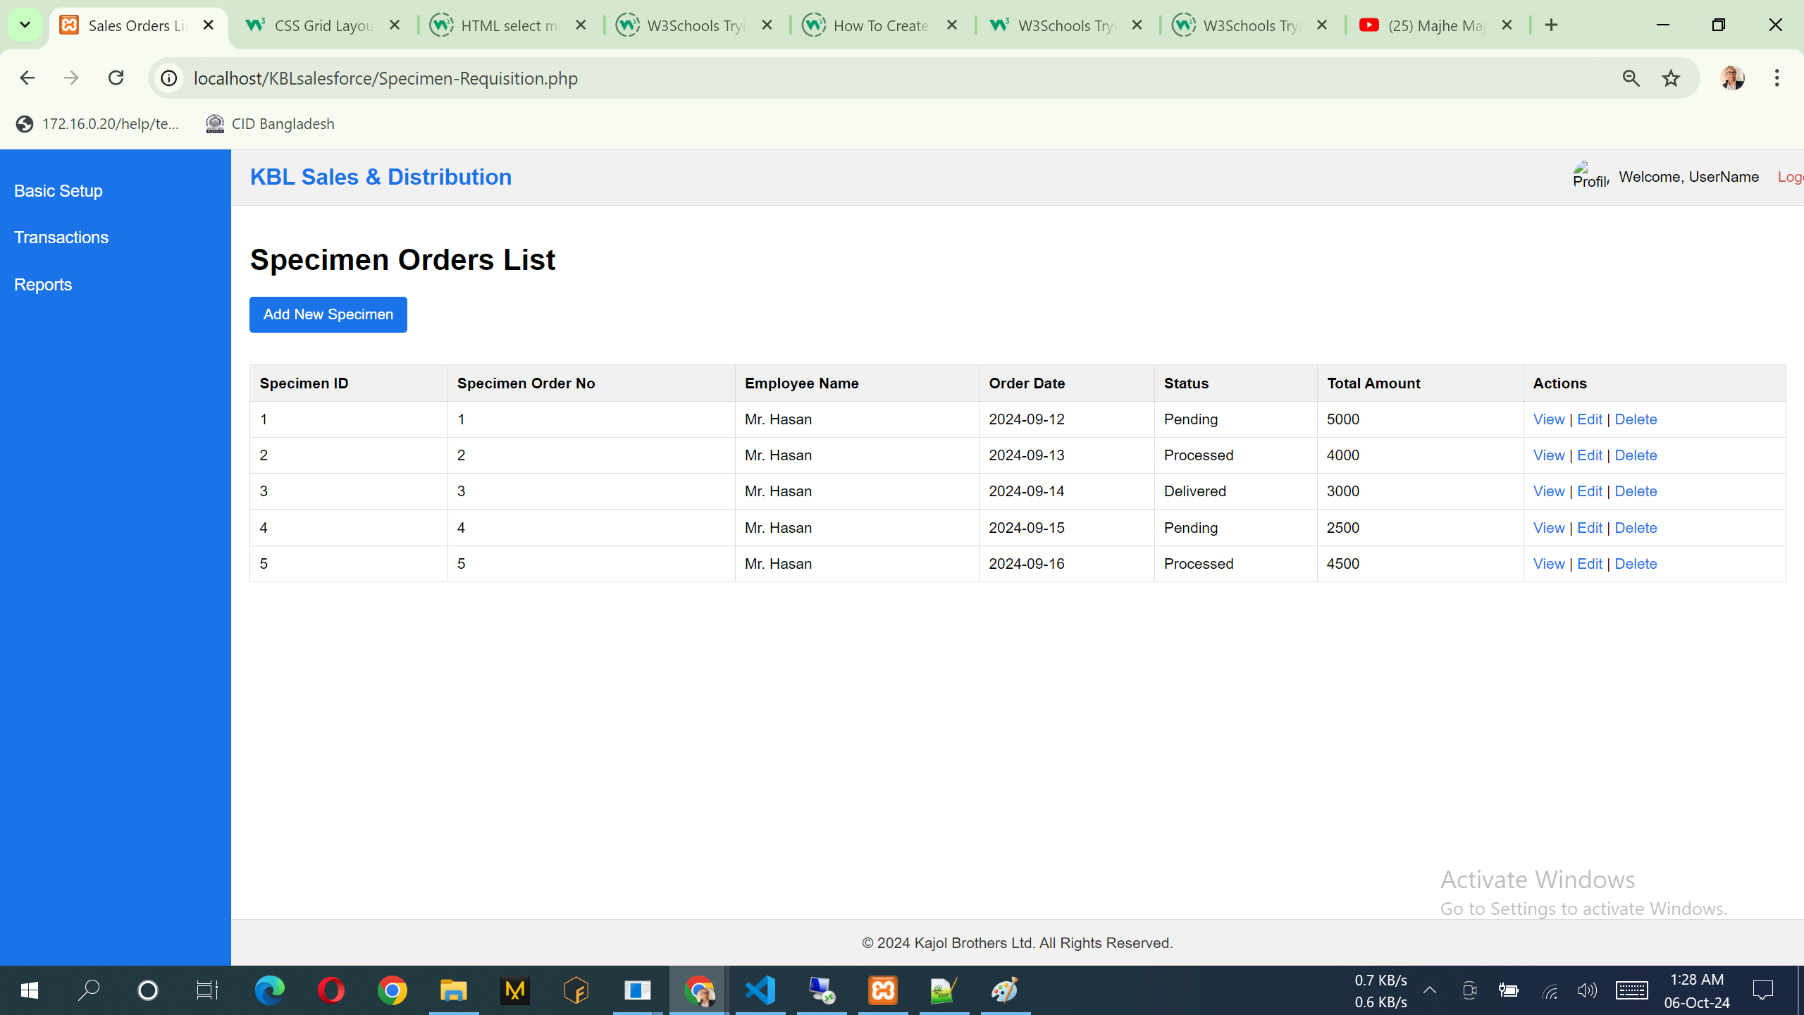

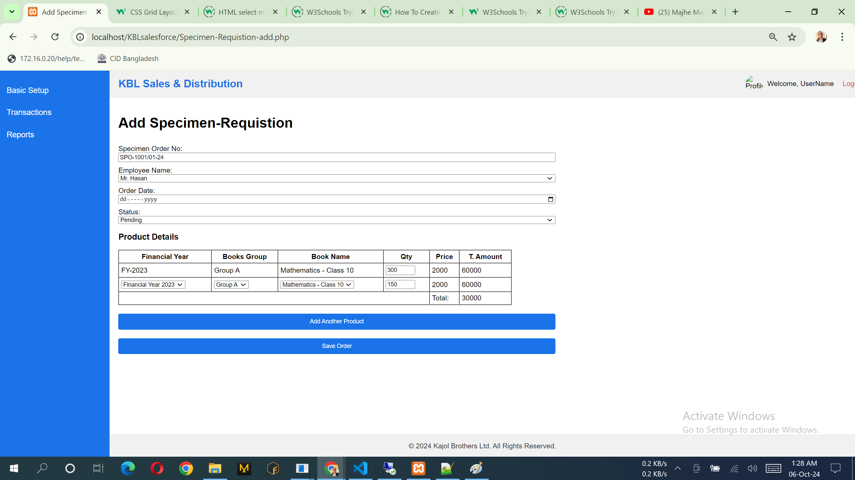

## **Specimen Approval**

